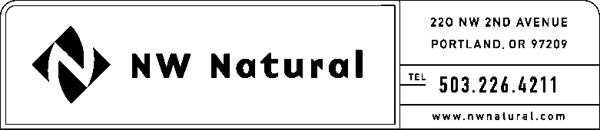

GAIL HAMMER
Tariffs and Regulatory Compliance
Tel: 503.226.4211, ext 5865
Fax: 503.721.2516
email: gail.hammer@nwnatural.com

VIA ELECTRONIC FILING AND U.S. MAIL

June 1, 2016

Steven V. King, Executive Director and Secretary
Washington Utilities & Transportation Commission
1300 S Evergreen Park Drive, SW
Post Office Box 47250
Olympia, Washington 98504-7250

Re: UG-_____ - 2015 Affiliated Interest Report and Cost Allocation Manual

Pursuant to WAC 480-90-264, enclosed please find an original and two copies of the 2015 Affiliated Interest Report and Cost Allocation Manual for Northwest Natural Gas Company, dba NW Natural.

NW Natural considers Exhibit A of this document to be confidential, and hereby requests that it be accorded confidential treatment in accordance with RCW 80.04.095 and WAC 480-07-160.

Exhibit A of the document has been printed on yellow paper and is sealed in an envelope bearing the legend: “CONFIDENTIAL PER WAC 480-07-160.” No portion of these materials may be copied, reproduced, or disclosed in any manner without the express permission of Northwest Natural Gas Company.

Please contact me should you have questions or require additional information.

Sincerely,

/s/ Gail Hammer
Gail Hammer
Rates and Regulation
enclosures

cc: Shawn Filippi
Brody Wilson
Alison Pear

