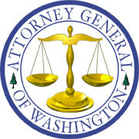
Bob Ferguson
ATTORNEY GENERAL OF WASHINGTON
Utilities and Transportation Division
PO Box 40128 • Olympia WA 98504-0128 • (360) 664-1183

Via Electronic and United States Mail

September 21, 2018

Mark L. Johnson, Executive Director and Secretary
Washington Utilities and Transportation Commission
1300 S. Evergreen Park Dr. S.W.
P.O. Box 47250
Olympia, Washington 98504-7250

RE: Richardson Water Company, L.L.C., v. WUTC
Docket UW-171068

Dear Mr. Johnson:

Enclosed for filing in the above-referenced docket is the original Motion for Order Removing Richardson Water L.L.C. from Regulation, and Certificate of Service.

Sincerely,

/s/ Nash Callaghan, WSBA No. 49682
Assistant Attorney General
Office of the Attorney General
Utilities and Transportation Division
P.O. Box 40128, Olympia, WA 98504-0128
(360) 664-1187
nash.callaghan@utc.wa.gov

NIC:klg
Enclosures
cc: Patrick Andreotti

