Puget Sound Energy

Meter and Billing Performance Annual Report

Annual Reporting Period:
January 1, 2014 - December 31, 2014

Filed on January 30, 2015

This Page Intentionally Left Blank

Table of Contents
Introduction 4
Summary Progress to Date 5
Meter and Billing Performance Summary 5
Resolution Results for Unassigned Energy Usage 5
Resolution Results for Stopped Meters 5
Zero Consumption 180-Day Investigation Report 6
Tracking and Reporting of Meter/Billing Issues 9
Issues Discussion 9
Appendix A: Background, Definitions, and Standards 13
Background 13
Definitions 14
Meter and Billing Performance Standards 14
Appendix B: Zero Consumption 180- Day Investigation Customer Notice 15
Customer Notice 15

Introduction

This is Puget Sound Energy Inc.’s (“PSE’s” or the “Company’s”) second Meter and Billing Performance Annual Report under the revised Meter and Billing Performance Standards set forth in the Partial Settlement in Order 8 of consolidated Docket Nos. UE-111048 and UG-111049 (“Partial Settlement”) for periods starting January 1, 2014 to December 31, 2014. PSE substantially met the standards for the correction of meters with unassigned energy usage problems and with the stopped meter performance standards.

The meter and billing performance standards per Partial Settlement paragraph 13 (“Meter and Billing Performance Standards” or “Meter and Billing Standards”) are:
- PSE will identify and correct 98 percent of all stopped meter and unassigned energy usage meter problems for both gas and electric meters within 12 months from initial occurrence of the problem.
- PSE will identify and correct all stopped meter and unassigned energy problems for both gas and electric meters within 24 months from the initial problems report.

This report also discusses the results of the on-going zero Consumption 180-day customer notification requirement (per Partial Settlement paragraph 18).

The layout and elements of this report are consistent with the draft annual meter and billing report outline reviewed and discussed with the Commission Staff on September 27, 2013. Staff provided additional comments and suggestions via an e-mail on October 30, 2013, which have been incorporated in this report.

Summary Progress to Date

Meter and Billing Performance Summary
PSE met the Meter and Billing Performance Standards for unassigned energy usage meter cases for the 12-month threshold (98%) and substantially met the 24-month threshold (9,034 of 9,043 meters). For the stopped meter cases, PSE is substantially in compliance with performance standards but was 5 points short of meeting the 12-month threshold and corrected 32 meter cases outside the 24-month threshold. The outlier meter issues will be discussed in the Tracking and Reporting of Meter/Billing Issues section of this report.

Resolution Results for Unassigned Energy Usage
The table below provides the total number of meters with Unassigned Energy Usage (“UEU”) that had been identified and correctly billed between January 1, 2014, and December 31, 2014. The time measure is based on the date the customer moved in to the location (i.e., the date of the customer’s initial unauthorized usage to the date the billing adjustment invoice is released in PSE’s billing system to be mailed to the customer (i.e., the date the back bill was issued) as prescribed in the paragraph 14 of the Partial Settlement.

 | Within 6 Months | Within 12 Months | Within 24 Months | Exceeds 24 Months | Total Meters | Within 12 Months | Within 24 Months | Exceeds 24 Months | Total Results
Electric | 4,331 | 385 | 91 | 9 | 4,816 | 98% | 2% | 0% | 100%
Gas | 3,535 | 624 | 68 | 0 | 4,227 | 98% | 2% | 0% | 100%
Total | 7,866 | 1,009 | 159 | 9 | 9,043 | 98% | 2% | 0% | 100%

Resolution Results for Stopped Meters
The table below provides the total number of stopped meters that had been identified and correctly back billed between January 1, 2014, and December 31, 2014. The time measure is based on the starting date of the billing adjustment (i.e., the date when the commodity was accurately measured) to the end date of the billing adjustment (i.e., the date the customer’s meter again accurately records usage) as prescribed in the paragraph 14 of the Partial Settlement.

 | Within 6 Months | Within 12 Months | Within 24 Months | Exceeds 24 Months | Total Meters | Within 12 Months | Within 24 Months | Exceeds 24 Months | Total Results
Electric | 278 | 28 | 15 | 7 | 328 | 93% | 5% | 2% | 100%
Gas | 1,713 | 324 | 131 | 25 | 2,193 | 93% | 6% | 1% | 100%
Total | 1,991 | 352 | 146 | 32 | 2,521 | 93% | 6% | 1% | 100%

Zero Consumption 180-Day Investigation Report

On June 1, 2013, PSE launched the customer notification process and the investigation process for meters measuring zero consumption for 180 consecutive days. This section of the report summarizes the results of these two processes for the period January 1, 2014, through December 31, 2014.
As part of the on-going customer notification process, PSE will notify each customer with a meter showing zero consumption for 180 consecutive days or more. Prior to October 1, 2014, the initial customer notification involved up to two auto dialer calls that included a method for receiving and tracking the customer response regarding the zero usage meter status. These calls were followed by a letter requesting that the customer contacts PSE to verify the zero readings if the auto dialer does not record a valid response from the customer.
Starting October 1, 2014, this customer notification process was amended to reflect the change in the delivery system of notification. In the current customer notification process, the auto dialer call is discontinued and only the letter is sent to the customers. An example of the customer notification letter is included for reference in Appendix B: Zero Consumption 180-Day Investigation Customer Notice.
Between January 1, 2014, and December 31, 2014, PSE launched 20,357 investigation cases (7,436 electric and 12,921 gas cases) and initiated contact to 17,887 customers whose meters were identified in the zero consumption 180-day investigation process.
The 17,887 customer notification count was inflated with the additional number of contact cases created after October 1, 2014, for existing investigation cases that already had a customer notification that created before October 1, 2014, but needed a letter notice under the new process. That is, some investigation cases have more than one associated contact cases. For example, there are more electric contacts initiated (7,503) than that of the number of investigation cases (7,436).
 | Investigation Cases Created | Contact Initiated | Resolved Cases | Confirmed Zero-usage | Resolved prior to notification | Billing adjustments
Electric | 7,436 | 7,503 | 7,378 | 6,688 | 654 | 36
Gas | 12,921 | 10,384 | 12,809 | 8,893 | 3,735 | 181
Total | 20,357 | 17,887 | 20,187 | 15,581 | 4,389 | 217

The chart below show the number of customer notifications breakdown by fuel and the month the customer notification was generated.

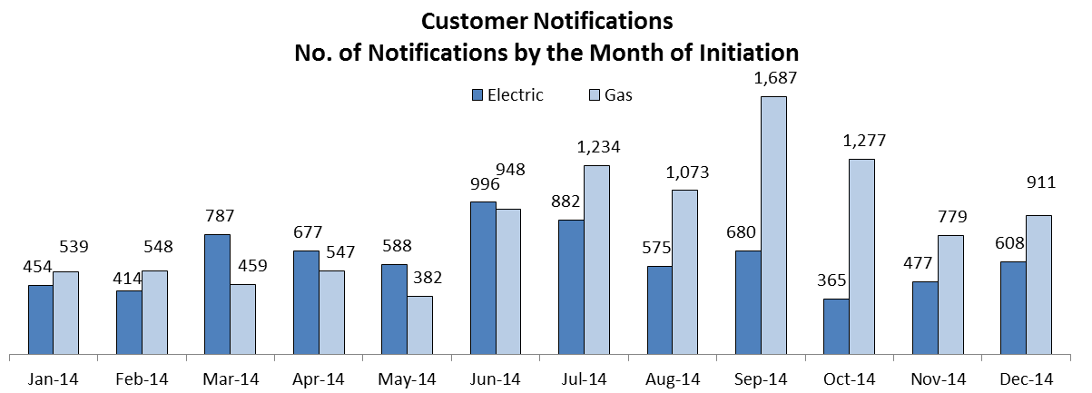

Of the 7,378 electric investigation cases resolved in 2014, 90.6% were identified as customer-confirmed zero-usage meters, 8.9% resolved prior to the initiation of the customer notification, and the remaining 0.5% (or 58) of the meters required billing adjustments.
The chart below shows the resolution status of these 2014 electric resolved cases by the month of the investigation completion as of December 31, 2014.

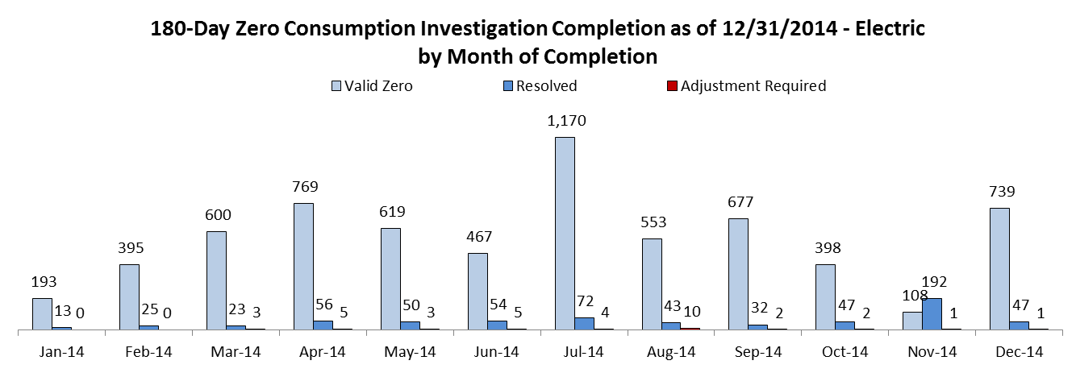

Of the 12,809 gas investigations that were resolved; 69.4% were customer-confirmed zero-usage meters, 29.2% resolved prior to the initiation of the customer notification, and 1.4% (181) of the meters required billing adjustments. The chart below shows the resolution status of these 2014 natural gas resolved cases by the month of the investigation completion as of December 31, 2014.
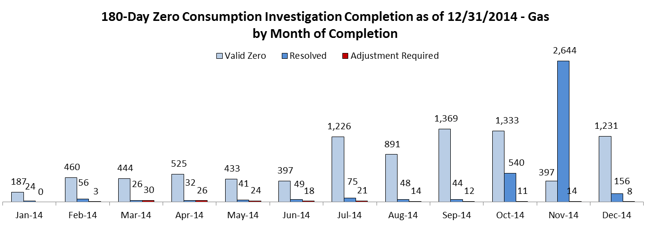

The Chart below shows the average length of bill adjustment and the average billing adjustment amount for the 36 electric meters identified by the customer notification process.

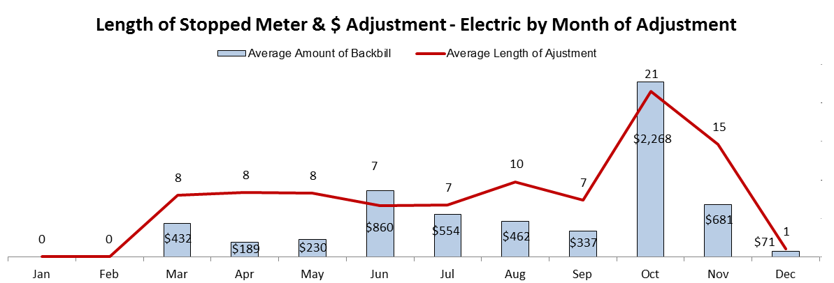

The Chart below shows the average length of back bill and the average back bill dollar amount for the 181 gas meters identified by the customer notification process.
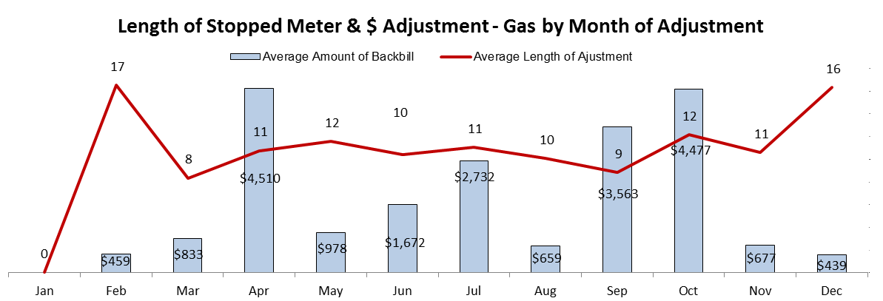

Tracking and Reporting of Meter/Billing Issues

Issues Discussion
This section explains the meter cases that were corrected outside the Meter and Billing Performance Standards and any other tracking and reporting issues.

Stopped Meters

The table below summarizes the stopped meter results by Meter and Billing Performance Standards for the applicable reporting period of January 1, 2014, through December 31, 2014 by energy.

Stopped Meter Results | Within 12 months | Within 24 months | Greater than 24 months | Total
Electric | 306 | 15 | 7 | 328
Gas | 2,037 | 131 | 25 | 2,193
Total | 2,343 | 146 | 32 | 2,521

The 32 electric and natural gas meters that were resolved outside of the 24-month time measurement were “poor performing” meters. These meters showed sporadic usage over a long period of time rather than constant zero consumption. Therefore, the initial period of time when these meters were not registering usage did not meet the thresholds for identification in the stopped meter process due to the sporadic usage. When the stopped meter thresholds were finally reached, the time measure would be longer than a meter that was completely stopped.
The resulting length of billing adjustments for these meters include the period of time where the zero consumption occurred through the time the meters were repaired or replaced and the period associated with the sporadic usage prior to completely stopping, thus resulting in a longer time measure than would have occurred if the meter had simply stopped.
There are three contributing factors that results in the 146 meter cases that exceeded the 12-month time measurement:

- 4 of 146 meters were a “poor performing” meter as described above that would take an extended period for a meter to completely stop.

- 86 of 146 meters with a module that had been slowing down overall time and failed to measure the correct actual usage but still registered some usage. Until the meter actually completely stopped, it could not be identified as a probable stopped meter. The billing adjustment for these slow meters would be longer than a typical stopped meter as the billing adjustment would be back to the point when a meter started slowing down which was prior to when the meter was completely stopped.

- 56 of 146 meters that showed usage after first identified by the automatic tracking of the stopped meter review process but before the completion of the investigation process. Typically, as a meter is identified as a probable stopped meter it is automatically logged into the stopped meter review process. When a meter resumed usage by itself prior to the manual investigation process taking place, the meter is no longer considered a stopped meter and is therefore removed from the automatic tracking of the stopped meter review process. However, if the meter has been move to the investigation process, it will remain in the automatic tracking of the stopped meter review process as the investigation process is still on going. For this particular type of meter issues, the length of the bill adjustment would include the time when the sporadic usage begun to the time that the investigation process confirms that the meter is indeed accurately records usage. Therefore, it takes a longer time to correct this type of meter cases.

In order to reduce the time required to complete the poor performing and slow meter cases PSE took the following actions in 2014:
- During the first half of 2014, PSE evaluated usage patterns that would help better understand how to identify poor performing and slow meters before they reach the current zero usage trigger.
- In August 2014, based upon the usage pattern analyses from the first half of 2014, PSE commenced developing a pilot program with PSE’s customer usage data management vendor, Oracle DataRaker, to identify these metering issues using customer usage data that DataRaker has been tracking.
- In September the pilot program was launched and completed in November 2014. PSE found through the pilot program that stopped metering issues can be identified more quickly and before the consumption dropped to zero. These new program logics from the pilot program will be implemented as a permanent processes as early as March 2015.

As discussed in the 2013 Report, filed in January 2014, PSE continues to look at ways to reduce the length of the backbill and to address meter and billing performance. It is important to review the performance in the context of PSE’s overall billing performance. In 2013 PSE issued 17,933,297 bills to customers, 0.016% of these bills were stopped meter related billing corrections. In 2014 PSE issued 17,906,670 bills to customers, the percentage of stopped meter related bills were reduced to 0.014%.

Limitations of the PSE’s stopped meter and UEU tracking system prior to 2015 prevented some meter issues from getting identified and resolved in a timely manner. As discussed in the process improvement section, with the functionality of those systems moved into SAP, PSE now has better visibility and identification of potential stopped meters and will be in a position to meet the performance standards.

Unassigned Energy Usage Meters

The table below summarizes the Unassigned Energy Usage meter results by energy and by Meter and Billing Performance Standards for the applicable reporting period of January 1, 2014, through December 31, 2014.

UEU Meters result | Within 12 Months | Within 24 Months | Greater than 24 Months | Total
Electric | 4,716 | 91 | 9 | 4,816
Gas | 4,159 | 68 | 0 | 4,227
Total | 8,875 | 159 | 9 | 9,043

The 9 meters fell outside of the 24-month time measurement had not registered the usage threshold is set by PSE to initiate an investigation. With the goal to compress the length of UEU identification time, PSE has begun reevaluating the usage thresholds that control when a customer UEU information form and a disconnect service notification are sent

Process Improvement
As mentioned above, part of process improvement and on-going effort to meet its obligation with the Performance Standard in the coming years, PSE took action in 2014 to reduce the risk exposure, improve its operations, and better serve the customer.
An analysis performed on the stopped meters with billing adjustments that spanned more than 24 months revealed that several of the longer adjustments were a result of either slowing or sporadic metered usage pattern. Since the automatic tracking of the stopped meter review process was built to only identify meters that were completely stopped, these meter cases had not been discovered in a timely manner. To rectify this, new program logics have been developed and will be implemented in 2015 as discussed above.
In an effort to improve PSE’s stopped meter and UEU processes, the Meter Exception Management System, the stopped and UEU meter tracking system, was retired in January 2015 and replaced by functionalities within SAP, PSE’s customer information and billing system. This change will provide better tracking of billing corrections process.
In 2014, PSE continued its efforts in reducing redundancy during data collection and commenced its migration of its legacy meter issues tracking system to a more collaborative and centralized process in SAP. These process improvements came after strategic decisions were made to enhance customer experience and to further technologic advancement such as the integration of the telephony system into SAP, which identifies the calling party and display information on the call center agent screen for rapid processing. The significant reduction of competing computer window screens for agents to review and the improvement in the data entry validation led to increase in productivity. The constant management focus to embrace more proactive responses related to customer service operation and to promote effective decision making based upon the “real-time” SAP data contributed a 24% decrease in the number of customer complaints for stopped meters or UEU meters.
PSE regards 2015 as a promising year for its customers and its operations. The net decrease of complaints in 2014, the continuous improvements of its operations coupled with recent and future technologic advancements set the tone for a genuine future at PSE and better results for the performance Standard.

Appendix A: Background, Definitions, and Standards

Background
This meter and billing performance annual reporting is designed to meet the terms and requirements of the Partial Settlement RE: Meter and Billing Performance Standards (“Partial Settlement”) in consolidated Docket Nos. UE-111048 and UG 111049 Order 08 (“Order 08”) dated May 7, 2012. The layout and elements of this report are consistent with the draft annual meter and billing report outline reviewed and discussed with the Commission Staff on September 27, 2013. Staff provided additional comments and suggestions via an e-mail on October 30, 2013, which have been incorporated in this report. The annual report is due no later than January 31 for the preceding calendar year.
The Partial Settlement dictates both the meter and billing performance standards and reporting requirements for the quarterly reporting periods 2012 Q2 through 2013 Q2 and the annual reporting periods starting 2013. The quarterly performance standards were included 2012 Q2 through 2013 Q2 reports. The on-going annual Meter and Billing Performance Standards per Partial Settlement paragraph 13 are outlined in the Standards section of this appendix.
For the meter cases that are corrected outside of the Meter and Billing Performance Standards, PSE will retain the following information for these cases:
- Stopped meters: the last date when the commodity was accurately billed, the date the customer's meter again accurately records usage and the date the Company issues the back-bill.
- Unassigned energy usage meters: the date of the customer's initial unauthorized usage and the date the Company issues the back-bill.

In addition, there are two meter and billing processes that PSE committed in the Partial Settlement to carry out after June 1, 2012.
- A one-time investigation process to identify and correct, if needed, meters with zero consumption for 365 consecutive days.
- An on-going process to notify each customer with a meter that showing zero consumption for 180 consecutive days.
The results of the two processes are included in the following two sections of this report: One Time Zero Consumption 365-Day Investigation Completion Report – Final Report and Zero Consumption 180-Day Investigation Report, respectively.

Definitions
For purposes of the Meter and Billing Performance Standards time measurement will be as follows:
- Stopped meters: The performance standard for stopped meters will be measured from the last date commodity was accurately measured (the "initial occurrence" for stopped meters) to the date the customer's meter again accurately records usage.
- Unassigned energy usage meters: The performance standard for meters with unassigned energy usage will be measured from the date of the customer's initial unauthorized usage (the "initial occurrence" for unassigned energy usage) to the date the back bill was issued.

Meter and Billing Performance Standards
For effective starting June 1, 2013, and continuing until changed, the two Meter and Billing Performance Standards (“Meter and Billing Performance Standards”) are:
- PSE will identify and correct 98 percent of all stopped meter and unassigned energy usage meter problems for both gas and electric meters within 12 months from initial occurrence of the problem.
- PSE will identify and correct all stopped meter and unassigned energy problems for both gas and electric meters within 24 months from the initial problem.

Appendix B: Zero Consumption 180- Day Investigation Customer Notice

Customer Notice
The following is an example of the new customer notice PSE is sending to any customer with a meter that did not register any usage for 180 consecutive days.
- Notice prior to October 1, 2014

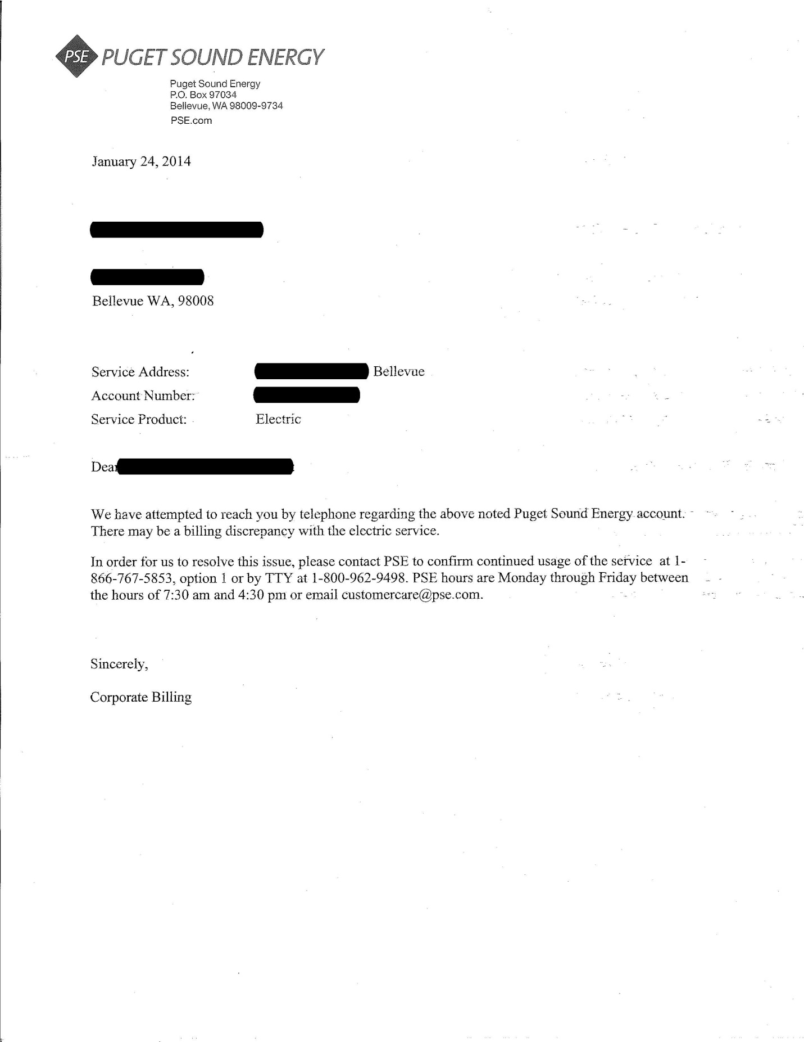

Notice for October 1, 2014, and after:
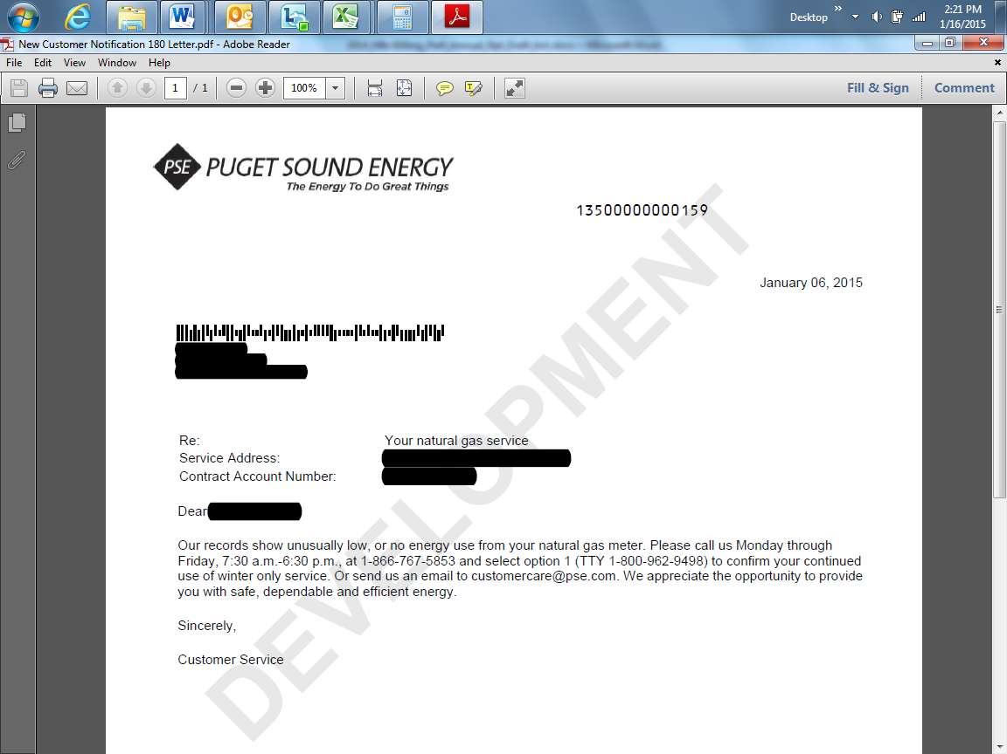

The auto dialer call script and flow and the customer notification letter were distributed in the June 7, 2012, PSE and UTC Staff meeting. UTC Staff did not raise any general or specific concerns about these notices in the meeting or via the e-mail following the meeting.

