June 30, 2014

Steven V. King, Executive Director and Secretary
Utilities and Transportation Commission
1300 S. Evergreen Park Dr. SW
P.O. Box 47250
Olympia, WA 98504-7250

RE: Washington Utilities and Transportation Commission v. Crescent Bar, Inc.

Commission Staff’s Response to Application for Mitigation of Penalties UW-140839

Dear Mr. King:

On May 29, 2014, the Utilities and Transportation Commission issued a $1,000 Penalty Assessment in Docket UW-140839 against Crescent Bar, Inc. for 10 violations of Washington Administrative Code (WAC) 480-110-505, which requires water companies to furnish annual reports to the commission no later than May 1 each year.¹

On June 16, 2014, Crescent Bar, Inc. wrote the commission requesting mitigation of penalties (Mitigation Request).² In its Mitigation Request, Crescent Bar, Inc. does not dispute that the violation occurred. The company states, “I would like to apologize for my 2013 annual report being late. This has never happened in the past and will certainly not happen again. It was just overlooked. Our water system lost close to 13,000 dollars last year. This penalty will be hard to absorb.”

It is the company’s responsibility to ensure that the regulatory fee is paid and the annual report is filed by the May 1 deadline. On February 28, 2014, Annual Report packets were mailed to all regulated water companies. The instructions for annual report completion page of the annual report informed the regulated company that it must complete the annual report form, pay the regulatory fees, and return the materials by May 1, 2014, to avoid enforcement action.

On May 21, 2014, Crescent Bar, Inc. filed its completed annual report and paid the regulatory fees and late payment penalty. The company was previously delinquent in filing the 2012 annual

UTC Annual Reports
June 30, 2014
Page 2

report and received an automatic mitigation of that penalty. Staff does not support the company’s request for mitigation due to prior violations.

If you have any questions regarding this recommendation, please contact Amy Andrews, Regulatory Analyst, at (360) 664-1157, or aandrews@utc.wa.gov.

Sincerely,

Sondra Walsh, Director
Administrative Services

ATTACHMENT A
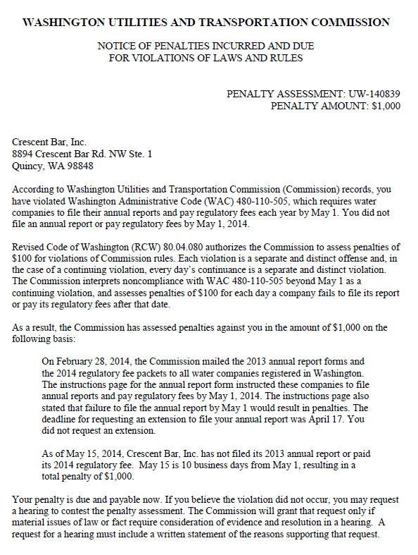

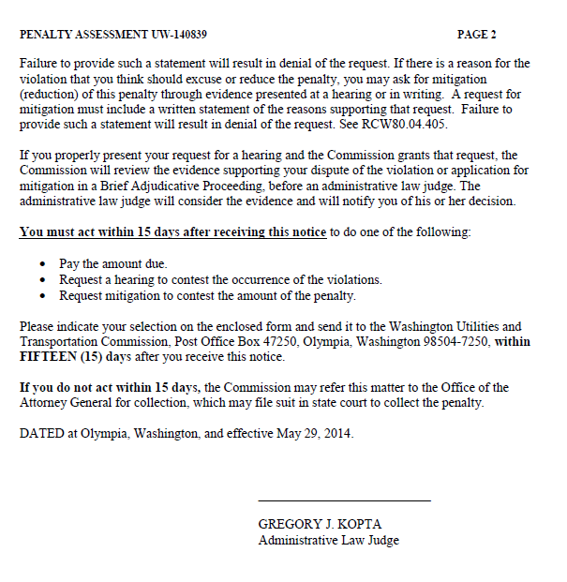

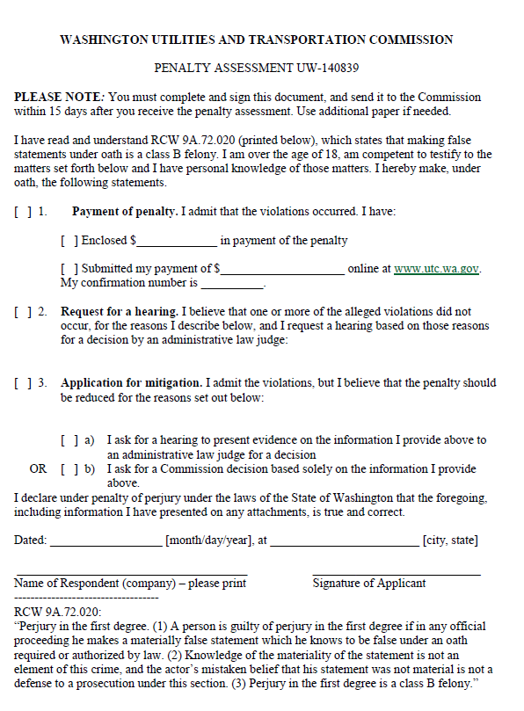

ATTACHMENT B
