September 28, 2012

David W. Danner, Executive Director and Secretary
Washington Utilities and Transportation Commission
1300 S. Evergreen Park Dr. SW
P. O. Box 47250
Olympia, Washington 98504-7250

RE: Washington Utilities and Transportation Commission v. Always Able Moving Service, LLC.
Commission Staff’s Response to Application for Mitigation of Penalties
Docket TV-120910

Dear Mr. Danner:

On July 23, 2012, the Washington Utilities and Transportation Commission issued a $2,100 Penalty Assessment in Docket TV-120910 against Always Able Moving Service, LLC for 21 violations of Washington Administrative Code (WAC) 480-15-480, which requires permitted household goods carriers to furnish annual reports to the commission no later than May 1 each year.

On August 10, 2012, Always Able Moving Service, LLC responded to the commission, requesting a hearing. In its Hearing Request, Always Able Moving Service, LLC did not provide a written statement of the reasons the company believed the alleged violation did not occur. The commission denied the request for a hearing and required Always Able Moving Service, LLC to file a written statement of the reason(s) in support of its request by 5:00 p.m., Thursday, August 23, 2012.

On August 22, 2012, Always Able Moving Service, LLC filed its response, which included a written statement of the reason(s) supporting its request. In its response, Always Able Moving Service, LLC, disputes that the violation occurred. The company states, “On July 23rd 2012, I received both an email and a certified letter stating that I failed to file an annual report by May 1, 2012. This was the first notice I received by any means that I needed to fill out any type of report or was late filling out a report. I did NOT receive any paperwork of any type from your agency prior to the July 23rd date. I currently reside in an apartment with my family. We have one small lock box where we receive our mail. If any mail comes to our address that does not fit in the small keyed box, it is usually held at our apartment complex front office. Your letter states that Annual Report forms and Fee packets were mailed to me on February 29th of this year. There is no way all this information would have fit in our small box; and according to our manager’s office, they never received any such packet. I am not sure where this information was actually sent to; or ended up. Your letter indicates that you started accessing fees of 100 dollars a day after the May 1, deadline.”

In its response, Always Able Moving Service, LLC asks the following questions:

- “Why did I not receive a certified letter right away?”
- “Why did you not send me an email notifying me of this fee being assessed?”
- “I do not understand? You obviously had a correct address and email for me, because I received both the certified letter and email on July 23rd, after you applied 2,100.00 worth of fees.”
- “You stated there is a WAC code which requires me to file an annual report with the Commission and I am fine with complying with that code, if I had known it was time to do so. Is there no code which YOU have to be able to show that I actually received the report?”
- “Why are the original report forms and fee packets not sent certified mail to ensure that I receive them?”
- “Why did I not receive an email from you stating that the forms were on their way, so I could have been on the lookout for them [sic].”

It is the company’s responsibility to ensure that the regulatory fee and the annual report are filed by the May 1 deadline. On February 29, 2012, Annual Report forms and Regulatory Fee packets were mailed to all regulated household goods carriers. In addition to other information, the cover letter informed the regulated company it must complete the annual report form, pay any regulatory fees and return the material by May 1, 2012 to avoid enforcement action. On May 15, 2012, the commission mailed a letter to those companies that had not yet filed an annual report notifying them that, to date, they had incurred a penalty of $900. The letter went on to explain that companies who filed their annual reports no later than May 25, 2012, would receive mitigated penalties of $25 per day, with an additional $25 per day for each instance in the previous five years that the company received a penalty for filing a late report.

In response to Always Able Moving Service, LLC’s questions above:

The commission mails annual report forms and instructions to each household goods permit holder at its address of record. If a carrier does not receive an annual report form, it is the carrier’s responsibility to contact the commission and request the form. This information can be found under WAC 480-15-480(1)(b).

Always Able Moving Service, LLC did not file its annual report by May 31, 2012, which is 21 business days past the deadline of May 1, 2012. The penalty is $100 per day for a total of $2,100. Always Able Moving Service, LLC was granted its provisional household goods license on July 13, 2011, and therefore has not previously received a penalty for filing a delinquent annual report.

Despite the circumstances, staff supports mitigating the assessed penalty from $2,100 to $1,050, which represents a 50 percent reduction because this is Always Able Moving Service, LLC’s first late filing.

If you have questions regarding this recommendation, please contact Mathew Perkinson, Compliance Investigator, at (360) 664-1105, or at mperkinson@utc.wa.gov.

Sincerely,

Sharon Wallace, Assistant Director
Consumer Protection and Communications

Attachment A
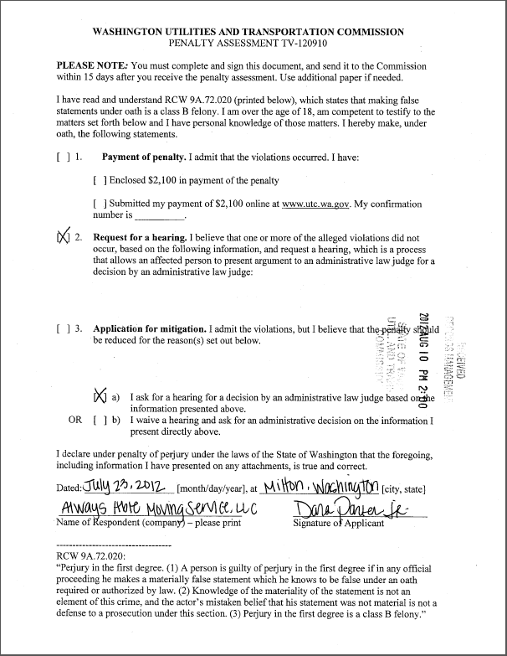
Attachment B
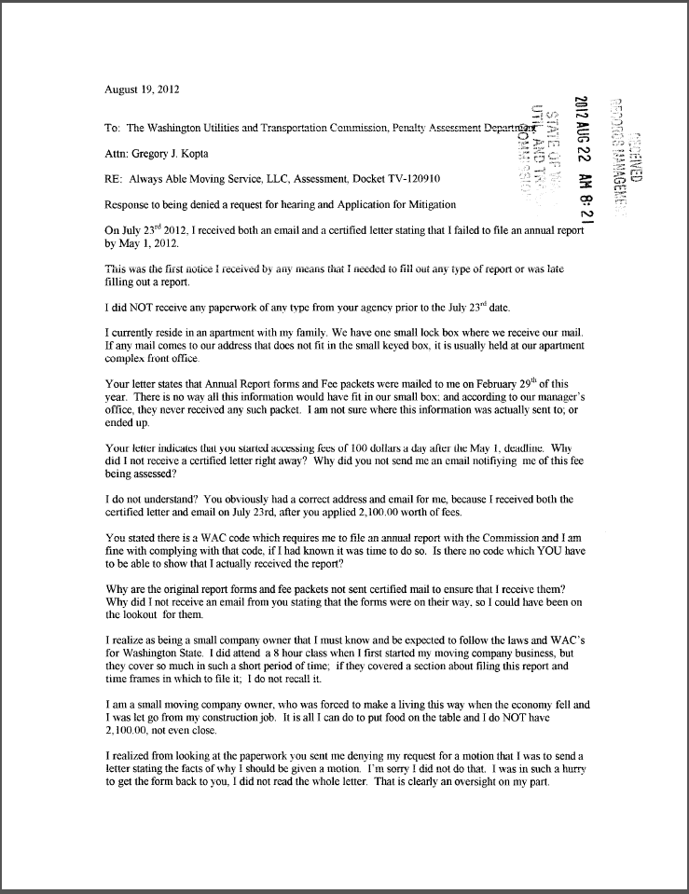
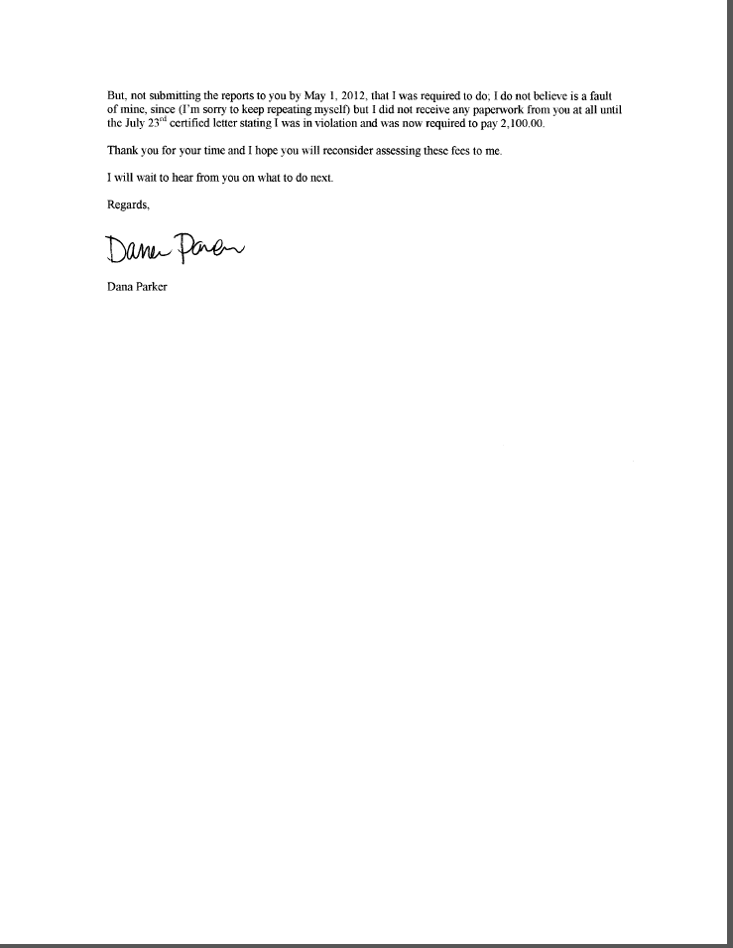
Attachment C

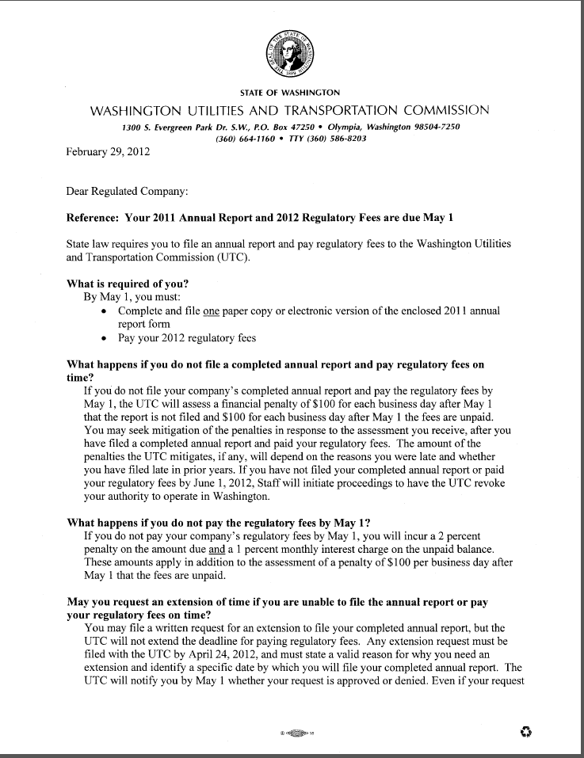
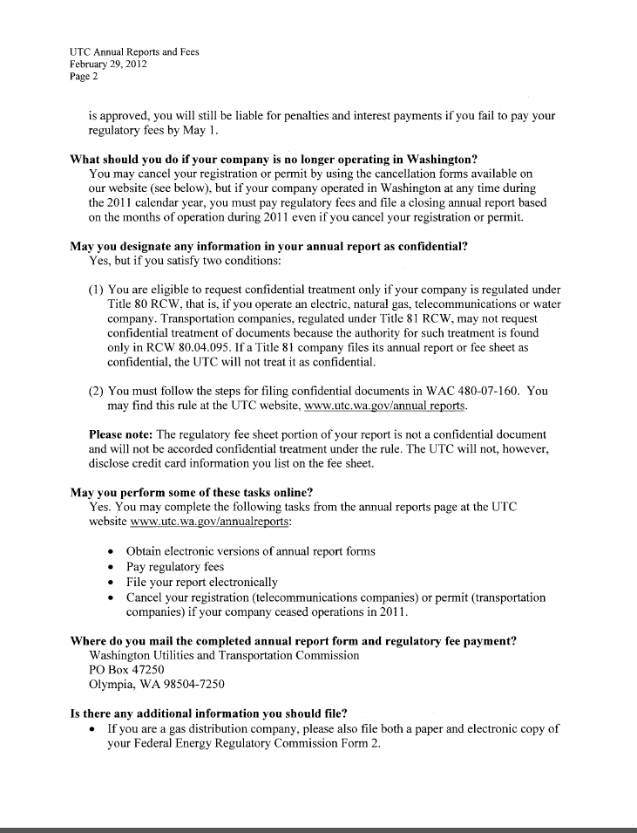
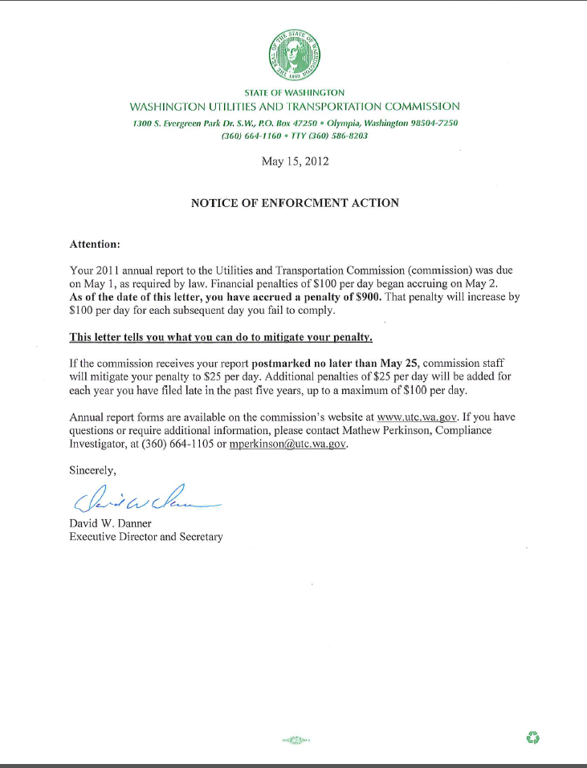
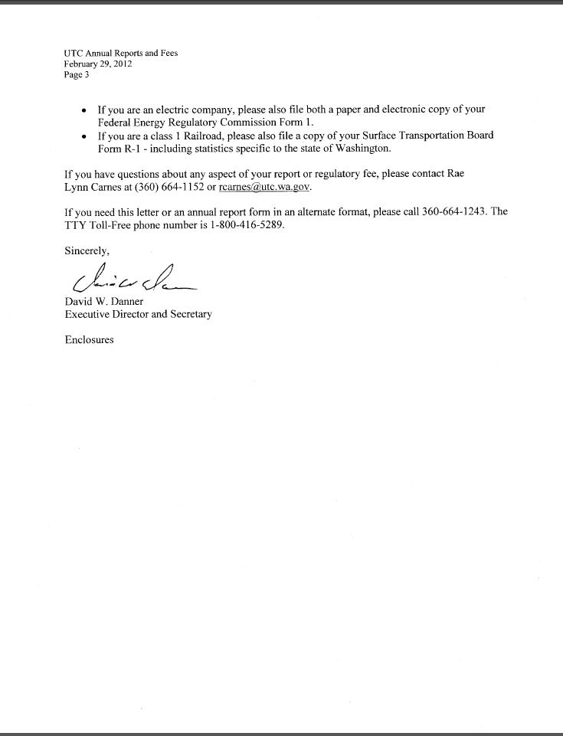
Attachment D

See attachment A for a copy of Always Able Moving Service, LLC Mitigation Request.
See attachment B for a copy of Always Able Moving Service, LLC written statement received August 22, 2012.
See attachment C for a copy of the letter sent to all regulated companies on February 29, 2012.
See attachment D for a copy of the enforcement letter sent to the company on May 15, 2012.

