2012

Electric Service Reliability Report

© 2013 Avista Corporation. All Right Reserved

Permission of the Copyright owner is granted to users to copy, download, reproduce, transmit or distribute any part of this document provided that: (1) the user includes Avista’s copyright notice on all copies, and (2) the materials are not used in any misleading or inappropriate manner. Furthermore, no portion of the attached work shall be republished in printed or digital form without the written permission of the Copyright owner.

Table of Contents

Introduction 1
Definitions 2
Data Collection and Calculation Changes 3
Data Collection 3
Interruption Cause Codes 3
Customers Experiencing Multiple Interruptions 4
Major Events 4
Table 1.1 – 2012 Major Event Days 5
Customer Complaints 5
System Indices 6
Table 2.1 - Reliability Statistic Target by Indice 6
Chart 2.1 – SAIFI - Sustained Interruptions / Customer 7
Chart 2.2 – Sustained Interruptions / Customer Historic Comparison 7
Chart 2.3 - SAIFI Linear Trend Line Chart 8
Chart 2.4 - MAIFI Momentary Interruption Events / Customer 9
Chart 2.5 – Momentary Interruptions/ Customer Historic Comparison 9
Chart 2.6 - SAIDI – Average Outage Time / Customer 10
Chart 2.7 - SAIDI Linear Trend Line Chart 11
Chart 2.8 - CAIDI – Average Restoration Time 11
OFFICE Indices 12
Chart 3.1 – SAIFI - Sustained Interruptions / Customer 12
Chart 3.2 - MAIFI Momentary Interruption Events / Customer 12
Chart 3.3 - SAIDI – Average Outage Time / Customer 12
Chart 3.4 - CAIDI – Average Restoration Time 13
Areas of Concern 14
Cause Information 14
Colville Area Work Plans 17
Table 4.1 - Colville Area Major Reliability Projects by Feeder 18
Table 4.2 - Colville Area Historical & Proposed Future Reliability Projects by Feeder 18
Avista System Wide Work Plans 19
Chart 4.1 – Squirrel Related Events 19
Chart 4.2 – Wood Pole Management Related Events 20
Chart 4.3 – Wood Pole Management Actions 20
Avista Feeder Upgrade Program 21
Avista System Wide Vegetation Management Plan 21
Customers Experiencing Multiple Interruptions 22
Chart 5.1 - Avista Service Territory - CEMI_{n} 22
Chart 5.2 - Colville Office - CEMI_{n} 23
Chart 5.3 - Davenport Office - CEMI_{n} 24
Chart 5.4 - Deer Park Office - CEMI_{n} 25
Chart 5.5 - Othello Office - CEMI_{n} 26
Chart 5.6 - Palouse Office - CEMI_{n} 27
Chart 5.7 - Lewis-Clark Office - CEMI_{n} 28
Chart 5.8 - Spokane Office - CEMI_{n} 29
Chart 5.9 - Sandpoint Office - CEMI_{n} 30
Chart 5.10 - Kellogg Office - CEMI_{n} 31
Chart 5.11 - Coeur d’Alene - CEMI_{n} 32
Chart 5.12 - Grangeville Office - CEMI_{n} 33
Monthly Indices 34
Chart 6.1 – SAIFI - Sustained Interruptions / Customer 34
Chart 6.2 - MAIFI Momentary Interruption Events / Customer 34
Chart 6.3 - SAIDI – Average Outage Time / Customer 35
Chart 6.4 - CAIDI – Average Restoration Time 35
Customer Complaints 36
Table 7.1 - Commission Complaints 36
Table 7.2 - Customer Complaints 36
Sustained Interruption Causes 36
Table 8.1 - % SAIFI per Cause by Office 36
Chart 8.1 – % SAIFI per Cause by Office 36
Table 8.2 - % SAIDI per Cause by Office 36
Chart 8.2 – % SAIDI per Cause by Office 36
Table 8.3 - % SAIFI per Cause by Month 36
Chart 8.3 – % SAIFI per Cause by Month 36
Table 8.4 - % SAIDI per Cause by Month 36
Table 8.4.1 Average Outage Time 36
Chart 8.4 – % SAIDI per Cause by Month 36
Momentary Interruption Causes 36
Table 9.1 - % MAIFI per Cause by Office 36
Table 9.1.1 - % MAIFI per Cause by Office (Washington only) 36
Chart 9.1 – % MAIFI per Cause by Office 36
Table 9.2 - % MAIFI per Cause by Month 36
Chart 9.2 – % MAIFI per Cause by Month 36
Major Event Day Causes 36
Chart 10.1 – % SAIFI by Cause Code for the Major Event Days 36
Table 10.1 – % SAIFI by Sub Cause Code for the Major Event Days 36
Table 10.2 – Yearly Summary of the Major Event Days 36
Interruption Cause Codes 36
Table 11.1 – Interruption Cause Codes 36
Office Areas 36
Chart 12.1 – Office Areas 36
Indices Calculations 36
Sustained Interruption 36
Momentary Interruption Event 36
SAIFI – System Average Interruption Frequency Index 36
MAIFI_{E} – Momentary Average Interruption Event Frequency Index 36
SAIDI – System Average Interruption Duration Index 36
CAIDI – Customer Average Interruption Duration Index 36
CEMI_{n} – Customers Experiencing Multiple Sustained Interruptions more than n. 36
CEMSMI_{n} – Customers experiencing multiple sustained interruption and momentary interruption events. 36
MED - Major Event Day 36
Numbers of Customers Served 36
Table 13.1 – Numbers of Customers Served 36
Attachment 1 – SAIDI and SAIFI Historical Summary 36
Company Contact 36

Introduction

Pursuant to WAC 480-100-398, Avista Corporation dba Avista Utilities (“Avista” or “the Company”) submits its annual Electric Service Reliability Report. The report describes the Company’s reliability monitoring and reliability metrics for 2012. All numbers included in this report are based on system-data. The Company’s system includes 11 geographical divisions with two of those divisions overlapping the Washington and Idaho border leading to a commingling of jurisdictional customers. A map of Avista’s operating area is included on page 56 of this report.

WAC 480-100-393 (3)(b) requires the establishment of baseline reliability statistics. The Company’s baseline statistics are included in this report and compare the current year data to the baseline year of 2005 and years in between. The Company also provides a statistical target that represents an analysis based on an average over a time period and adding two standard deviations. Year to year variations should be below this target, but may provide information that shows continuing trends.

Avista has reported in its previous annual reports that the completion of the transition to the Outage Management Tool (OMT) system had caused an increase in the variability of the data collected from 2001 to 2007. The 2009 Annual Report (UE-100659) indicated that a gradual increase in the SAIFI and SAIDI numbers that cannot be attributed to the transition to the OMT system was occurring. This trend line is still showing a gradual increase but at a slower rate after including the 2012 data. The charts on pages 8 and 11 show a trend line for SAIFI and SAIDI historical data.

Continued scrutiny will be important over the next year or two to determine if the rate of increase for SAIFI/SAIDI continues to slow, due to the reliability improvement programs implemented in 2010, 2011, and 2012.

The 2012 SAIFI and SAIDI reliability indices are slightly higher than the 2005 baseline, which may be due to the under reporting that may have occurred during the transition to OMT in 2005. On another note both the 2012 MAIFI and CAIDI reliability indices are below the 2005 baseline.

Avista added a new section beginning in the 2007 annual report (UE-080787) which analyzes the areas where customers are experiencing multiple sustained outages. This new section provides analysis of a reliability index called CEMI_{n}, which implies Customers Experiencing Multiple sustained Interruptions more than n times.

Avista continues to review its annual baseline reliability statistics in light of operational experience under current regulatory protocol. Avista may modify its baseline statistics as appropriate and will update the Commission accordingly.

Definitions

“Reliability Statistic” – Standard Statistics measures and calculation methods are per the IEEE Standard 1366-2003 (or latest version) Titled “IEEE Guide for Electric Power Distribution Reliability Indices”. Same as Reliability Indices.

"Major event" – Modified this definition to the IEEE Standard 1366-2012 (or latest version) of Major Event Day (MED), which uses a process “Beta Method” to identify a Major Event Day. The previous definition was “An event that impacts more than 5% of the Company’s customers and causes outages of more than 24 hours in duration in any given division within its territory”.

“Sustained Interruption” - An interruption lasting longer than 5 minutes.

“Momentary Event Interruption” – An interruption(s) of duration 5 minutes or less. Each event consists of one trip and one reclose operation that occur within 5 minutes. For example, if an interrupting device operates three times and then holds, this would be counted as three events with the number of customers affected as three times the Ni.

"Baseline reliability statistic" – Avista will compare its reliability statistics to the year 2005.

“Reliability Target” - A statistical method was developed in 2004 for baseline statistics. The method is defined as the average over a specific timeframe and 2 times the standard deviation. For 95% of the time, the Reliability Statistic should be below the target.

“Customer Complaint” - When a customer is not satisfied with the Company as it relates to Electric Reliability and makes a complaint directly to a Company representative.

“Commission Complaint” – When a customer is not satisfied with the Company as it relates to Electric Reliability and files a complaint directly with the Commission.

Data Collection and Calculation Changes

WAC 480-100-398 (2) requires the Company to report changes made in data collection or calculation of reliability information after initial baselines are set. This section addresses changes that the Company has made to data collection.

Data Collection
Since Avista’s Electric Service Reliability Monitoring and Reporting Plan was filed in 2001 (UE-011428), there have been several improvements in the methods used to collect outage data. In late 2001, centralizing the distribution trouble dispatch and data collection function for Avista’s entire service territory began. The distribution dispatch office is located in the Spokane main complex. At the end of September 2005, 100% of the Company’s feeders, accounting for 100% of the customers, are served from offices that employ central dispatching.

The data collected for 2012 represents the sixth full year of outage data collected through the Outage Management Tool (OMT). For 2012, all data was collected using the “Outage Management Tool” (OMT) based on the Company’s Geographic Information System (GIS). The OMT system automates the logging of restoration times and customer counts.

Avista discovered a software coding error that has been within the OMT system since 2002 that caused a small increase in the SAIDI and CAIDI for 2008. Previous years were also evaluated to determine the overall impact to the Avista baseline statistics and at this time Avista is not proposing a change to the baseline numbers. The software error only occurred during very specific outage conditions when a group of customers with an initial outage starting time were “rolled” up into another group of customers that were determined to be part of the first group outage. The second group may have had a later outage starting time. When the first group of customer outage information was rolled up, the original outage starting time was lost and the second group outage starting time was used for both groups of customers instead of using the first outage starting time. The number of customers was counted correctly.

Even as good as the OMT system is at quantifying the number of customers and duration of the outage duration, there still are areas where the data collection is not precise. Determining the exact starting time of an outage is dependent on when a customer calls in, how well the Avista Distribution Dispatcher determines where the outage is and defines the device that has opened to remove the faulted section.

As AMR/AMI metering is implemented in the future and the customer meter provides outage information to the OMT system through an interface, the SAIDI and CAIDI numbers are expected to increase. This is similar to the above discussion.

Use of the OMT system and GIS data has improved the tracking of the numbers of customers without power, allowed for better prioritization of the restoration of service, and the improved dispatching of crews.

Interruption Cause Codes
Cause code information is provided in this report to give readers a better understanding of outage sources. Further, the Company uses cause information to analyze past outages and, if possible, reduce the frequency and duration of future outages.
Since 2011, Avista has stopped using the subcategory “protected” under the “Animal” category. Almost all birds are considered protected, so there is little differentiation between the “Bird” and “Protected” subcategories. Avista will include additional information in the Remarks section as reported from the field personnel.

Customers Experiencing Multiple Interruptions

The IEEE Standard 1366P-2003 provides for two methods to analyze data associated with customers experiencing multiple momentary interruptions and/or sustained interruptions. Avista’s Outage Management Tool (OMT) and Geographical Information System (GIS) provide the ability to geospatially associate an outage to individual customer service points. This association allows for graphically showing Customers Experiencing Multiple sustained Interruptions (CEMI_{n}) with Major Event Day data included onto GIS produced areas. Data can be exported to MS Excel to also create graphs representing different values of n. 2012 information is provided in the Customer Experiencing Multiple Interruptions (page 22) to summarize the analysis Avista performed on the 2012 outage data. The calculation for CEMI_{n} and Customers Experiencing Multiple Sustained and Momentary Interruptions CEMSMI_{n} is provided in the Indices Calculations section (page 57).

Major Events

Major Events and Major Event Days as used in this report are defined per the IEEE Guide for Electric Power Distribution Reliability Indices, IEEE P1366-2012. The following definitions are taken from this IEEE Guide.

Major Event – Designates an event that exceeds reasonable design and or operation limits of the electric power system. A Major Event includes at least one Major Event Day (MED).

Major Event Day – A day in which the daily system SAIDI exceeds a threshold value, T_{MED}. For the purposes of calculating daily system SAIDI, any interruption that spans multiple calendar days is accrued to the day on which the interruption began. Statistically, days having a daily system SAIDI greater than T_{MED} are days on which the energy delivery system experienced stresses beyond that normally expected (such as severe weather). Activities that occur on major event days should be separately analyzed and reported.

The Company will use the process defined in IEEE P1366 to calculate the threshold value of T_{MED} and to determine MED’s. All indices will be reported both including and excluding MED’s. The comparisons of service reliability to the baseline statistics in subsequent years will be made using the indices calculated without MED’s.

Table 1.1 – 2012 Major Event Days

Major Event Days | SAIDI (Customer-Minutes) | Cause
2012 Major Event Day Threshold | 9.49
January 19, 2012 | 9.93 | Snow Storm
December 17, 2012 | 14.35 | Wind and Snow Storm
Additional analysis of the 2012 Major Event Days is provided in this Annual Report as was done in previous years in the Major Event Day Causes section on page 51.

Customer Complaints

The Company tracks reliability complaints in two areas, Commission Complaints and Customer Complaints, which are defined in the Definitions section. See the Customer Complaints section on Page 36 for a summary of results for this year.

System Indices

The charts below show indices for Avista’s Washington and Idaho (“system”) electric service territory by year. Breakdown by division is included later in this report. Each chart shows seven years of data along with the baseline reliability statistic which is highlighted in green. The Company also has calculated a reliability target that is the average over the previous five years plus two standard deviations. This target is shown in yellow on the reliability index charts.

The reliability targets have been adjusted by removing Major Event Days, MED’s, as defined in the previous section.

Table 2.1 - Reliability Statistic Target by Index

Index | 2006-2011  Average  (Excluding Major Events) | 2005  Baseline | Reliability  Target  (Ave + 2 Standard Deviations)
SAIFI | 1.28 | 0.97 | 1.60
MAIFI | 3.77 | 3.58 | 5.52
SAIDI | 149 | 108 | 200
CAIDI | 116 | 112 | 129

Additional comparisons of the Reliability Indices are provided in the Office Indices section (page 12) and Monthly Indices section (page 34) of this report.

The Company continues to use the definition of major events as described above to be consistent with IEEE Standards. Therefore, the following charts show statistics including the effect of major events per this definition. Both the Baseline Statistic is shown for the year 2005 (green bar), along with the Avista Target Statistic which is shown as the yellow bar.

Refer to Attachment 1 – SAIDI and SAIFI Historical Summary for additional historical information.

Chart 2.1 – SAIFI - Sustained Interruptions / Customer
Baseline Year 2005

Chart 2.2 – Sustained Interruptions / Customer Historic Comparison

SAIFI for 2012 was slightly over the 2005 baseline statistic and does represent an increasing trend, but at a slower rate than previously reported in the 2011 Annual Report (UE-120586). The 2012 SAIFI number is slightly lower than 2010 and slightly higher than 2011 and may represent gains due to Company expenditures specifically targeting reliability. An increase in weather related outages is the main factor in the increased level over last year. Using a simple linear regression to establish a trend line, it would look like about a 0.63% growth in the number of customers affected. The R² coefficient of determination shows a much weaker correlation to the data than last year. A chart of this analysis has been provided just after this discussion.

There were 103,066 customers affected by sustained outages caused by weather in 2012. This compares to the 2006–2011 average of 96,732 customers and the 2011 level of 56,460 customers.

24,266 customers were affected by sustained outages associated with animal related incidents. This compares to the 2006-2011 average of 31,910 customers. The vast majority of the animal related reasons were associated with squirrel caused incidents.

Public outages affected 50,938 customers as compared to the 2006-2011 average of 39,947 customers.

Outages associated with Tree causes affected 39,588 customers as compared to the 2006–2011 average of 58,126.

Chart 2.3 - SAIFI Linear Trend Line Chart

Chart 2.4 - MAIFI Momentary Interruption Events / Customer
Baseline Year 2005

Chart 2.5 – Momentary Interruptions/ Customer Historic Comparison

The 2012 results for MAIFI show a similar level to the 2011 data, a decrease over both 2009 and 2010 data and also a decrease from the 2005 baseline year data. There was an increase in weather related momentary outages and a corresponding decrease in the number of undetermined outages. This shift may be due to accuracy improvement efforts in Distribution Dispatch. The overall improvements in the MAIFI numbers may be due to tree trimming efforts along with Overhead Equipment replacement and Underground Equipment replacement. Some of the Urban areas have had the instantaneous trip function blocked, which reduces the total feeder customer momentary impacts, but may increase both SAIFI and SAIDI numbers for a few customers located downstream of a fused lateral.

Distribution Dispatch continues to make improvements in correlating the momentary outages with subsequent sustained outages, which reduces the undetermined causes.

All other categories showed a slight decrease that would be consistent with previous years.

Chart 2.6 - SAIDI – Average Outage Time / Customer
Baseline Year 2005

Chart 2.7 - SAIDI Linear Trend Line Chart

Chart 2.8 - CAIDI – Average Restoration Time
Baseline Year 2005

OFFICE Indices

Chart 3.1 – SAIFI - Sustained Interruptions / Customer

Chart 3.2 - MAIFI Momentary Interruption Events / Customer

Chart 3.3 - SAIDI – Average Outage Time / Customer

Chart 3.4 - CAIDI – Average Restoration Time

Areas of Concern

As in previous years, Colville continues to have the lowest reliability of Washington’s operating areas. However, the Colville area continues to show improvement over previous years as work plans are implemented. Colville was judged lowest based on its performance in the yearly indices for SAIFI, SAIDI, CAIDI, and MAIFI. Within the Colville area, five feeders were identified as the Areas of Concern for 2012. Additionally two feeders in the Deer Park area are included as areas of concern. These feeders are Gifford 34F1, Gifford 34F2, Colville 34F1, Spirit 12F1 and Valley 12F1 in the Colville Area, and Deer Park 12F1 and Deer Park 12F2 in the Deer Park area. Deer Park 12F1, Deer Park 12F2, and Valley 12F1 are new areas of concern for 2012 while the remaining feeders were also identified in the 2011 report (UE-120586).

Cause Information

Generally rural areas have a greater number of outages per customer. Colville and Deer Park are predominately rural and forested areas. There are approximately 2,071 miles of distribution line exposed to weather, underground cable failures and tree problems. Unlike most of the Company’s system, lines in these areas are built on the narrow, cross-country rights-of-way, typical of PUD construction practices prior to Avista acquiring the system. These conditions make patrolling, tree trimming, rights-of-way clearing and other maintenance difficult. When cost effective, Avista moves sections of these overhead lines to road rights-of-way and/or converts them to underground.

Further, when outages occur in rural areas, the time required to repair damage is longer. More time is required for first responders to arrive and assess the damage and more time is required for the crew to reach the site. Often the damage is off road and additional time is required to transport materials and equipment to the site.

Snow loading on green healthy trees growing beyond the rights-of-way often causes them to bend or break and contact distribution lines. These trees are not cut as part of our vegetation management program because they are outside our rights-of-way and are considered healthy marketable timber.

Listed below is a summary of the specific cause data for each feeder. This is a compilation of data from the Avista Outage Management Tool and the reporting from our local servicemen to Distribution Dispatch. Data from the reporting system is shown as a percentage of total customer-outages, (SAIFI) for that feeder.

Planned maintenance and equipment related outages were a major contributor to the Deer Park feeders becoming areas of concern in 2012. It is expected that the planned maintenance on these feeders will diminish and the reliability indices will normalize in the future.

Gifford 34F1
- 6.6% ANIMAL
- 1.6% POLE FIRE
- 2.5% PUBLIC
- 12.3% TREE
- 17.2% UNDETERMINED
- 27.9% WEATHER
- 10.7% EQUIPMENT OH
- 1.6% EQUIPMENT UG
- 19.7% PLANNED

Gifford 34F2

- 1.2% ANIMAL
- 4.7% PUBLIC
- 12.9% TREE
- 4.7% UNDETERMINED
- 49.4% WEATHER
- 14.1% EQUIPMENT OH
- 12.9% PLANNED

Colville 34F1

- 4.1% ANIMAL
- 1.4% COMPANY
- 2.7% PUBLIC
- 17.6% TREE
- 12.8% UNDETERMINED
- 44.6% WEATHER
- 9.5% EQUIPMENT OH
- 4.7% EQUIPMENT UG
- 2.7% PLANNED

Spirit 12F1

- 5.5% ANIMAL
- 5.5% PUBLIC
- 9.1% TREE
- 12.7% UNDETERMINED
- 32.7% WEATHER
- 16.4% EQUIPMENT OH
- 1.8% EQUIPMENT UG
- 16.4% PLANNED

Valley 12F1

- 11.8% ANIMAL
- 11.8% PUBLIC
- 19.6% TREE
- 13.7% UNDETERMINED
- 27.5% WEATHER
- 3.9% EQUIPMENT OH
- 2.0% EQUIPMENT UG
- 9.8% PLANNED

Deer Park 12F1

- 12.2% PUBLIC
- 6.1% TREE
- 6.1% UNDETERMINED
- 8.2% WEATHER
- 12.2% EQUIPMENT OH
- 10.2% EQUIPMENT UG
- 44.9% PLANNED

Deer Park 12F2

- 4.3% ANIMAL
- 4.3% COMPANY
- 4.3% PUBLIC
- 4.3% TREE
- 13.0% UNDETERMINED
- 17.4% WEATHER
- 13.0% EQUIPMENT OH
- 4.3% EQUIPMENT SUB
- 34.8% PLANNED

Colville Area Work Plans

The improvement work that has been accomplished or planned for each feeder is listed below. The Company’s reliability working group is continuing to study these feeders to develop additional work plans. Each of the identified feeders also had planned outages that correspond to the maintenance and replacement activities in the area.

Gifford 34F1
- Storm damage to lines led an effort to reconductor sections to 2/0 ACSR in 2012.
- A recloser is budgeted to be installed in 2013/2014 that will allow for better sectionalizing between the northern and southern sections of the feeder during outage events.

Gifford 34F2
- Due to Cultural review issues on some of the Tribal lands only 3,000 feet was replaced in 2010. Continued work and negotiations for the remaining 5,000 feet occurred in 2011. Final work was completed in 2012.
- Vegetation Management work planned for 2012 was re-prioritized to 2011 after circuit assessment showed a large number of dead or dying trees within radius of contact of our lines. Line clearance crews trimmed 651 trees and removed 867 trees in 2011. No additional work is planned for 2013.

Colville 34F1
- Vegetation Management crews were called to trim 3 trees and remove 59 trees as “unplanned” work on this circuit in 2011. A fall 2011 assessment of this circuit showed a significantly high mortality rate of trees within radius of contact of these lines. A line clearance crew began Risk Tree mitigation work on this circuit in February, 2012.
- $100k was budgeted in 2011 to replace outage prone overhead sections with URD cable.
- $62k was budgeted to install wild life guards in 2011. Approximately 65% of the CLV12F1 feeder was completed in 2011. Remaining work was completed in 2012.
- $250k is budgeted in 2013to replace overhead line sections with URD cable to reduce tree exposure.
- $50k is budgeted in 2013 to install a recloser to allow for better outage sectionalizing.

Spirit 12F1
- Feeder is scheduled to be part of the feeder upgrade program for 2013/2014.

Valley 12F1
- No work scheduled for 2013.

Table 4.1 - Colville Area Major Reliability Projects by Feeder

Feeder | Decisions/ basis | 2013 | 2014 and Beyond
Gifford 34F1 | Reliability improvements | Reconfigure to install recloser | No work planned in the next 5 years.
Gifford 34F2 | Reliability improvements | No work planned | No work planned in the next 5 years.
Colville 34F1 | Reliability improvements | Underground Cable conversion, install recloser | No work planned in the next 5 years.
SPI12F1 | Reliability Improvements | Feeder Upgrade Program Feeder | Finish feeder upgrade in 2014
Valley 12F1 | Reliability Improvements | No work planned. | No work planned in the next 5 years.

Table 4.2 - Colville Area Historical & Proposed Future Reliability Projects by Feeder

Feeder Name | Last WPM Insp. | Proposed WPM Inspection | Proposed WPM Follow-up | Transformer Change-outs | Last Veg. Mgmt. | Veg. Mgmt. Proposed Year | Wildlife Guards Proposed Year
GIF34F1 | 2011-2014 | 25% per year for 4 yrs | 25% was completed in 2012/  25% in 2013  25% IN 2014  25% IN 2015 | 18 in 2014 | 2009 | 2015 | Last 2011  N/A on Proposed
GIF34F2 | 1995 | Past 2018 Plan AM will need to project | N/A | 69 in 2013/2014 | 2011 | 2016 | N/A
CLV34F1 | 2007 | 2027  20 year cycle | 2028 | 49 in 2015 | 2007 | 2013 | Last 2011  N/A on Proposed
VAL12F1 | 2010 | 2030  20 year cycle | Completed in 2011 (except for WSDOT ROW poles) | 188 in 2013/2014 | 2010 | 2016 | N/A
SPI12F1 | 2013 | 2033  20 year cycle | Feeder Upgrade Project | 6 in 2013 | 2011 | 2016 | N/A

Avista System Wide Work Plans

Material records show that some wildlife guards were installed on new distribution transformers installations starting in the mid 1980’s. With the recognition of increases in animal caused outages, new materials and improvements have been made in the construction standards for new distribution transformer installations to reduce these types of outages. Initial indications show that the outage reduction on a feeder after wildlife guards are installed is significant.

2009 was the start of the multiyear wildlife guard installation program to reduce the squirrel and bird related outages on approximately sixty feeders in Washington and Idaho. Most of the wildlife guards were installed with a hot stick on existing transformers that do not have an existing wildlife guard.

Avista installed a total of 413 wildlife guards on 8 feeders in 2012 all in Washington. The chart below shows the effectiveness of the wildlife guard program in reducing squirrel related outages.

Chart 4.1 – Squirrel Related Events

Chart 4.2 – Wood Pole Management Related Events

Asset Management in conjunction with the Wood Pole Management Program over the last three years has stubbed/reinforced or replaced numerous poles, replaced numerous pole top transformers and associated cutouts/arresters. The impacts of the program are shown in the chart above. Below is a chart that summarizes the Wood Pole Management activities.

Chart 4.3 – Wood Pole Management Actions

Avista Feeder Upgrade Program

Feeder Upgrade Program Overview
Avista has initiated a Feeder Upgrade Program that is designed to reduce energy losses, improve operation, and increase the long-term reliability of its overhead and underground electric distribution system. The program will include replacing the following item: poles, transformers, cross arms, arresters, air switches with steel arms, grounds, cutouts, riser wire, insulators, and conductors to address concerns related to age, capacity, high electrical resistance, strength, and mechanical ability. Changes, including the addition of wildlife guards, smart grid devices, switch capacitor banks, balancing feeders, removing unauthorized attachments, replacing open wire secondary, and reconfigurations are included in the Program.

Feeder Upgrade Program Objectives
- Safety – Focus on safe practices for crew work by designing work plans to avoid safety risks.
- Reliability – Replacing aging and failed infrastructure that has a high likelihood of creating an unplanned crew call-out.
- Energy Savings – Replace equipment that has high energy losses with new equipment that is more energy efficient and improve the overall feeder energy performance.
- Operational Ability – Replace conductor and equipment that hinders outage detection and install smart grid devices that enable isolation of outages.

Avista System Wide Vegetation Management Plan

Avista has an annual vegetation management plan and budget to accomplish the plan. The budget is allocated into distribution, transmission, administration, and gas line re-clearing.

Distribution
Avista’s distribution system is managed by Avista’s Utility Arborist. Every distribution circuit is scheduled to be line clearance pruned on a regular maintenance cycle of five years. The program also identifies risk trees system wide every two years. Risk tree management includes:
- Improved mid-cycle (two to three years after planned maintenance work is completed) Risk Tree assessment and mitigation on circuits in our more heavily vegetated areas (such as the Colville Division).
- Herbicide program to assess and address needed work on each circuit over a five year cycle (three years after line clearance work performed).

Transmission
The transmission system is managed by Avista’s forester. All 230 kV lines are patrolled annually for hazard trees and other issues, and mitigation is done in that same year. Approximately one third of the 115 kV transmission system is patrolled annually for hazard tree identification and assessment of right-of-way clearing needs. Right-of-way clearing maintenance is scheduled and performed approximately every ten to fifteen years (for each line). Interim spot work is done as identified and needed. Engineering specifications for various voltages, line configurations are followed when clearing the right-of-way. Currently, the work is bid to a variety of contractors.

Customers Experiencing Multiple Interruptions

Avista has used the data from the OMT system integrated with the GIS system to geospatially display reliability data for specific conditions. The specific conditions imply looking at the number of sustained interruptions for each service point (meter point). This would be similar to the SAIFI indice, but would be related to a certain number of sustained interruptions. Avista includes all sustained interruptions including those classified under Major Event Days. This provides a view of what each customer on a specific feeder experiences on an annual basis. Momentary Interruptions are not included in the CEMI_{n} indice because by IEEE definition is only applies to sustained outages. Other Momentary Indices are not included because of the lack of indication at many rural substations and line locations.

The first chart below provides a view of the percentage of customers served from the Avista system that have sustained interruptions. 72 % of Avista customers had one or fewer sustained interruptions and 3.1% of Avista customers had six or more sustained interruptions during 2012.

The remaining geographic plots show the sustained interruptions by color designation according to the legend on each plot for each office area. Note the office area is designated as the area in white for each plot and that there is overlap between adjacent office area plots. The adjacent office areas are shown in light yellow.

The plots provide a quick visual indication of varying sustained interruptions, but significant additional analysis is required to determine underlying cause(s) of the interruptions and potential mitigation.

Chart 5.1 - Avista Service Territory - CEMI_{n}

Chart 5.2 - Colville Office - CEMI_{n}
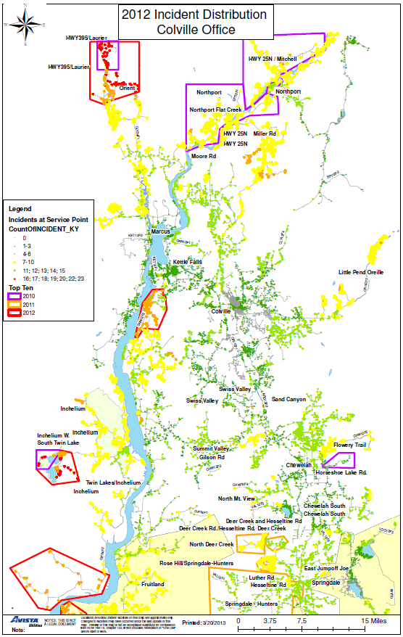

Chart 5.3 - Davenport Office - CEMI_{n}
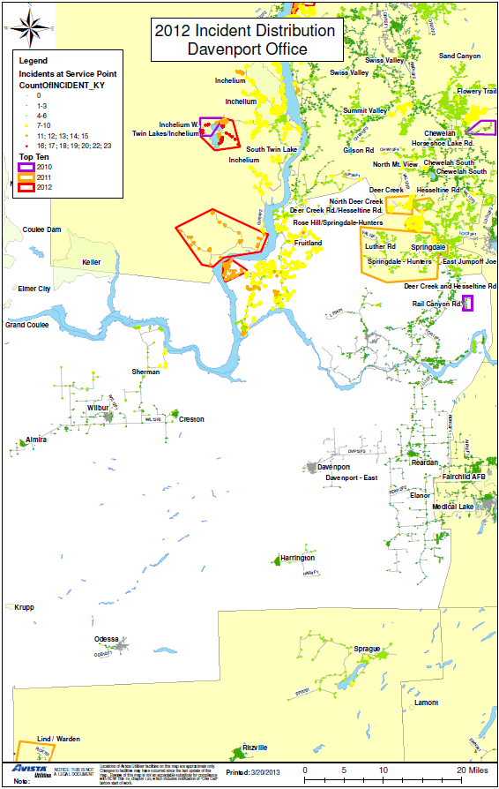
Chart 5.4 - Deer Park Office - CEMI_{n}
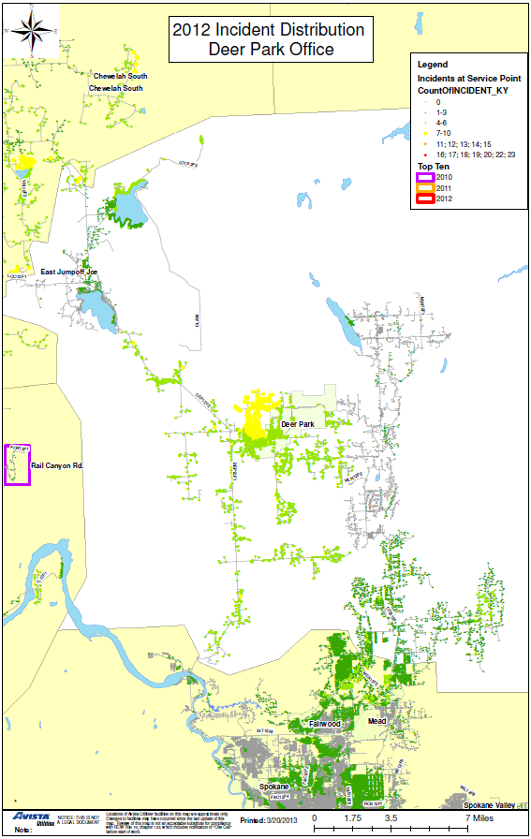

Chart 5.5 - Othello Office - CEMI_{n}
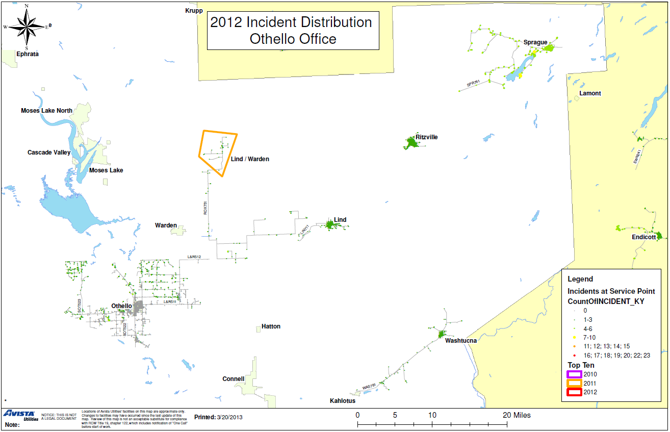
Chart 5.6 - Palouse Office - CEMI_{n}
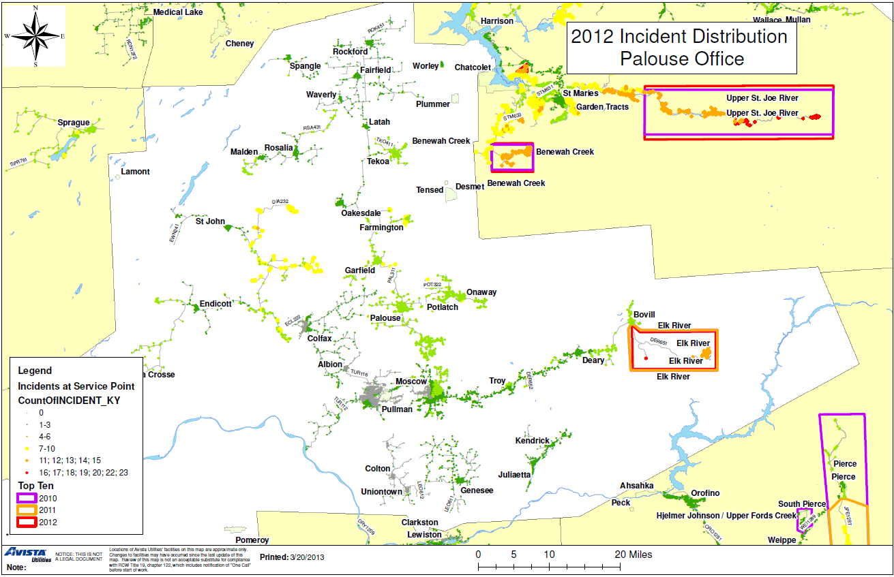
Chart 5.7 - Lewis-Clark Office - CEMI_{n}

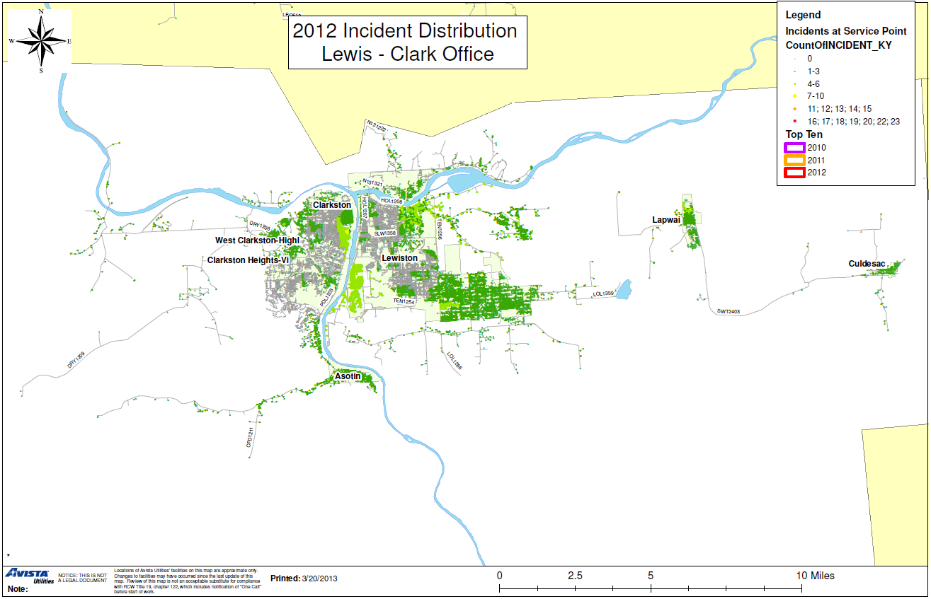
Chart 5.8 - Spokane Office - CEMI_{n}

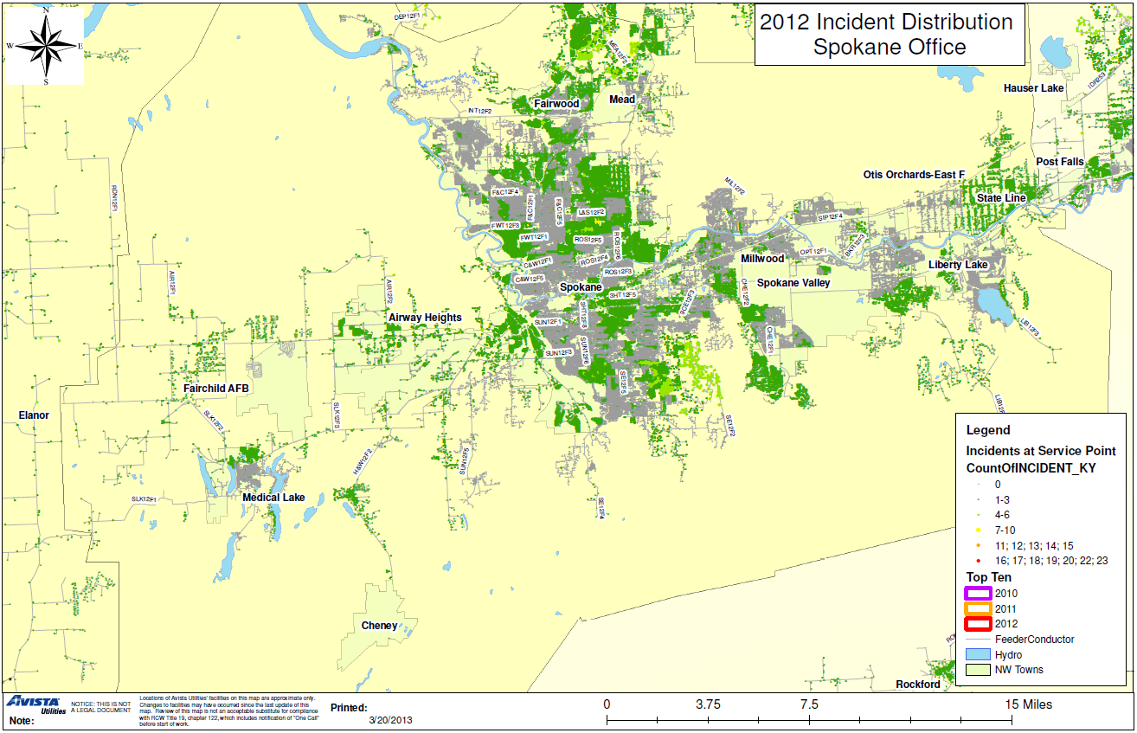
Chart 5.9 - Sandpoint Office - CEMI_{n}

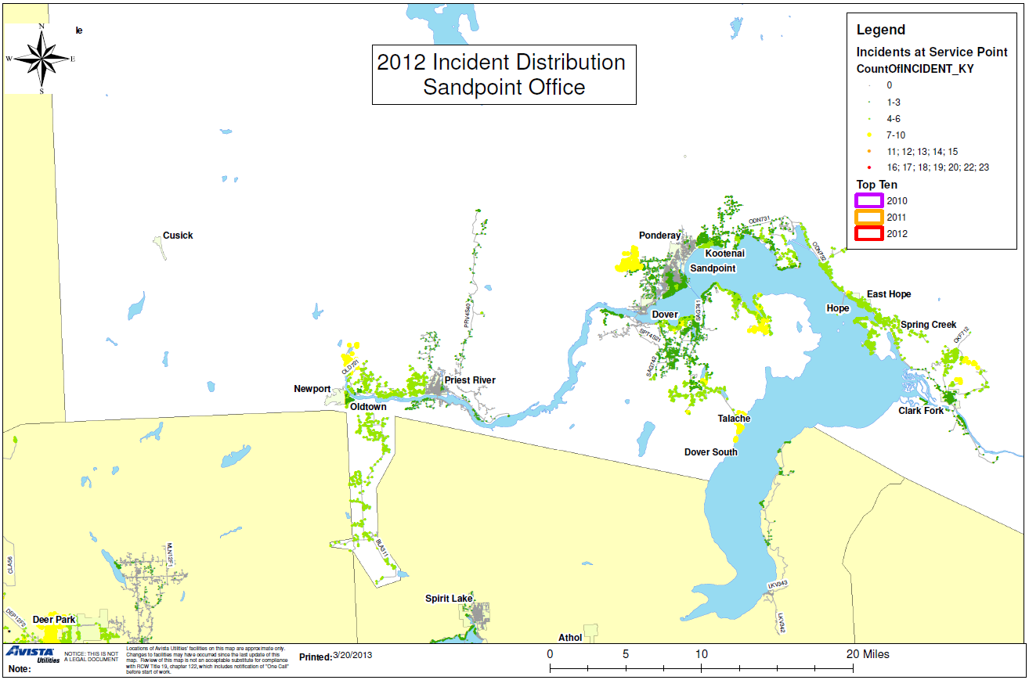
Chart 5.10 - Kellogg Office - CEMI_{n}

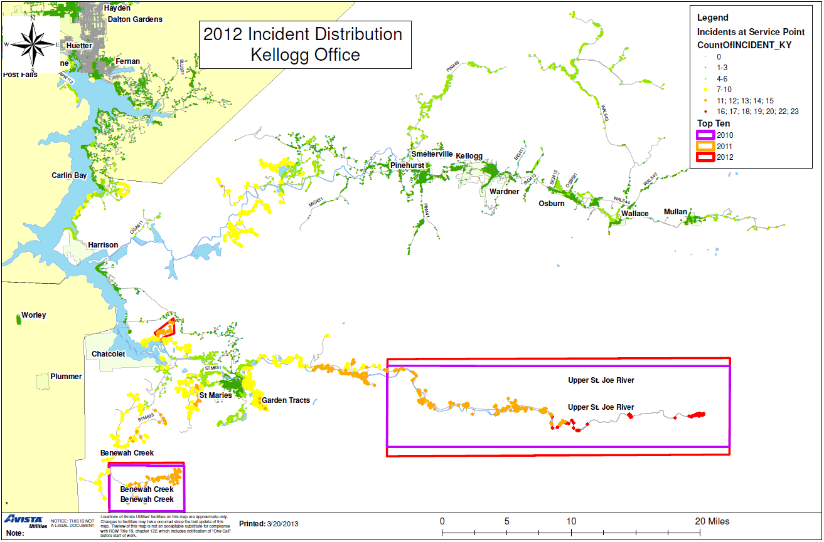

Chart 5.11 - Coeur d’Alene - CEMI_{n}
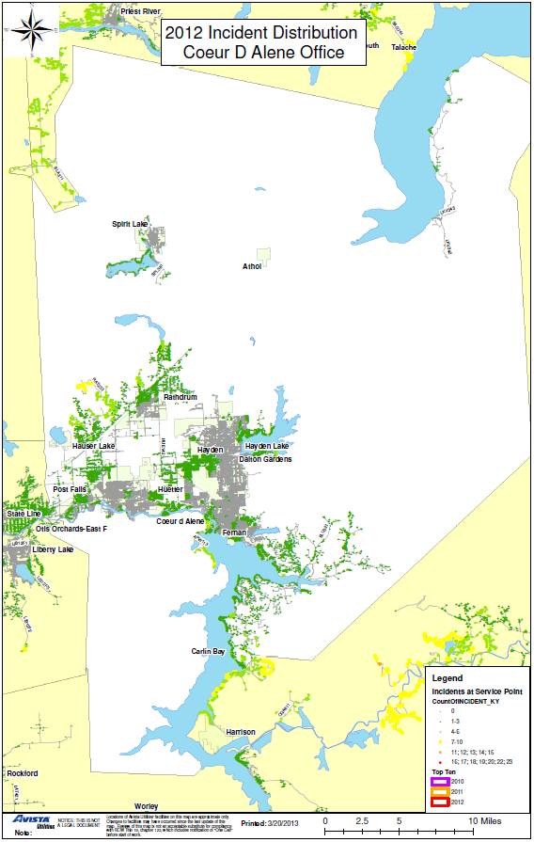

Chart 5.12 - Grangeville Office - CEMI_{n}
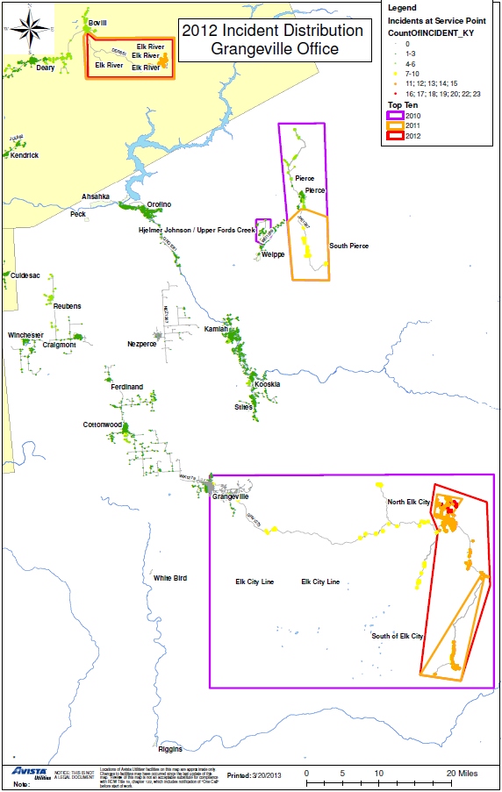
Monthly Indices

Each of the following indices, reported by month, shows the variations from month to month. These variations are partially due to inclement weather and, in some cases, reflect incidents of winter snowstorms, seasonal windstorms, and mid- and late summer lightning storms. They also reflect varying degrees of animal activity causing disruptions in different months of the year.

Chart 6.1 – SAIFI - Sustained Interruptions / Customer

Chart 6.2 - MAIFI Momentary Interruption Events / Customer

Chart 6.3 - SAIDI – Average Outage Time / Customer

Chart 6.4 - CAIDI – Average Restoration Time

Customer Complaints

Table 7.1 - Commission Complaints
There were no complaints made to the Commission during 2012.

Table 7.2 - Customer Complaints
The following is a list of complaints made to our Customer Service Representatives.

Customer / Feeder | Complaint | Complaint Category | Resolution
Medical Lake WA  SLK12F1 | Customer called and was upset with poor electric quality and continuous outages. | Outages | There were 2 Sustained Outages in 2012. Both outages resulting from lightning storms, one causing a pole fire.  No Resolution Documented.
Deer Park WA  DEP12F1 | Customer called and was upset about constant power outages in the Deer Park area. | Outages | There were 6 sustained outages in 2012. Two of these were for planned maintenance, and one was a public caused outage.  Area Manager contacted customer to explained equipment failures and planned maintenance work.
Sprague WA  SPR761 | Customer feels lines from substation are very old and would like to see the town’s system upgraded to protect from outages. | Outages | There were 4 sustained outages in 2012. Three of these outages were whole feeder outages due to lightning storms, all within one week.  Referred customer to Operations Director.
St. Maries WA  STM633 | Customer unhappy with service in the St. Maries area. Commented on dim and flickering lights. | Outages | There were 7 sustained outages in 2012. Four were weather related.  Area Manager contacted customer to explain outages.
Springdale WA  VAL12F1 | Customer called and is upset about outages happening too often. | Outages | There were 4 sustained outages in 2012. Two were tree related, one was planned maintenance and one was a car hit pole.  Customer contacted by Area Manager to explain events.

Sustained Interruption Causes

Table 8.1 - % SAIFI per Cause by Office

The following table lists the percentage SAIFI contribution by causes for outages excluding major event days.

Reason | CDC | COC | DAC | GRC | KEC | LCC | OTC | PAC | SAC | SPC | DPC | All Offices
ANIMAL | 8.8% | 2.6% | 2.1% | 5.3% | 0.2% | 4.5% | 4.0% | 1.1% | 2.5% | 14.5% | 1.0% | 5.8%
MISCELLANEOUS | 0.2% | 0.0% | 0.0% | 0.0% | 0.3% | 0.0% | 0.0% | 0.0% | 0.0% | 0.0% | 0.0% | 0.0%
POLE FIRE | 5.0% | 0.2% | 1.5% | 6.2% | 0.8% | 8.4% | 1.2% | 7.5% | 0.1% | 10.3% | 0.0% | 5.1%
WEATHER | 21.8% | 30.4% | 8.5% | 29.8% | 54.5% | 10.5% | 28.3% | 21.3% | 50.9% | 12.7% | 11.9% | 24.7%
UNDETERMINED | 1.4% | 15.3% | 20.9% | 23.1% | 12.9% | 16.5% | 37.4% | 11.2% | 23.3% | 11.7% | 20.5% | 14.4%
TREE | 6.0% | 18.9% | 17.5% | 12.0% | 9.0% | 6.9% | 0.1% | 9.5% | 15.8% | 3.6% | 7.6% | 9.5%
PUBLIC | 29.2% | 6.6% | 15.8% | 1.4% | 6.4% | 13.6% | 3.5% | 17.6% | 2.8% | 13.7% | 17.8% | 12.2%
COMPANY | 0.1% | 4.8% | 3.5% | 0.0% | 2.0% | 0.0% | 0.1% | 0.1% | 0.0% | 10.3% | 1.3% | 3.9%
EQUIPMENT OH | 18.3% | 9.8% | 23.6% | 12.4% | 4.0% | 9.9% | 8.7% | 19.0% | 3.1% | 7.2% | 11.8% | 10.4%
EQUIPMENT UG | 2.4% | 0.3% | 0.2% | 0.5% | 0.2% | 6.8% | 0.1% | 1.2% | 0.5% | 0.6% | 0.1% | 1.1%
EQUIPMENT SUB | 0.0% | 0.0% | 1.7% | 0.0% | 0.0% | 17.6% | 0.0% | 0.0% | 0.0% | 4.8% | 12.9% | 3.3%
PLANNED | 6.6% | 11.2% | 4.6% | 9.3% | 9.7% | 5.2% | 16.5% | 11.4% | 1.0% | 10.7% | 15.1% | 9.6%

CDC | Coeur d’Alene | LCC | Lewiston-Clarkston
COC | Colville | OTC | Othello
DAC | Davenport | PAC | Palouse
DPC | Deer Park | SAC | Sandpoint
GRC | Grangeville | SPC | Spokane
KEC | Kellogg/ St. Maries
Chart 8.1 – % SAIFI per Cause by Office

The following chart shows the percentage SAIFI contribution by causes for outages excluding major event days.

Table 8.2 - % SAIDI per Cause by Office

The following table lists the percentage SAIDI contribution by causes for outages excluding major event days.

Reason | CDC | COC | DAC | GRC | KEC | LCC | OTC | PAC | SAC | SPC | DPC | All Offices
ANIMAL | 1.3% | 1.4% | 3.4% | 3.6% | 0.2% | 2.9% | 2.8% | 0.7% | 2.2% | 10.0% | 1.9% | 3.3%
MISCELLANEOUS | 0.4% | 0.0% | 0.0% | 0.0% | 0.2% | 0.0% | 0.0% | 0.0% | 0.0% | 0.0% | 0.0% | 0.0%
POLE FIRE | 7.2% | 0.1% | 2.2% | 6.9% | 0.7% | 11.5% | 2.9% | 7.2% | 0.1% | 13.9% | 0.0% | 5.2%
WEATHER | 28.9% | 54.4% | 18.1% | 52.0% | 43.2% | 18.4% | 35.2% | 27.1% | 59.1% | 20.8% | 18.9% | 37.1%
UNDETERMINED | 2.7% | 7.4% | 13.6% | 7.4% | 14.9% | 8.8% | 16.0% | 4.8% | 16.6% | 6.1% | 9.3% | 8.4%
TREE | 12.2% | 17.1% | 14.5% | 11.4% | 12.7% | 3.9% | 0.1% | 3.1% | 14.1% | 5.1% | 4.3% | 10.2%
PUBLIC | 18.7% | 4.5% | 7.6% | 2.9% | 7.0% | 20.8% | 8.3% | 22.9% | 4.3% | 15.9% | 16.7% | 11.5%
COMPANY | 0.0% | 0.6% | 0.3% | 0.0% | 0.1% | 0.0% | 0.1% | 0.1% | 0.0% | 4.3% | 2.4% | 1.2%
EQUIPMENT OH | 18.2% | 7.2% | 36.2% | 10.1% | 5.2% | 12.0% | 10.3% | 13.3% | 2.0% | 8.6% | 18.4% | 10.2%
EQUIPMENT UG | 3.9% | 0.4% | 0.3% | 1.2% | 0.3% | 3.5% | 0.3% | 2.6% | 1.2% | 1.9% | 0.2% | 1.4%
EQUIPMENT SUB | 0.0% | 0.0% | 1.7% | 0.0% | 0.0% | 14.3% | 0.0% | 0.0% | 0.0% | 2.5% | 24.3% | 2.5%
PLANNED | 6.4% | 6.8% | 2.1% | 4.5% | 15.4% | 4.0% | 24.1% | 18.2% | 0.4% | 10.8% | 3.7% | 8.9%

CDC | Coeur d’Alene | LCC | Lewiston-Clarkston
COC | Colville | OTC | Othello
DAC | Davenport | PAC | Palouse
DPC | Deer Park | SAC | Sandpoint
GRC | Grangeville | SPC | Spokane
KEC | Kellogg/ St. Maries

Chart 8.2 – % SAIDI per Cause by Office

The following chart shows the percentage SAIDI contribution by causes for outages excluding major event days.

Table 8.3 - % SAIFI per Cause by Month

The following table lists the percentage SAIFI contribution by causes for all outages, excluding major event days.

Reason | Jan | Feb | Mar | Apr | May | June | July | Aug | Sept | Oct | Nov | Dec | Yearly
ANIMAL | 0.2% | 5.8% | 1.5% | 6.7% | 4.1% | 31.3% | 1.7% | 1.8% | 2.2% | 1.1% | 13.7% | 2.2% | 5.8%
MISCELLANEOUS | 0.0% | 0.2% | 0.0% | 0.0% | 0.0% | 0.0% | 0.0% | 0.0% | 0.0% | 0.2% | 0.0% | 0.0% | 0.0%
POLE FIRE | 0.0% | 0.2% | 1.1% | 1.1% | 5.1% | 1.0% | 4.3% | 9.6% | 0.0% | 17.6% | 5.4% | 0.0% | 5.1%
WEATHER | 9.2% | 47.8% | 21.6% | 10.7% | 11.2% | 9.4% | 57.5% | 12.4% | 11.0% | 29.7% | 4.3% | 32.9% | 24.7%
UNDETERMINED | 10.9% | 3.1% | 4.2% | 19.4% | 20.4% | 4.8% | 13.3% | 40.3% | 9.8% | 15.1% | 16.2% | 20.1% | 14.4%
TREE | 16.8% | 8.8% | 16.9% | 4.8% | 19.7% | 3.8% | 9.2% | 5.4% | 19.7% | 5.6% | 5.5% | 6.9% | 9.5%
PUBLIC | 31.6% | 0.2% | 25.8% | 17.5% | 4.0% | 31.1% | 4.6% | 3.5% | 16.4% | 7.5% | 4.9% | 9.8% | 12.2%
COMPANY | 1.0% | 11.3% | 0.1% | 15.1% | 3.9% | 1.8% | 0.0% | 0.7% | 4.8% | 0.7% | 11.0% | 4.6% | 3.9%
EQUIPMENT OH | 18.9% | 12.4% | 11.3% | 18.5% | 12.0% | 5.6% | 3.7% | 4.3% | 3.9% | 11.8% | 14.4% | 16.9% | 10.4%
EQUIPMENT UG | 0.2% | 1.6% | 0.5% | 0.6% | 0.8% | 0.2% | 0.8% | 1.4% | 6.6% | 0.1% | 0.2% | 0.1% | 1.1%
EQUIPMENT SUB | 0.0% | 0.0% | 0.0% | 0.0% | 0.0% | 0.0% | 0.0% | 15.2% | 9.5% | 2.2% | 14.4% | 0.0% | 3.3%
PLANNED | 11.2% | 8.8% | 17.1% | 5.6% | 18.7% | 11.2% | 4.8% | 5.5% | 16.1% | 8.5% | 10.0% | 6.4% | 9.6%

Chart 8.3 – % SAIFI per Cause by Month

The following chart shows the percentage SAIFI contribution by causes for all outages, excluding major event days.

Table 8.4 - % SAIDI per Cause by Month

The following table lists the percentage SAIDI contribution by causes for outages excluding major event days.

REASON | Jan | Feb | Mar | Apr | May | June | Jul | Aug | Sept | Oct | Nov | Dec | Yearly
ANIMAL | 0.2% | 0.5% | 2.7% | 6.3% | 5.7% | 18.0% | 1.4% | 2.0% | 2.1% | 0.7% | 9.9% | 1.1% | 3.3%
MISCELLANEOUS | 0.0% | 0.2% | 0.0% | 0.0% | 0.0% | 0.0% | 0.0% | 0.0% | 0.0% | 0.1% | 0.0% | 0.0% | 0.0%
POLE FIRE | 0.1% | 0.3% | 1.1% | 1.4% | 6.9% | 2.6% | 4.3% | 13.2% | 0.0% | 15.4% | 6.4% | 0.0% | 5.2%
WEATHER | 13.4% | 62.3% | 21.4% | 16.4% | 20.9% | 11.7% | 62.2% | 25.8% | 22.9% | 33.7% | 5.4% | 71.4% | 37.1%
UNDETERMINED | 6.2% | 1.4% | 4.4% | 11.5% | 11.6% | 5.5% | 2.7% | 23.1% | 12.5% | 9.5% | 18.4% | 5.7% | 8.4%
TREE | 9.3% | 13.7% | 18.0% | 9.1% | 9.1% | 10.3% | 12.0% | 6.7% | 14.9% | 8.4% | 10.3% | 4.3% | 10.2%
PUBLIC | 29.2% | 0.7% | 30.3% | 15.9% | 5.7% | 29.9% | 6.3% | 4.9% | 15.0% | 10.6% | 5.0% | 6.1% | 11.5%
COMPANY | 0.1% | 1.1% | 0.0% | 16.0% | 2.9% | 0.6% | 0.0% | 0.1% | 0.2% | 0.1% | 2.7% | 0.5% | 1.2%
EQUIPMENT OH | 23.6% | 11.6% | 10.1% | 15.8% | 15.9% | 7.3% | 4.8% | 8.7% | 6.3% | 10.2% | 13.7% | 7.9% | 10.2%
EQUIPMENT UG | 0.3% | 2.2% | 1.2% | 1.5% | 1.6% | 0.9% | 1.7% | 3.6% | 4.1% | 0.2% | 0.5% | 0.1% | 1.4%
EQUIPMENT SUB | 0.0% | 0.0% | 0.0% | 0.0% | 0.0% | 0.0% | 0.0% | 7.4% | 13.0% | 0.4% | 14.3% | 0.0% | 2.5%
PLANNED | 17.6% | 6.2% | 10.7% | 6.1% | 19.7% | 13.1% | 4.5% | 4.4% | 9.1% | 10.6% | 13.3% | 2.8% | 8.9%

Table 8.4.1 Average Outage Time (HH:MM)

Reason | Jan | Feb | Mar | Apr | May | June | July | Aug | Sept | Oct | Nov | Dec | Yearly
ANIMAL | 1:19 | 0:09 | 3:19 | 1:24 | 2:34 | 0:51 | 2:01 | 1:50 | 1:59 | 1:29 | 1:25 | 1:48 | 1:08
COMPANY | 0:06 | 0:11 | 1:02 | 1:35 | 1:22 | 0:29 | 1:43 | 0:08 | 0:05 | 0:26 | 0:29 | 0:24 | 0:36
EQUIPMENT OH | 1:54 | 1:47 | 1:41 | 1:16 | 2:28 | 1:57 | 3:17 | 3:20 | 3:25 | 1:49 | 1:52 | 1:42 | 1:58
EQUIPMENT SUB | 0:00 | 0:00 | 0:00 | 0:00 | 3:11 | 0:00 | 0:00 | 0:48 | 2:51 | 0:24 | 1:57 | 0:00 | 1:33
EQUIPMENT UG | 2:13 | 2:44 | 4:42 | 3:27 | 3:42 | 7:00 | 5:39 | 4:23 | 1:18 | 3:54 | 5:51 | 2:56 | 2:40
MISCELLANEOUS | 1:43 | 2:42 | 0:00 | 0:00 | 0:00 | 0:00 | 0:00 | 0:00 | 0:00 | 1:23 | 0:00 | 0:00 | 1:50
PLANNED | 2:24 | 1:20 | 1:10 | 1:39 | 1:57 | 1:45 | 2:22 | 1:18 | 1:10 | 2:37 | 2:38 | 1:36 | 1:52
POLE FIRE | 3:35 | 2:51 | 1:56 | 1:55 | 2:31 | 4:04 | 2:32 | 2:16 | 0:00 | 1:50 | 2:19 | 5:33 | 2:05
PUBLIC | 1:24 | 5:48 | 2:13 | 1:21 | 2:37 | 1:26 | 3:26 | 2:20 | 1:55 | 2:58 | 2:00 | 2:14 | 1:54
TREE | 0:50 | 2:57 | 2:00 | 2:51 | 0:51 | 4:05 | 3:17 | 2:02 | 1:34 | 3:10 | 3:42 | 2:16 | 2:10
UNDETERMINED | 0:52 | 0:51 | 1:58 | 0:53 | 1:03 | 1:42 | 0:30 | 0:56 | 2:39 | 1:19 | 2:14 | 1:02 | 1:11
WEATHER | 2:13 | 2:29 | 1:52 | 2:17 | 3:28 | 1:51 | 2:43 | 3:26 | 4:20 | 2:23 | 2:30 | 7:53 | 3:01

Chart 8.4 – % SAIDI per Cause by Month

The following chart shows the percentage SAIDI contribution by causes for outages excluding major event days.

Momentary Interruption Causes

The cause for many momentary interruptions is unknown. Because faults are temporary, the cause goes unnoticed even after the line is patrolled. Momentary outages are recorded using our SCADA system (System Control and Data Acquisition). On average, about 88% of Avista’s customers are served from SCADA controlled stations.

Table 9.1 - % MAIFI per Cause by Office

The following table lists the percentage MAIFI contribution by causes for outages excluding major event days.

REASON | CDC | COC | DAC | GRC | KEC | LCC | OTC | PAC | SAC | SPC | DPC | All Offices
ANIMAL | 1.1% | 0.0% | 0.0% | 0.0% | 0.1% | 2.4% | 0.0% | 1.3% | 0.0% | 0.7% | 0.0% | 0.9%
POLE FIRE | 0.0% | 0.0% | 0.0% | 0.0% | 0.0% | 0.5% | 0.0% | 0.0% | 0.0% | 0.0% | 0.0% | 0.1%
WEATHER | 32.3% | 43.4% | 20.0% | 35.6% | 31.7% | 27.7% | 32.2% | 25.6% | 34.7% | 30.8% | 0.0% | 33.3%
TREE | 0.0% | 3.9% | 8.3% | 0.7% | 0.0% | 0.0% | 0.0% | 0.9% | 2.1% | 0.0% | 0.0% | 0.8%
PUBLIC | 0.0% | 1.9% | 0.0% | 0.9% | 6.6% | 0.0% | 0.0% | 0.0% | 0.0% | 0.0% | 0.0% | 0.4%
MISC | 0.0% | 0.0% | 0.0% | 0.0% | 6.6% | 0.0% | 0.0% | 0.0% | 0.0% | 0.0% | 0.0% | 0.1%
COMPANY | 0.0% | 0.0% | 0.0% | 0.0% | 0.0% | 1.3% | 0.0% | 0.0% | 0.0% | 4.1% | 0.0% | 0.8%
UNDETERMINED | 54.6% | 43.7% | 68.0% | 58.4% | 52.8% | 61.4% | 54.2% | 65.9% | 52.6% | 49.4% | 0.0% | 54.6%
EQUIPMENT UG | 0.7% | 0.0% | 0.0% | 0.0% | 0.0% | 0.0% | 3.0% | 0.0% | 4.3% | 1.6% | 0.0% | 0.8%
EQUIPMENT OH | 0.0% | 0.0% | 0.0% | 0.0% | 0.0% | 0.0% | 0.0% | 0.0% | 0.0% | 5.3% | 0.0% | 0.8%
PLANNED | 1.8% | 4.1% | 0.0% | 2.3% | 2.2% | 1.6% | 0.0% | 0.0% | 0.0% | 0.0% | 0.0% | 1.2%

CDC | Coeur d’Alene | LCC | Lewiston-Clarkston
COC | Colville | OTC | Othello
DAC | Davenport | PAC | Palouse
DPC | Deer Park | SAC | Sandpoint
GRC | Grangeville | SPC | Spokane
KEC | Kellogg/ St. Maries

Table 9.1.1 - % MAIFI per Cause by Office (Washington only)

The following table lists the percentage MAIFI contribution by causes for outages excluding major event days.

REASON | COC | DAC | OTC | SPC | DPC | PAC-WA | LCC-WA | All WA Offices
ANIMAL | 2.59% | 2.09% | 0.95% | 1.27% | 3.99% | 1.88% | 14.51% | 7.59%
COMPANY | 4.82% | 3.50% | 1.31% | 0.00% | 0.13% | 0.28% | 10.25% | 6.13%
MISCELLANEOUS | 0.00% | 0.00% | 0.00% | 0.00% | 0.00% | 0.00% | 0.01% | 0.00%
POLE FIRE | 0.23% | 1.50% | 0.00% | 49.52% | 1.23% | 11.70% | 10.32% | 6.69%
PUBLIC | 6.56% | 15.78% | 17.77% | 2.78% | 3.55% | 11.62% | 13.71% | 11.65%
TREE | 18.89% | 17.49% | 7.63% | 6.14% | 0.13% | 5.69% | 3.56% | 8.89%
UNDETERMINED | 15.32% | 20.93% | 20.54% | 5.07% | 37.36% | 3.52% | 11.68% | 13.47%
WEATHER | 30.37% | 8.51% | 11.91% | 24.98% | 28.33% | 29.36% | 12.67% | 19.63%
EQUIPMENT OH | 9.75% | 23.63% | 11.83% | 4.17% | 8.71% | 19.76% | 7.21% | 10.40%
EQUIPMENT UG | 0.27% | 0.21% | 0.09% | 4.31% | 0.09% | 2.04% | 0.62% | 0.65%
EQUIPMENT SUB | 0.00% | 1.74% | 12.87% | 0.00% | 0.02% | 0.00% | 4.79% | 3.48%
PLANNED | 11.20% | 4.61% | 15.09% | 1.77% | 16.46% | 14.14% | 10.67% | 11.42%

COC | Colville | OTC | Othello
DAC | Davenport | PAC-WA | Palouse Washington
DPC | Deer Park | SPC | Spokane
LCC-WA | Lewiston-Clarkston Washington

Chart 9.1 – % MAIFI per Cause by Office

The following chart shows the percentage MAIFI contribution by causes for outages excluding major event days.

Table 9.2 - % MAIFI per Cause by Month

The following table lists the percentage MAIFI contribution by causes for outages excluding major event days.

REASON | Jan | Feb | Mar | Apr | May | June | Jul | Aug | Sept | Oct | Nov | Dec | Yearly
ANIMAL | 3.0% | 0.0% | 0.0% | 0.0% | 2.3% | 0.5% | 1.6% | 0.0% | 4.1% | 0.0% | 0.0% | 0.0% | 0.9%
POLE FIRE | 0.0% | 0.0% | 0.0% | 0.0% | 0.0% | 0.0% | 0.0% | 0.0% | 0.0% | 0.0% | 1.9% | 0.0% | 0.1%
WEATHER | 23.1% | 24.3% | 11.1% | 10.4% | 5.9% | 72.6% | 39.2% | 3.3% | 2.4% | 40.7% | 4.9% | 54.9% | 33.3%
TREE | 0.0% | 2.0% | 2.5% | 0.0% | 0.0% | 0.0% | 0.0% | 0.0% | 10.0% | 0.0% | 0.0% | 0.0% | 0.8%
PUBLIC | 0.0% | 0.0% | 0.0% | 0.0% | 2.3% | 1.0% | 0.0% | 0.0% | 0.0% | 0.0% | 0.0% | 0.0% | 0.4%
COMPANY | 3.4% | 0.0% | 4.3% | 0.0% | 1.5% | 1.2% | 0.0% | 0.0% | 0.0% | 0.0% | 0.0% | 0.0% | 0.8%
UNDETERMINED | 70.5% | 54.4% | 81.0% | 87.3% | 86.1% | 24.8% | 58.2% | 80.3% | 79.1% | 55.7% | 0.0% | 31.7% | 54.6%
EQUIPMENT OH | 0.0% | 6.8% | 1.2% | 0.0% | 0.0% | 0.0% | 1.0% | 0.0% | 0.0% | 0.0% | 0.0% | 0.0% | 0.8%
PLANNED | 0.0% | 12.5% | 0.0% | 2.2% | 0.0% | 0.0% | 0.0% | 0.2% | 0.0% | 0.0% | 0.0% | 0.1% | 1.2%
EQUIPMENT SUB | 0.0% | 0.0% | 0.0% | 0.0% | 0.0% | 0.0% | 0.0% | 12.0% | 0.0% | 0.0% | 0.0% | 0.0% | 0.8%
MISCELLANIOUS | 0.0% | 0.0% | 0.0% | 0.0% | 1.9% | 0.0% | 0.0% | 0.0% | 0.0% | 0.0% | 0.0% | 0.0% | 0.1%

Chart 9.2 – % MAIFI per Cause by Month

The following chart shows the percentage MAIFI contribution by causes for outages excluding major event days.

Major Event Day Causes

Chart 10.1 – % SAIFI by Cause Code for the Major Event Days

The following chart shows the percentage SAIFI contribution by causes for outages during major event days.

Table 10.1 – % SAIFI by Sub Cause Code for the Major Event Days

The following table shows the SAIFI contribution and Customer hours by cause for the 2012 major event days.

Reason | Sum of Ni | Sum of ri x Ni (hours)
ANIMAL | 0 | 0:00
COMPANY | 0 | 0:00
EQUIPMENT OH | 18 | 55:12
EQUIPMENT SUB | 0 | 0:00
EQUIPMENT UG | 3 | 20:04
MISCELLANEOUS | 0 | 0:00
PLANNED | 316 | 279:02
POLE FIRE | 0 | 0:00
PUBLIC | 82 | 70:24
TREE | 626 | 1912:32
UNDETERMINED | 2248 | 15031:51
WEATHER | 38783 | 130509:26
Total | 42076 | 147803:17

Table 10.2 – Yearly Summary of the Major Event Days

Table 10.2 is provided as an initial review of Major Event Day information. The main premise of the IEEE Major Event Day calculation is that using the 2.5b method should classify 2.3 days each year as MED’s. The following table shows the previous major event days, the daily SAIDI value and the relationship of the yearly T_{MED}.

Year | Date | SAIDI | T_{MED}
2004 | 05-21-2004 | 7.11 | 6.35
 | 08-02-2004 | 7.36
 | 12-08-2004 | 31.00
2005 | 06-21-2005 | 39.53 | 4.916
 | 06-22-2005 | 9.03
 | 08-12-2005 | 19.60
2006 | 01-11-2006 | 12.10 | 7.058
 | 03-09-2006 | 8.58
 | 11-13-2006 | 30.79
 | 12-14-2006 | 29.26
 | 12-15-2006 | 158.31
2007 | 01-06-2007 | 9.98 | 8.017
 | 06-29-2007 | 32.64
 | 07-13-2007 | 12.79
 | 08-31-2007 | 21.30
2008 | 01-27-2008 | 17.57 | 9.224
 | 07-10-2008 | 36.74
 | 08-18-2008 | 9.49
2009 | None |  | 9.925
2010 | 5/3/2010 | 21.04 | 11.110
 | 11/16/2010 | 68.67
2011 | None |  | 10.848
2012 | 1/19/2012 | 9.93 | 9.489
 | 12/17/2012 | 14.35
2013 |  |  | 8.956

Interruption Cause Codes

Table 11.1 – Interruption Cause Codes

MAIN CATEGORY | Proposed  (Changes Only) | SUB CATEGORY | Proposed  (Changes Only) | Definition
ANIMAL |  | Bird |  | Outages caused by animal contacts. Specific animal called out in sub category.
 |  | Squirrel
 |  | Underground
 |  | Other
PUBLIC |  | Car Hit Pad |  | Underground outage due to car, truck, construction equipment etc. contact with pad transformer, junction enclosure etc...
 |  | Car Hit Pole |  | Overhead outage due to car, truck, construction equipment etc. contact with pole, guy, neutral etc.
 |  | Dig In |  | Dig in by a customer, a customer’s contractor, or another utility.
 |  | Fire |  | Outages caused by or required for a house/structure or field/forest fire.
 |  | Tree |  | Homeowner, tree service, logger etc. fells a tree into the line.
 |  | Other |  | Other public caused outages
COMPANY |  | Dig in |  | Dig in by company or contract crew.
 |  | Other |  | Other company caused outages
EQUIPMENT OH |  | Arrestors |  | Outages caused by equipment failure. Specific equipment called out in sub category.
 |  | Capacitor
 |  | Conductor - Pri
 |  | Conductor - Sec
 |  | Connector - Pri
 |  | Connector - Sec
 |  | Crossarm- rotten
 |  | Cutout / Fuse
 |  | Insulator
 |  | Insulator Pin
 |  | Other
 |  | Pole - Rotten
 |  | Recloser
 |  | Regulator
 |  | Switch / Disconnect
 |  | Transformer - OH
 |  | Wildlife Guard |  | Wildlife guard failed or caused an outage
EQUIPMENT UG |  | URD Cable - Pri |  | Outages caused by equipment failure. Specific equipment called out in sub category.
 |  | URD Cable- Sec
 |  | Connector - Sec
 |  | Elbow
 |  | Junctions
 |  | Primary Splice
 |  | Termination
 |  | Transformer - UG
 |  | Other
MAIN CATEGORY | Proposed  (Changes Only) | SUB CATEGORY | Proposed  (Changes Only) | Definition
EQUIPMENT SUB |  | High side fuse
 |  | Bus Insulator
 |  | High side PCB
 |  | High side Swt / Disc
 |  | Low side OCB/Recloser
 |  | Low side Swt / Disc
 |  | Relay Misoperation
 |  | Regulator
 |  | Transformer
 |  | Other
MISCELLANEOUS |  | SEE REMARKS |  | For causes not specifically listed elsewhere
NOT OUR PROBLEM  (Outages in this category are not included in reported statistics) |  | Customer Equipment  SEE REMARKS |  | Customer equipment causing an outage to their service. If a customer causes an outage to another customer this is covered under Public.
 |  | Other Utility |  | Outages when another utility’s facilities cause an outage on our system.
POLE FIRE |  |  |  | Used when water and contamination causes insulator leakage current and fire. If insulator is leaking due to material failure list under equipment failure. If cracked due to gunfire use customer caused other.
PLANNED |  | Maintenance / Upgrade |  | Outage, normally prearranged, needed for normal construction work
 |  | Forced |  | Outage scheduled to repair outage damage
TREE |  | Tree fell |  | For outages when a tree falls into distribution primary/secondary or transmission during normal weather
 |  | Tree growth |  | Tree growth causes a tree to contact distribution primary/secondary or transmission during normal weather.
 |  | Service |  | For outages when a tree falls or grows into a service.
 |  | Weather |  | When snow and wind storms causes a tree or branch to fall into, or contact the line. Includes snow loading and unloading.
UNDETERMINED |  |  |  | Use when the cause cannot be determined
WEATHER |  | Snow / Ice |  | Outages caused by snow or ice loading or unloading on a structure or conductor. Use weather tree for snow and ice loading on a tree.
 |  | Lightning |  | Lightning flashovers without equipment damage. Equipment failures reported under the equipment type.
 |  | Wind |  | Outages when wind causes conductors to blow into each other, another structure, building etc.

Office Areas

Chart 12.1 – Office Areas

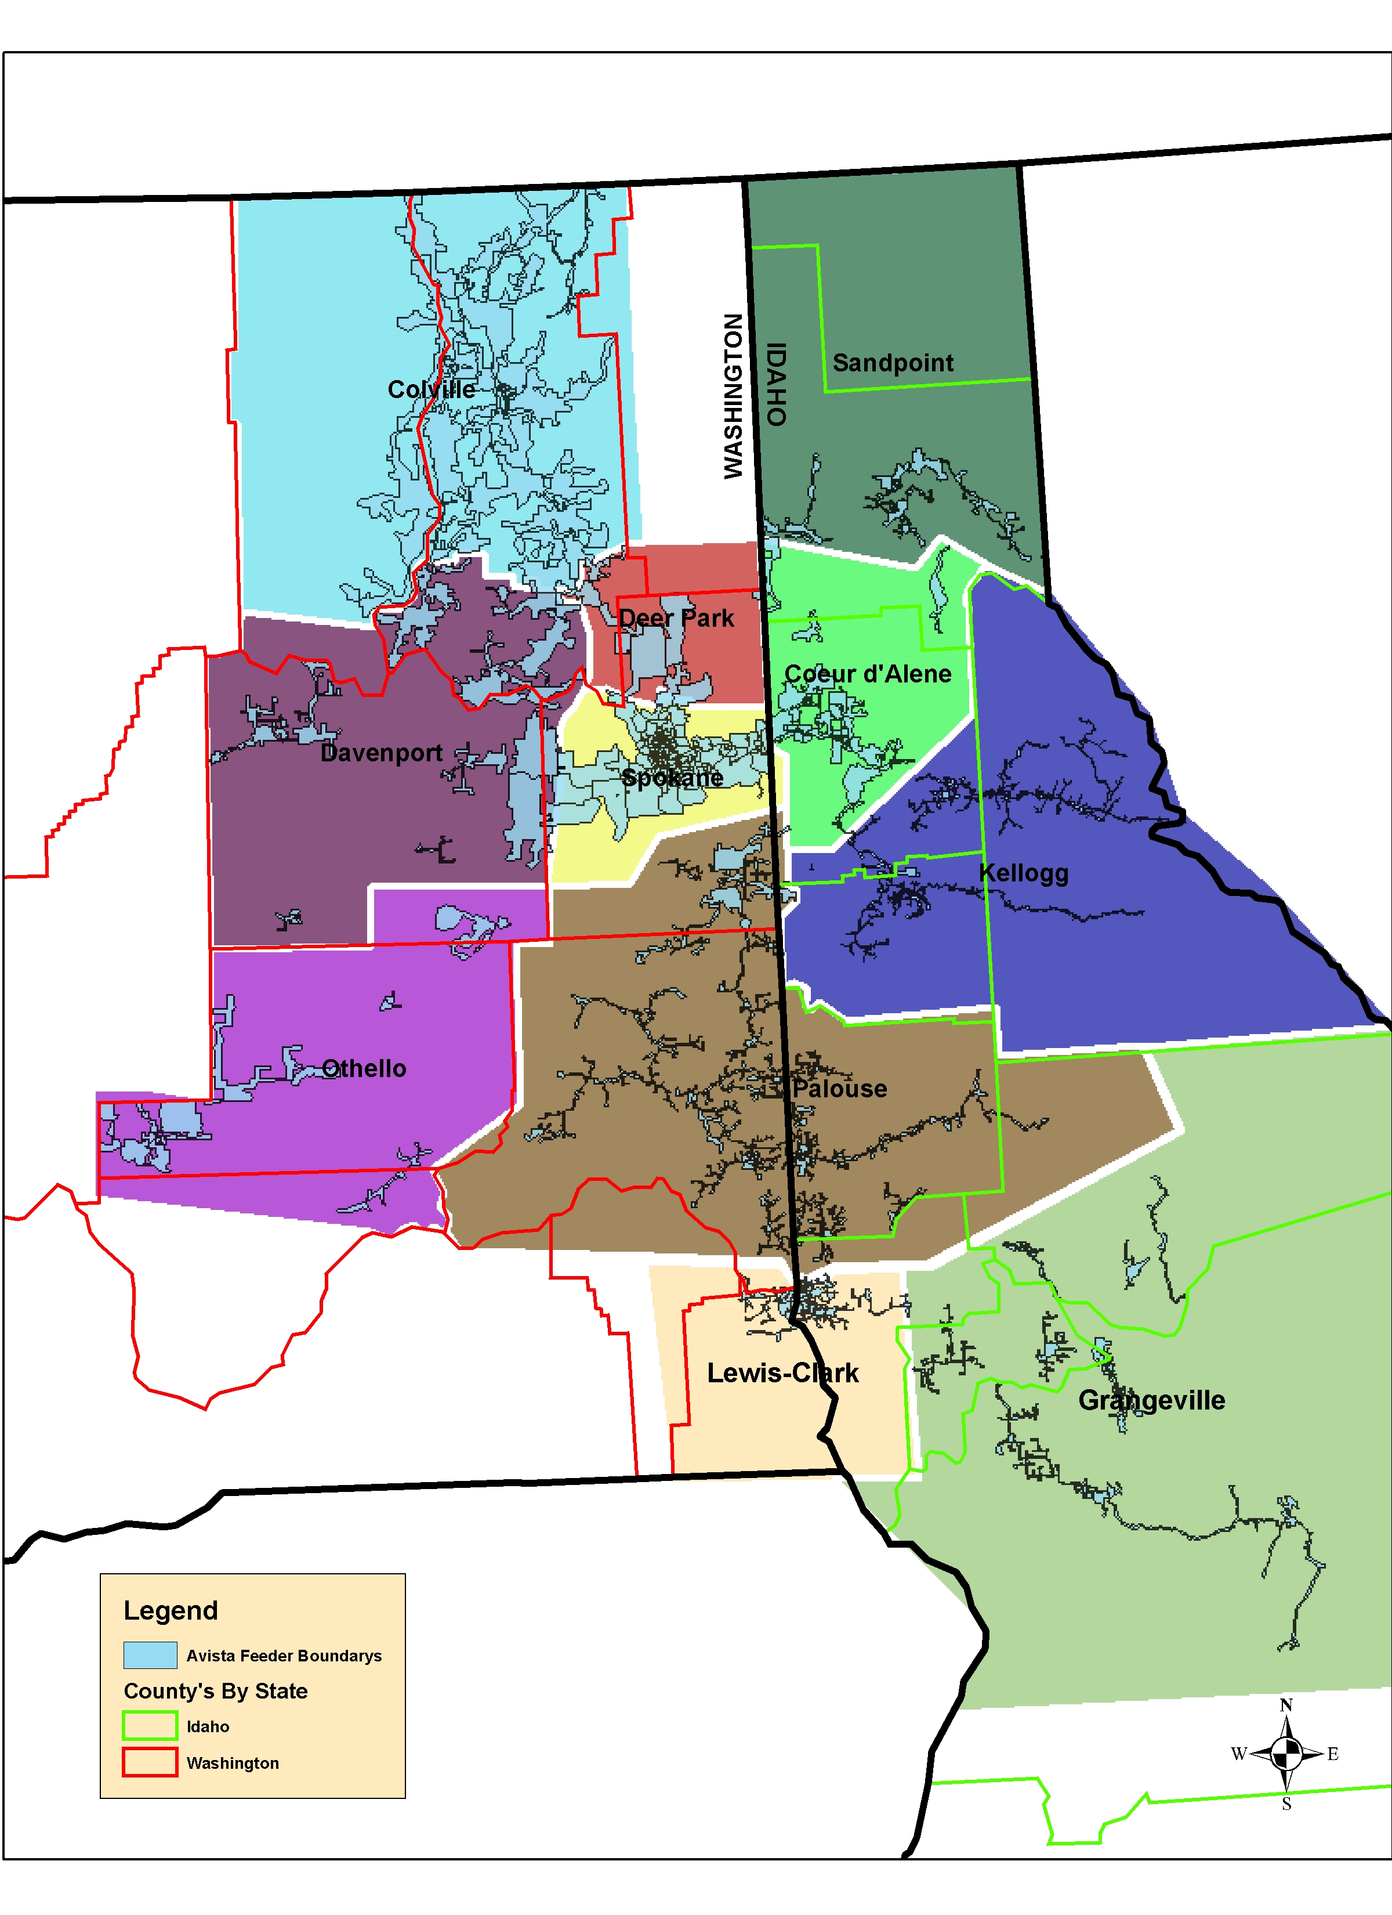
Indices Calculations
Coeur d’Alene –CDC Colville – COC
Davenport – DAC
Deer Park - DPC
Grangeville – GRC
Kellogg – KEC
Lewis-Clark – LCC
Othello – OTC
Palouse – PAC
Sandpoint – SAC
Spokane - SPC

Sustained Interruption
- An interruption lasting longer than 5 minutes.

Momentary Interruption Event
- An interruption lasting 5 minutes or less. The event includes all momentary interruptions occurring within 5 minutes of the first interruption. For example, when an interrupting device operates two, three, or four times and then holds, it is considered a single event.

SAIFI – System Average Interruption Frequency Index
- The average number of sustained interruptions per customer
- = The number of customers which had sustained interruptions
Total number of customers served
- =

MAIFI_{E} – Momentary Average Interruption Event Frequency Index
- The average number of momentary interruption events per customer
- = The number of customers which had momentary interruption events
Total number of customers served
- =
- MAIFI can be calculated by one of two methods. Using the number of momentary interruptions or the number momentary events. This report calculates MAIFI_{E} using momentary events. The event includes all momentary interruptions occurring within 5 minutes of the first interruption. For example, when an automatic interrupting device opens and then recloses two, or three times before it remains closed, it is considered a single event.

SAIDI – System Average Interruption Duration Index
- Average sustained outage time per customer
- = Outage duration multiplied by the customers effected for all sustained interruptions
Total number of customers served
- =

CAIDI – Customer Average Interruption Duration Index
- Average restoration time
- = Outage duration multiplied by the customers effected for all sustained interruptions
The number of customers which had sustained interruptions
- =

Quantities
i = An interruption event;
r_{i} = Restoration time for each interruption event;
T = Total;
ID_{E} = Number of interrupting device events;
N_{i} = Number of interrupted customers for each interruption event during the reporting period;
N_{T} = Total number of customers served for the area being indexed;

CEMI_{n} – Customers Experiencing Multiple Sustained Interruptions more than n.
- CEMI_{n}
- = Total Number of Customers that experience more than n sustained interruptions
Total Number of Customers Served
- = CN_{(k>n)}
N_{T}

CEMSMI_{n} – Customers experiencing multiple sustained interruption and momentary interruption events.
- CEMSMIn
- = Total Number of Customers experiencing more than n interruptions
Total Number of Customers Served
- = CNT_{(k>n)}
N_{T}

MED - Major Event Day
A major event day is a day in which the daily system SAIDI exceeds a threshold value. Its purpose is to allow major events to be studied separately from daily operation, and in the process, to better reveal trends in daily operation that would be hidden by the large statistical effect of major events.

T_{MED} is calculated (taken from the IEEE 1366-2003 Standard)
The major event day identification threshold value, T_{MED}, is calculated at the end of each reporting period (typically one year) for use during the next reporting period as follows:
a) Collect values of daily SAIDI for five sequential years ending on the last day of the last complete reporting period. If fewer than five years of historical data are available, use all available historical data until five years of historical data are available.
b) Only those days that have a SAIDI/Day value will be used to calculate the T_{MED} (do not include days that did not have any interruptions).
c) Take the natural logarithm (ln) of each daily SAIDI value in the data set.
d) Find a (Alpha), the average of the logarithms (also known as the log-average) of the data set.
e) Find b (Beta), the standard deviation of the logarithms (also known as the log-standard deviation) of the data set.
f) Compute the major event day threshold, TMED, using equation (25).

T_{MED} = e^{⟨a+ 2.5 b)} (25)

g) Any day with daily SAIDI greater than the threshold value TMED that occurs during the subsequent reporting period is classified as a major event day. Activities that occur on days classified as major event days should be separately analyzed and reported.

Numbers of Customers Served

The following numbers of customers were based on the customers served at the beginning of the year. These numbers were used to calculate indices for this report.

Table 13.1 – Numbers of Customers Served

Office | Customers | % of Total
Coeur d'Alene | 50662 | 13.9%
Colville | 19258 | 5.3%
Davenport | 5903 | 1.6%
Deer Park | 10738 | 2.9%
Grangeville | 10208 | 2.8%
Kellogg/St. Maries | 14377 | 3.9%
Lewis-Clark | 29536 | 8.1%
Othello | 6750 | 1.8%
Palouse | 38917 | 10.6%
Sandpoint | 14736 | 4.0%
Spokane | 164473 | 45.0%
System Total | 365558

Attachment 1 – SAIDI and SAIFI Historical Summary

See attachment.

Company Contact

For further information regarding this document, please contact:

WUTC Electric Service Reliability Report
Avista Utilities
E. 1411 Mission Avenue
Spokane, WA 99220
(509) 495 - 4580 (phone)
(509) 495 - 4975 (phone)
(509) 495 - 4060 (fax)

