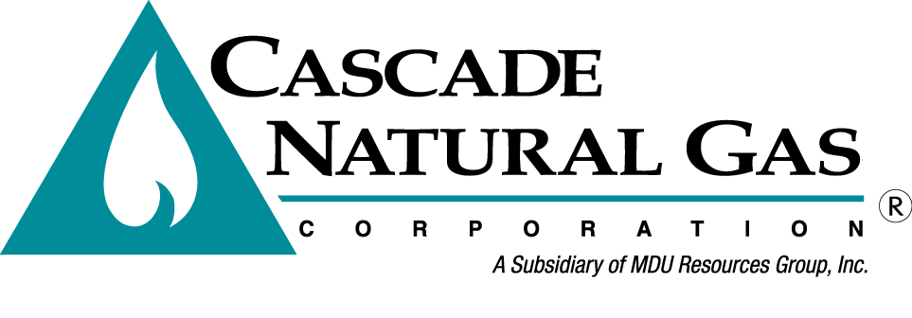
8113 W. GRANDRIDGE BLVD., KENNEWICK, WASHINGTON 99336-7166
TELEPHONE 509-734-4500 FACSIMILE 509-737-9803
www.cngc.com

June 29, 2016

Washington Utilities & Transportation Commission
Mr. Steven King, Executive Director & Secretary
P.O. Box 47250
Olympia, WA 98504-7250

RE: Cascade Natural Gas Corporation 2016 Integrated Resource Plan
(Docket UG-160453)

Dear Mr. King:

Subsequent to recent discussions with Commission Staff in regards to scheduling conflicts, Cascade Natural Gas Corporation respectfully requests a change of date for the 2nd, 3rd, and 5th Integrated Resource Plan (IRP) Technical Advisory Group meetings. We have also corrected the filing date to reflect the correct date as stated in the WUTC’s April 14, 2016 letter to Cascade regarding the 2014 IRP and Work Plan for 2016 IRP.

Attached is the proposed work plan and schedule based on the requested date changes being granted.

If there are any questions regarding this matter, please contact Brian Robertson at (509) 734-4546 or myself at (509) 734-4589. Alternatively, we may be reached at brian.robertson@cngc.com and mark.sellers-vaughn@cngc.com.

Sincerely,
CASCADE NATURAL GAS CORPORATION
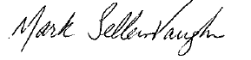
Mark Sellers-Vaughn
Manager, Supply Resource Planning

Enclosures

Date | Process Element | Location (Subject to change)
Thursday, June 09, 2016 | TAG 1 slides distributed to stakeholders
Thursday, June 16, 2016 | TAG 1: Process, Key Assumptions, IRP Team, Timeline, Latest Economic Indicators, Price Forecast and Demand Forecast, Plan for dealing with issues raised in 2014 IRP | Seattle Airport Conference Center
Wednesday, July 13, 2016 | TAG 2 slides distributed to stakeholders
Tuesday, July 19, 2016 | TAG 2: Drilling down into segments of demand forecast, Current Supply Resources, Transport Issues, Alternative Resources, Update on 2 Year Plan | Seattle Airport Conference Center
Wednesday, August 17, 2016 | TAG 3 slides distributed to stakeholders
Tuesday, August 23, 2016 | TAG 3: Conservation, Distribution System Planning, Planned Scenarios and Sensitivities | Cascade Headquarters in Kennewick, WA
Thursday, September 08, 2016 | TAG 4 slides distributed to stakeholders
Thursday, September 15, 2016 | TAG 4: Preliminary Resource Integration Results, Avoided Costs, Proposed new 2 year Plan | Seattle Airport Conference Center
Friday, October 07, 2016 | TAG 5: Final Integration Results, finalization of plan components | Seattle Airport Conference Center
Monday, October 17, 2016 | Draft of 2016 IRP distributed | Kennewick, WebEx
Monday, November 07, 2016 | Comments due on draft from all stakeholders
Thursday, November 17, 2016 | TAG 6, if needed | Seattle Airport Conference Center
Wednesday, November 23, 2016 | Final IRP goes to press
Thursday, December 01, 2016 | Executive Summary Presentation to Senior Management | Kennewick, WebEx
Wednesday, December 14, 2016 | IRP filing in Washington

