January 5th, 2017

Mr. Steven King, Executive Secretary
Washington Utilities and Transportation Commission
1300 South Evergreen Park Drive SW
Olympia, WA 98504-7250

Re: Lifeline Certification Pursuant to WAC 480-07-140(4)
Docket No. UT-170008

Dear Mr. King:

Enclosed is an amended copy of FCC Form 555 for 2016. Please contact me should you require any additional information.

Sincerely,

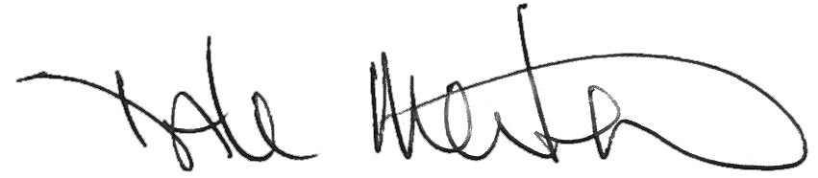

Dale Merten
Chief Operating Officer

