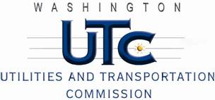

Memorandum
February 3, 2011

To: TR-100687 - File

From: Kathy Hunter, Deputy Assistant Director Transportation Safety

Subject: TR-100687 Cascade and Columbia River Railroad
Grade Crossing Protective Fund (GCPF) Project at the Intersection of
SR-97 and Cascade and Columbia River Railroad’s Tracks in the City of Oroville, Washington

On May 25, 2010, the Washington Utilities and Transportation Commission (Commission) awarded a GCPF grant totaling $6,734 to replace obsolete incandescent lights with LED type lights and cross-bucks at the SR-97 crossing in the City of Oroville. The USDOT number assigned to this crossing is 096383V.

On February 3, 2011, the applicant, Cascade and Columbia River Railroad submitted a request for reimbursement pursuant to Commission order. On January 26, 2011, Commission staff conducted a site visit and verified that the project is completed according to the specifications outlined in the order approving the grant.

Please close this docket.

