Beat It (or Don't): An Update to a Chilly Earnings Season
February 6, 2023 Liz Ann SondersKevin Gordon
In the face of persistent macro headwinds, earnings growth continues to deteriorate, putting the fundamental backdrop for the market at risk.
With fourth-quarter earnings season now in full swing (half of S&P 500 members have reported results at the time of this report's publishing), it's worth taking stock of the outcome thus far. Overall, results continue to skew less impressive, with downward momentum building for the blended growth rate, beat rate, and percentage by which companies are beating estimates. Profits haven't been apocalyptic by any means, but it's worth noting that the bar has been lowered significantly of late—thus making "beats" seem less severe and "misses" that much gloomier.
The latest Refinitiv data show a blended earnings growth rate (already-reported earnings combined with forward estimates of what is still to be reported) of -2.8%, and as has been the case for the past year, the rate drops significantly (to -7%) when excluding the Energy sector. The percentage of companies beating estimates has fallen to 69.3%, down from the average of 76% over the prior four quarters, but above the long-term average (since 1994) of 66%. The "surprise" factor—the percentage by which companies are beating estimates—has fallen to 1.2%. That compares to an average of 5.3% over the prior four quarters and a long-term average (since 1994) of 4.1%.
As shown in the table below, the Energy sector is yet again outpacing its peers with a growth rate of 59.8%, while Communication Services is decisively in last place with a decline of -27.2%. In fact, the latter has the lowest beat rate and surprise factor among all sectors, along with the largest deterioration in consensus estimates for overall growth relative to last April. Conversely, even though earnings growth for Utilities isn't the strongest, the sector currently has the highest beat rate and surprise factor among its peers.

Earnings weakness persists
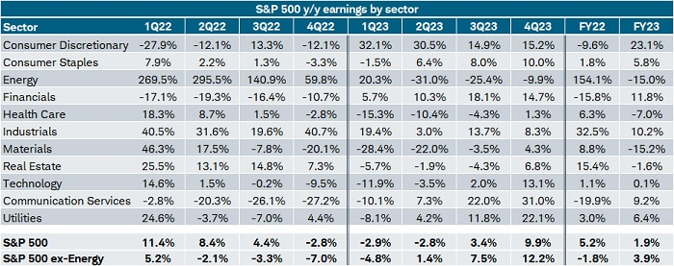
Source: Charles Schwab, I/B/E/S data from Refinitiv, as of 2/6/2023.
Forecasts contained herein are for illustrative purposes only, may be based upon proprietary research and are developed through analysis of historical public data. Past performance is no guarantee of future results.
A closer look at the table's third row shows what looks to be a troubling road ahead for the Energy sector, given estimates for double-digit percentage declines starting in the second quarter of this year. Much of that is due to steep year-over-year comparisons as opposed to a significant deterioration in underlying fundamentals. In fact, Energy is the only sector with a consensus estimate for earnings growth higher today than it was last April. The worst deterioration has been concentrated in large-cap growth sectors like Communication Services, Tech, and Consumer Discretionary (worth noting given they will start to face relatively easy base effects this year).

Surprise party of none
As mentioned, a glaring feature of this earnings season has been an unimpressive showing for the beat rate and surprise factor. Both are shown in the chart below—plotted on different axes—to underscore not only how swiftly they've fallen, but that they're at risk of falling further into recessionary territory. In fact, the current surprise factor of 1.2% is the lowest since the fourth quarter of 2008. We're nowhere near the drop seen back then (-55.4%), but it's still worth noting given the bounce back during the pandemic has been completely reversed.

Pandemic beat boom over
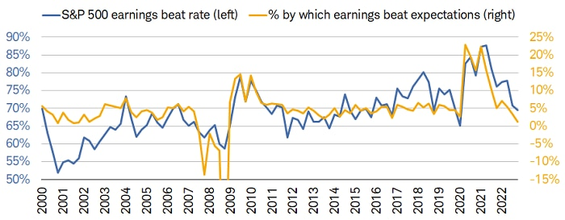
Source: Charles Schwab, I/B/E/S data from Refinitiv, as of 2/6/2023.
Right y-axis truncated for visual purposes.
We've been vocal—particularly, over the past couple quarters—about the risk that earnings present to the market moving forward, namely because analysts (up until now) have been quite slow to cut forward estimates. As shown in the chart below, it wasn't until the end of 2022 that estimates for the first half of this year fell sharply. The upside is analysts are adjusting to reality in the near term, but the downside is they are likely still too optimistic looking further out—evidenced by the relatively sanguine outlook for the fourth quarter of 2023.

Pace of downward revisions accelerates
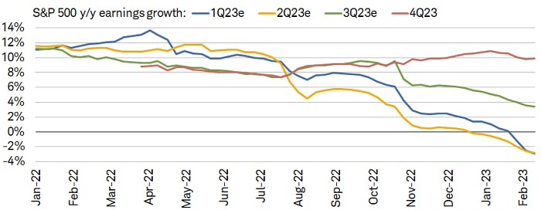
Source: Charles Schwab, I/B/E/S data from Refinitiv, as of 2/6/2023.
Forecasts contained herein are for illustrative purposes only, may be based upon proprietary research and are developed through analysis of historical public data.

Maybe next year
Upping the pace of negative revisions in the first half of the year has brought estimates for calendar year (CY) 2023 earnings down quite rapidly. As shown in the chart below, the consensus estimate for the overall dollar amount of earnings this year has fallen to $224, down markedly from the peak of $252 and relatively close to CY 2022's $219.

2023 estimates down sharply
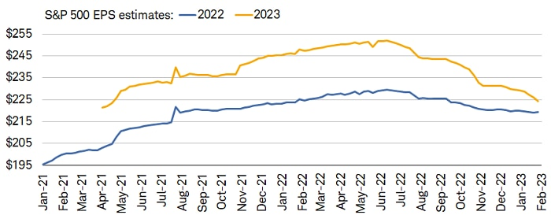
Source: Charles Schwab, I/B/E/S data from Refinitiv, as of 2/6/2023.
Forecasts contained herein are for illustrative purposes only, may be based upon proprietary research and are developed through analysis of historical public data.
As is implied by the chart above, estimates still point to positive earnings growth by the end of this year, which we think is unlikely. Not only does the downward momentum in revisions give little support for a pop in growth this year, but there are several macro headwinds keeping pressure on profits. The lagged impact of tighter monetary policy is still working through the economy and input costs remain high for many segments of the market; in the face of decelerating growth, that continues to weigh on productivity.
Not only that, but leading economic indicators continue to show increasingly less support (if any at all) for earnings growth. To wit:
- The Leading Economic Index (LEI) from The Conference Board is contracting by -6% year-over-year and has fallen on a month-over-month basis for 10 consecutive months (a streak only seen during recessions).
- The ISM Manufacturing Index's new orders component has fallen further into contraction and is at its lowest since the pandemic began.
- Rapid disinflation on the goods side of the economy is sending a worrisome signal for revenue and profits, especially given S&P revenue growth in 2022 was mostly due to high inflation (unit growth was mediocre).
- Homebuilder sentiment—though ticking up slightly of late—remains far from its peak and has collapsed at a rate only seen during recessions.

In sum
There are indeed likely brighter days ahead for earnings and the stock market's trajectory, but we need to see confirmation from leading indicators (those listed above among them) that growth is turning a healthy corner before asserting high conviction that risk assets are out of the woods. Of course, in the eyes of the Federal Reserve, an eventual bounce in growth must happen without a worrisome resurgence in inflationary pressures. If that isn't the case, the case for a hard landing strengthens considerably.
We continue to think the economy will suffer from rolling recessions, evidenced by the fact that corporate earnings growth is now entering its downturn (nearly a full year after housing entered its own recession). With a shrinking number of companies maintaining strength on the bottom line, investors should keep their focus on segments of the market that are high-quality in nature—namely, those with positive earnings revisions, healthy profit margins, and strong balance sheets.

