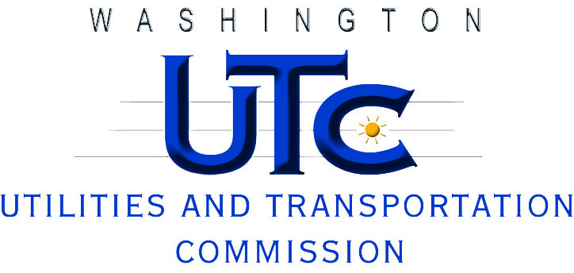

Investigation Report
Ivan Ratko DBA
Best Moving & Delivery

TV-110977

Rayne Pearson
Compliance Investigations

December 2011

