July 3rd, 2017

Mr. Steven V. King, Executive Secretary
Washington Utilities and Transportation Commission
1300 South Evergreen Park Drive SW
Olympia, WA 98504-7250

Re: Annual USF Compliance Report
Docket: UT-160947

Dear Mr. King:

Please find enclosed the Companies Annual USF Compliance Report as per WAC 480-123-130

Sincerely,

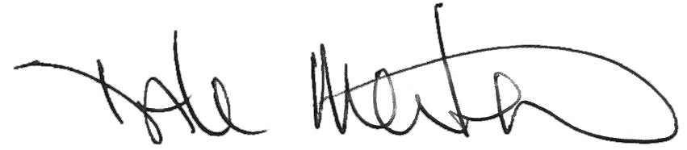

Dale Merten
Vice President

Encl/

