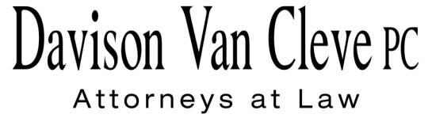
TEL (503) 241-7242 ● FAX (503) 241-8160 ● row@dvclaw.com
Suite 400
333 S.W. Taylor
Portland, OR 97204

November 26, 2014

Via Email and Federal Express

Mr. Steven V. King
Executive Director
Washington Utilities & Transportation Commission
1300 S. Evergreen Pk. Dr. S.W.
P. O. Box 47250
Olympia, WA 98504-7250

Re: The Walla Walla Country Club v. PacifiCorp, d/b/a Pacific Power & Light Company.
Docket No. UE-143932

Dear Mr. King:

Enclosed for filing in the above-referenced docket, please find the original and twelve (12) copies of the Notice of Appearance for The Walla Walla Country Club.

Thank you for your assistance. If you have any questions, please do not hesitate to contact our office.

Sincerely,

/s/ Rainbow Wainright
Rainbow Wainright
Enclosures

cc: Service List

CERTIFICATE OF SERVICE

I hereby certify that I have this day served the attached Notice of Appearance upon all parties in this proceeding by sending a copy via electronic mail and by mailing a copy via First Class U.S. Mail, postage pre-paid, to the following parties at the following addresses.
DATED 26th day of November, 2014.
Davison Van Cleve, P.C.

/s/ Rainbow Wainright
Rainbow Wainright

 | R. BRYCE DALLEY  Vice President, Regulation  PacifiCorp  825 NE Multnomah STE 2000  Portland, OR 97232  bryce.dalley@pacificorp.com | SARAH WALLACE  Senior Counsel  Pacific Power & Light Co.  825 NE Multnomah STE 1800  Portland OR 97232  sarah.wallace@pacificorp.com

