8113 W. GRANDRIDGE BLVD., KENNEWICK, WASHINGTON 99336-7166
TELEPHONE 509-734-4500 FACSIMILE 509-737-9803
www.cngc.com

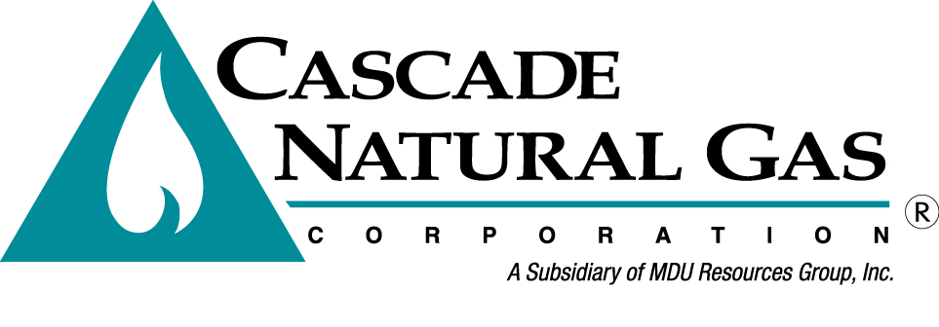
July 9, 2015

Mr. Steven V. King
Executive Director and Secretary
Washington Utilities & Transportation Commission
Post Office Box 47250
Olympia, Washington 98504-7250

Re: Replacement 2014 Affiliated Interest Report

Dear Mr. King:

On April 29, 2015, in accordance with WAC 480-90-264, Cascade Natural Gas Corporation (Cascade or the Company) filed its Affiliated Interest Report (Report) for the 12-month period ending December 31, 2014. The Company identified an error in the original Report and herewith submits a replacement Report.

Any questions regarding this filing may be directed to me at (509) 734-4593.

Sincerely,

Michael Parvinen
Director, Regulatory Affairs

Attachment

