September 6, 2012

David W. Danner, Executive Director and Secretary
Washington Utilities and Transportation Commission
1300 S. Evergreen Park Dr. SW
P. O. Box 47250
Olympia, Washington 98504-7250

RE: Washington Utilities and Transportation Commission v. Yak Communications (America) Inc.
Commission Staff’s Response to Application for Mitigation of Penalties
Docket UT-121025

Dear Mr. Danner:

On August 1, 2012, the Washington Utilities and Transportation Commission issued a $900 Mitigated Penalty Assessment in Docket UT-121025 against Yak Communications (America) Inc. (Yak Communications) for 21 violations of Washington Administrative Code (WAC) 480-120-382, which requires competitively classified telecommunications companies to furnish annual reports to the commission no later than May 1 each year.

On August 14, 2012, Yak Communications wrote the commission requesting mitigation of penalties (Mitigation Request). In its Mitigation Request, Yak Communications does not dispute the violations occurred. The company states, “Company is no longer providing service in Washington due to no volume.”

Yak Communications filed its incomplete annual report on April 30, 2012. The report was missing the company’s income statement and balance sheet. The company filed the income statement and balance sheet on May 25, 2012.

A company that went out of business during the prior year but did not cancel its UTC-issued permit or registration is not required to file an annual report or pay a regulatory fee. According to Yak Communications 2011 annual report information, which was provided by the company itself, Yak Communications had a total gross intrastate operating revenue of $1,894 in 2011. This shows that Yak Communications did provide service in the state of Washington during 2011. Therefore, the company is subject to penalties. If Yak Communications wishes to cease operating in the state of Washington, it must submit a voluntary cancellation form, as required by WAC 480-120-148 and WAC 480-120-083, which notifies the commission it no longer intendeds to retain authority. Yak Communications must notify its customers if it intends to cancel its authority.

It is the company’s responsibility to ensure that the regulatory fee and the annual report are filed by the May 1 deadline. On February 29, 2012, Annual Report forms and Regulatory Fee packets were mailed to all regulated household goods carriers. In addition to other information, the cover letter informed the regulated company it must complete the annual report form, pay any regulatory fees and return the material by May 1, 2012, to avoid enforcement action. The letter also stated a company may file a written request for an extension, however the request must be filed with the UTC by April 24, 2012, and must state a valid reason for why the extension is needed along with the date the report will be filed. The company did not file a request for an extension. On May 15, 2012, the commission mailed a letter to those companies that had not yet filed an annual report notifying them that, to date, they had incurred a penalty of $900. The letter went on to explain that companies who filed their annual reports no later than May 25, 2012, would receive mitigated penalties of $25 per day, with an additional $25 per day for each instance in the previous five years that the company received a penalty for filing a late report.

Yak Communications’ annual report was submitted 24 days past the deadline of May 1, 2012, making the company liable for a penalty of up to $2,400. The commission nevertheless exercised its discretion and assessed a penalty of $900 against Yak Communications, based on the number of business days the company’s filing was late, rather than on the basis of calendar days. The commission, as a courtesy mails each company an annual report form and regulatory fee sheet. Staff believes that the $900 penalty assessed is a reasonable punitive measure to impose for the company’s continued violations of WAC 480-120-382.

Staff does not support mitigating the assessed penalty as the penalty has already been reduced and because Yak Communications has continued violations of WAC 480-120-382.

If you have any questions, please contact Mathew Perkinson, Compliance Investigator, at (360) 664-1105, or at mperkinson@utc.wa.gov.

Sincerely,

Sharon Wallace, Assistant Director
Consumer Protection and Communications

Attachment A

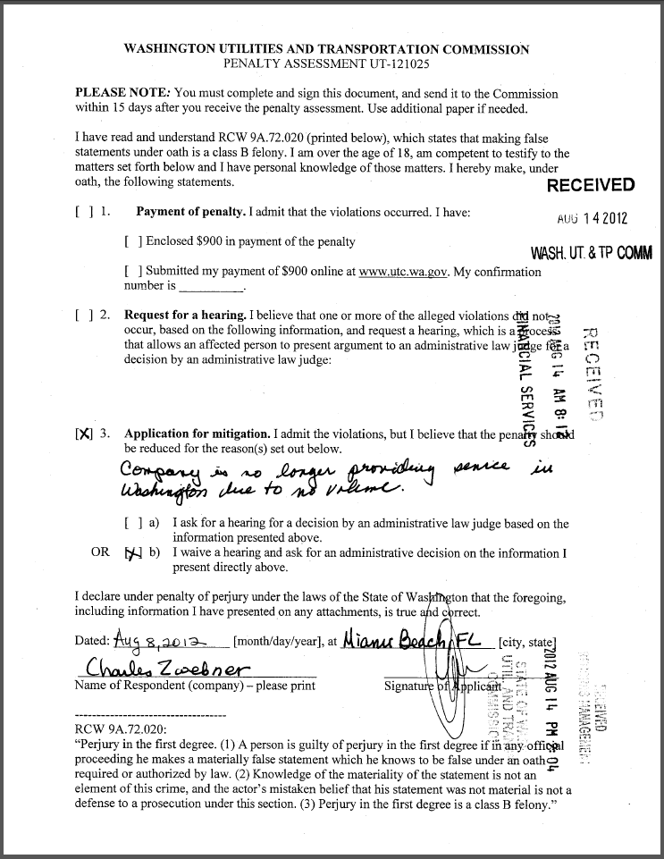

Attachment B

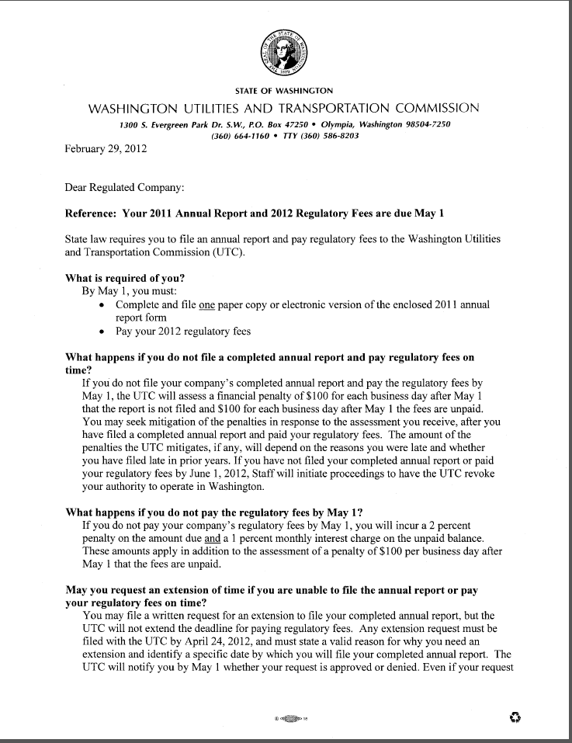
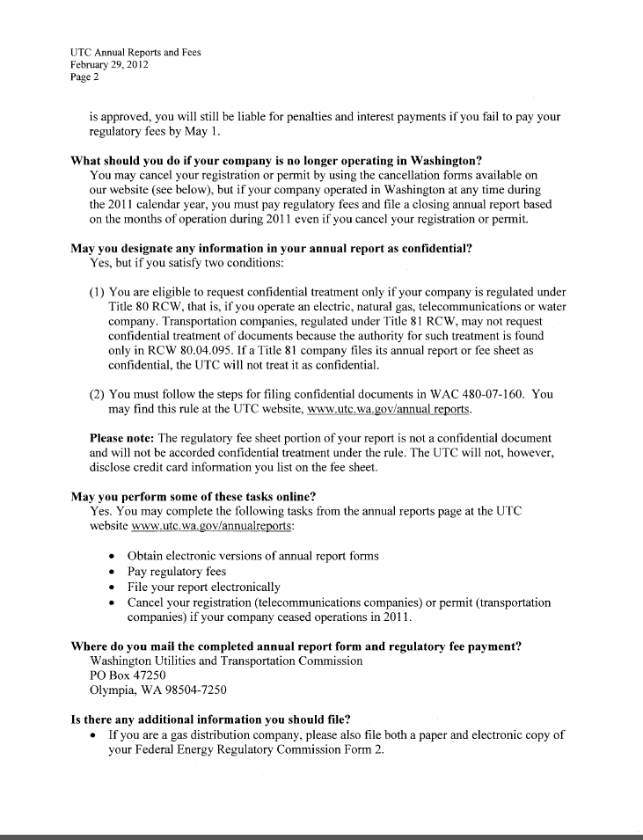
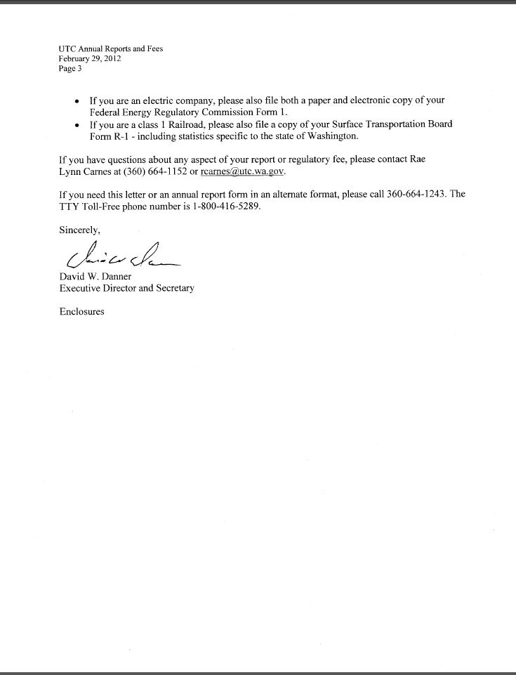

Attachment C
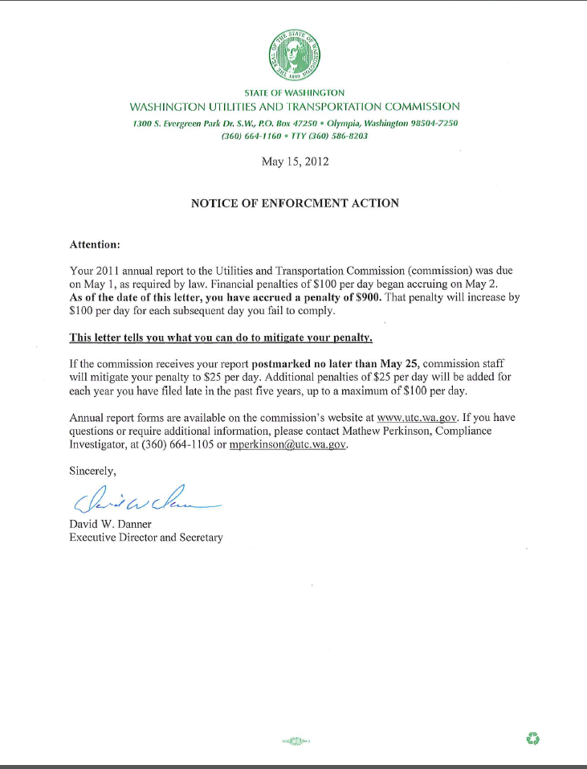

See attachment A for a copy of Yak Communications Mitigation Request received by the commission on August 14, 2012.
See attachment B for a copy of the letter sent to all regulated companies on February 29, 2012.
See attachment C for a copy of the enforcement letter sent to the company on May 15, 2012.

