June 26, 2015

Mr. Steven King
Executive Director and Secretary
Washington Utilities and Transportation Commission
1300 South Evergreen Park Drive SW
Olympia WA 98504-7250

RE: Docket No. UT [Not Yet Assigned]
Adoption of the Interconnection Agreement by and between Ellensburg Telephone Company d/b/a FairPoint Communications and 360 Networks, LLC by CenturyLink Communications, LLC

Dear Mr. King:

In accordance with WAC 480-07-640, attached please find the fully executed Request for Adoption from CenturyLink Communications, LLC to adopt the previously approved Interconnection Agreement between Ellensburg Telephone Company d/b/a FairPoint Communications and 360 Networks (USA), LLC. The original agreement was approved by the Commission on August 15, 2011 in Docket No. UT-113011.

The enclosed Agreement does not discriminate against non-party carriers. It is consistent with state and federal law, and is in the public interest. Ellensburg Telephone Company d/b/a FairPoint Communications respectfully requests that the Commission approve this Adoption.

Please contact me at the number below or at sdavis@fairpoint.com or Beth Westman at 207.535.4249 or bwestman@fairpoint.com with any questions or concerns regarding this filing.

Sincerely,
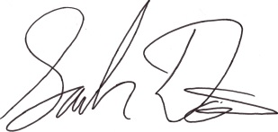
Sarah Davis
Senior Director Government Relations
FairPoint Communications
207.535.4188

