July 1, 2014

Steven V. King, Executive Director and Secretary
Utilities and Transportation Commission
1300 S. Evergreen Park Dr. SW
P.O. Box 47250
Olympia, WA 98504-7250

RE: Washington Utilities and Transportation Commission v. Aloha Joe Movers, LLC

Commission Staff’s Response to Application for Mitigation of Penalties TV-140941

Dear Mr. King:

On June 4, 2014, the Utilities and Transportation Commission issued a $500 Penalty Assessment in Docket TV-140941 against Aloha Joe Movers, LLC for 5 violations of Washington Administrative Code (WAC) 480-15-480, which requires household goods carrier companies to furnish annual reports to the commission no later than May 1 each year.¹

On June 17, 2014, Aloha Joe Movers, LLC wrote the commission requesting mitigation of penalties (Mitigation Request).² In its Mitigation Request, Aloha Joe Movers, LLC does not dispute that the violation occurred. The company provided an unexpected out of country vacation and the reliance of family members to mail the report with no prior late filings as supporting information for the mitigation request.

It is the company’s responsibility to ensure that the regulatory fee is paid and the annual report is filed by the May 1 deadline. On February 28, 2014, Annual Report packets were mailed to all regulated household goods companies. The instructions for annual report completion page of the annual report informed the regulated company that it must complete the annual report form, pay the regulatory fees, and return the materials by May 1, 2014, to avoid enforcement action.

On May 8, 2014, Aloha Joe Movers, LLC. filed the 2013 annual report and paid the required regulatory fees and late payment penalty. The company has been active since September 23, 2004. No previous violations of WAC 480-15-480 are on commission record. Staff supports

UTC Annual Reports
July 1, 2014
Page 2

the company’s request for mitigation as this is the company’s first delinquent filing. Staff recommends a reduced penalty of $25 per day resulting in a total penalty assessment of $125.

If you have any questions regarding this recommendation, please contact Amy Andrews, Regulatory Analyst, at (360) 664-1157, or aandrews@utc.wa.gov.

Sincerely,

Sondra Walsh, Director
Administrative Services

ATTACHMENT A
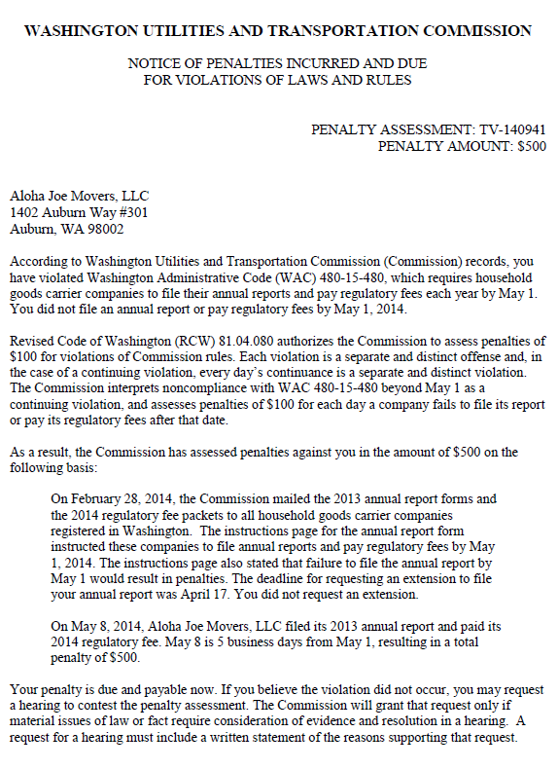

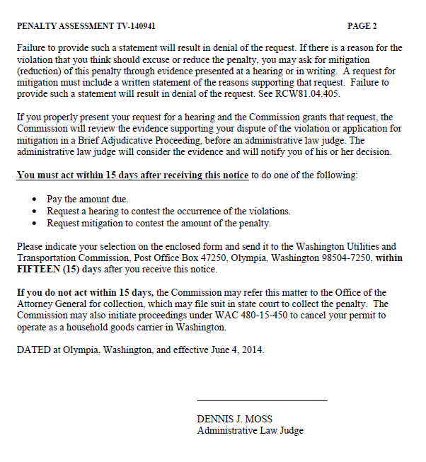

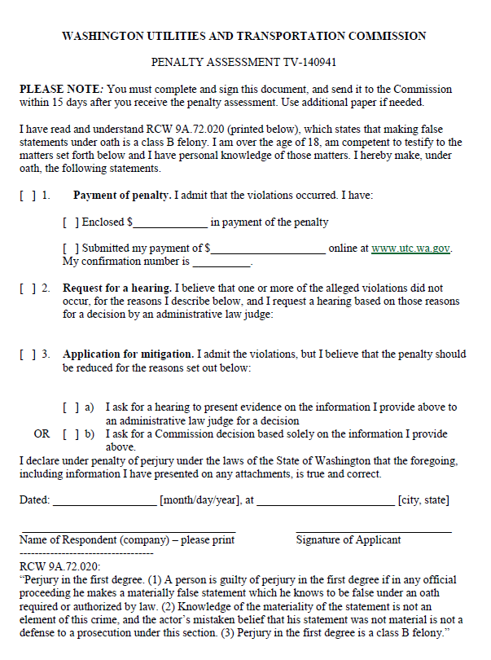

ATTACHMENT B
