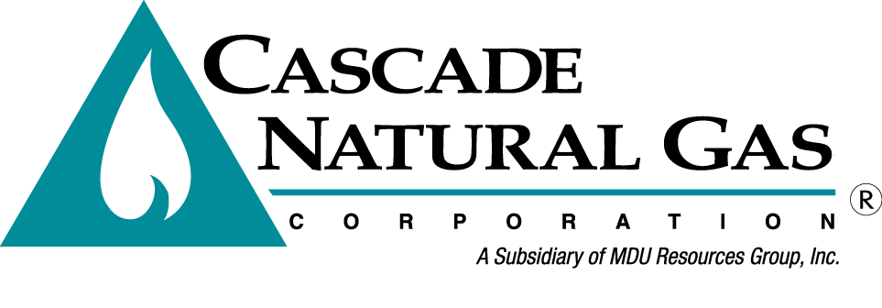 | 8113 W. GRANDRIDGE BLVD., KENNEWICK, WASHINGTON 99336-7166  TELEPHONE 509-734-4500 FACSIMILE 509-737-7166  www.cngc.com
VIA ELECTRONIC MAIL
records@utc.wa.gov

January 16, 2017

Records Center
Washington Utilities and Transportation Commission
1300 S. Evergreen Park Drive SW
Olympia, WA 98504

Re: Tariff Revisions
Advice No. CNGC/W17-01-01

Cascade Natural Gas Corporation (Cascade or the Company) files herewith the revisions to its Tariff WN U-3, stated to become effective with service February 15, 2017:

Fifty-Third Rev. Sheet No. 500-A

The tariff sheet provides for the following changes:

On November 30, 2016, the City of West Richland passed ordinance No. 22-16 Effective January 1, 2017, the gas utility tax percentage being paid to the City will decrease from 8.5% to 6% of the total gross operating revenues.

On December 9, 2016, the Yakima City Council passed ordinance No. 2016-039. Effective February 8, 2017, this ordinance increases the cap from $4,000 per customer per month to $8,000 per customer per month on 4% of the 6% utility tax levied by the City. 2% is still being charged on 100% of the bill.

Cascade Natural Gas is submitting a Less than Statutory Notice (LSN) to request the tariff to become effective on and after February 8, 2017.

The proposed change will affect all customers residing within the city limits of West Richland and Yakima. Cascade estimates that approximately 17,109 residential, 2827 commercial, and 51 industrial customers in total will be impacted by this change.

If you have any questions regarding this report, please contact me at (509) 734-4593.

Sincerely,

Michael Parvinen
Director, Regulatory Affairs

