Agenda Date: February 25, 2016
Item Number: A1

Docket: UG-152394
Company: Avista Corporation

Staff: Christopher Hancock, Regulatory Analyst
Joanna Huang, Regulatory Analyst

Recommendation
Issue an order approving the proposed accounting treatment and change in line extension allowance methodology and approve revisions to Tariff WN U-29, Schedule 151.

Discussion
On October 2, 2014, the commission opened Docket UG-143616 to investigate the need for expanding natural gas distribution infrastructure. Modifications to line extension policies were proposed in two rounds of comments as one way in which to accomplish this goal.

Avista’s filing contains three main elements: a change in the methodology used to calculate line extension allowances; accounting treatment of an excess allowance to customers for the purchase of space and water-heating equipment when the cost of the line extension is less than the value of the line extension allowance; and, a since-retracted request for a limited waiver of WAC 480-90-223(1) concerning utility advertising.

Change in Allowance Methodology
Avista proposes adopting a new methodology for the calculation of line extension allowances. This methodology is known as the Perpetual Net Present Value method. The methodology is reviewed in a paper titled “Line Extensions for Natural Gas: Regulatory Considerations,” by Ken Costello of the National Regulatory Research Institute. Staff supports using this methodology because it produces the maximum line extension allowance that is economically-viable for the company.

A benefit of this methodology is that it simple to calculate, and uses figures that are established by the commission during a rate case. The anticipated revenue from the customer is divided by the authorized rate of return. The resulting figure is the net present value of the customer’s presence on the system, and therefore the financial break-even point at which the company and existing customers are indifferent to the customer’s presence.

A key assumption in this methodology is that the recovery period approaches infinity. Mathematically, this is reasonably approximate to the depreciable life of distribution assets, which are commonly 30 to 50 years. While the notion of an infinite recoverable life may on the surface seem absurd, it is not significantly different than a calculation that uses a standard depreciable life of 30-plus years. The chart below illustrates this point.

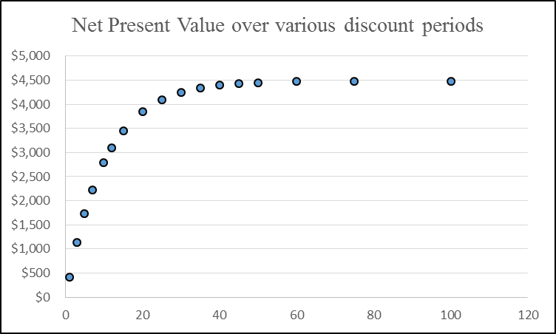

Avista’s current line extension allowance methodology is more arbitrary, and less generous. An average Avista customer currently receives a line extension allowance of $1,920, based on three times an average customer’s contributed revenue of $640 per year. Customers connected under the existing line extension methodology contribute $110 more to the utility than they cost to serve on an annual basis. The change in methodology better ensures that the company is acquiring new customers who will aid in lowering fixed costs recovered from existing customers.

Excess Residential Allowance for Customer Equipment
Avista is proposing a rebate program for existing single-family, Residential Schedule 101 customers that have received a natural gas line extension as part of conversion to natural gas from another fuel source. In cases where the customer’s line extension allowance exceeds the cost of providing the line extension, an “excess allowance” remains. Customers in these circumstances can, within 90 days, apply for a rebate to cover the costs of purchasing and installing high-efficiency natural gas appliances for space-heating and water-heating. The size of the rebate is capped at the size of the excess allowance. This provision ensures that the company does not spend more on acquiring the customer than is economical, and ensures that new customers acquired are not acquired to the detriment of existing customers.

Many customers who will be eligible for this rebate will also be eligible for incentives under the company’s conservation program. Under that program, customers can be eligible for over $3500 in assistance when converting from electric to natural gas services. In these instances, customers will only be eligible for the excess allowance rebate if their costs have not been fully covered by the conservation program, and the total amount of assistance provided to the customer by the company will not exceed the costs of equipment and installation.

The excess allowance rebate will aid in mitigating the switching costs for many customers who are interested in natural gas services.

Proposed Accounting Treatment
Avista seeks to defer the aforementioned excess allowance rebates paid to Washington residential customers upon conversion to natural gas from another fuel source. Deferring these expenses for later recovery is appropriate, given that acquisition of these new customers will aid in lowering costs to existing customers by spreading the burden of fixed costs over a larger user base. The three year period requested for this treatment provides a reasonable timeframe in which to expect the company to file a general rate case, which will serve as an opportunity to review the program.

Limited Waiver of WAC 480-90-223(1)
Avista originally sought waiver of the so-called “advertising rule” in WAC 480-90-223(1). The company now no longer seeks this waiver because it does not believe it is necessary.

Conclusion
Avista’s revised natural gas line extension allowance methodology allows the company to make natural gas service a more viable option to single-family residences in its service territory.

Recommendation
Issue an order approving the proposed accounting treatment and change in line extension allowance methodology and approve revisions to Tariff WN U-29, Schedule 151.

Line Extensions for Natural Gas: Regulatory Considerations, by Ken Costello. February 2013, National Regulatory Research Institute. See page 20.
The anticipated revenue from the customer is found by summing the annual revenues from basic charges and the decoupled revenue per customer, after “backing out” the rate of return component embedded in those figures. The company earns a rate of return on the line extension when the line extension is added to rate base.
The utility’s authorized rate of return is a proxy for the time-value of money to the utility. Future revenue streams are discounted by the rate used (here, the authorized rate of return), and revenues received at dates further out in the future converge towards a value of zero. Put more simply, $100 received today is worth more than $100 received 50 years from today.
“High efficiency” is as defined in the company’s conservation and demand-side management program, similar in standards to the Department of Energy’s Energy STAR program.

