August 5th, 2014

Mr. Steven King, Executive Secretary
Washington Utilities and Transportation Commission
1300 South Evergreen Park Drive SW
Olympia, WA 98504-7250

Re: Request for Certification Pursuant to WAC 480-123-060 and 47 C.F.R. 54.314

Dear Mr. King:

Enclosed is a revised edition to our original filing with information requested by Roger Hahn.

The certifications and reports that are specified in WAC 480-123-060, WAC 480-123-070 and WAC 480-123-080 are enclosed.

Sincerely,

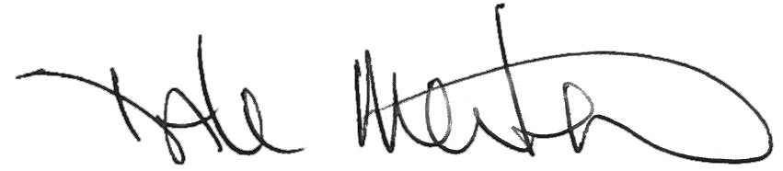

Dale Merten
Chief Operating Officer

