June 10, 2015

Steven V. King, Executive Director and Secretary
Utilities and Transportation Commission
1300 S. Evergreen Park Dr. SW
P.O. Box 47250
Olympia, WA 98504-7250

RE: Washington Utilities and Transportation Commission v. Crown Moving Company, Inc.

Commission Staff’s Response to Application for Mitigation of Penalties TV-150900

Dear Mr. King:

On May 27, 2015, the Utilities and Transportation Commission issued a $1,000 Penalty Assessment in Docket TV-150900 against Crown Moving Company, Inc. for 10 violations of Washington Administrative Code (WAC 480-15-480), which requires household goods carrier companies to furnish annual reports to the commission no later than May 1 each year.

On June 1, 2015, America’s Elite, Inc. wrote the commission requesting mitigation of penalties. In its mitigation request, Crown Moving Company, Inc. does not dispute the violation occurred. The company states, “I have attached an updated annual report that includes all of the requested information. Historically, we have not provided this information. We have noted “statistics not available” and not been penalized. We will provide going forward”.

It is the company’s responsibility to ensure that the regulatory fee is paid and the annual report is filed by the May 1 deadline. On February 27, 2015, Annual Report packets were mailed to all regulated household goods companies. The instructions for annual report completion page of the annual report informed the regulated company that it must complete the annual report form, pay the regulatory fees, and return the materials by May 1, 2015, to avoid enforcement action.

On May 5, 2015, Crown Moving Company, Inc. filed an incomplete 2014 annual report and paid the required regulatory fees. On June 1, 2015, the company filed the required information and the report was considred complete.

¹See Attachment A for a copy of the 2013 Annual Report submitted by Crown Moving Co, Inc.
²See attachment B for a copy of email communications sent on May 7, 2014 and May 9, 2014
UTC Annual Reports
June 10, 2015
Page 2

The mileage and household goods moves information omitted from Schedule 1 of the 2014 report, which resulted in the report being incomplete, was also omitted from the 2013 report¹. However, commission staff contacted the company regarding the 2013 report requiring the information be submitted on May 7, 2014 via email. The company complied on May 9, 2014 via email². During the 2013 reporting year, no penalty was assessed as the commission had previously accepted Crown Moving Company’s report without the mileage data.

Crown Moving Company, Inc. previously missed the deadline for filing its annual report and paying its regulatory fees for the 2012 annual report year. Due to the prior violation of WAC 480-15-480 and prior notification of required mileage and household goods moves data, staff does not support any mitigation.

If you have any questions regarding this recommendation, please contact Amy Andrews, Regulatory Analyst, at (360) 664-1157, or aandrews@utc.wa.gov.

Sincerely,

Sondra Walsh, Director
Administrative Services

ATTACHMENT A

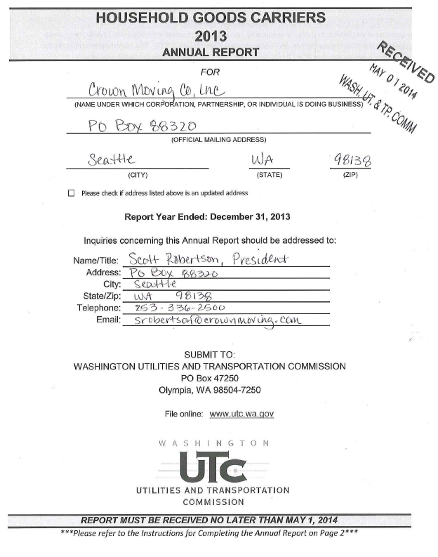

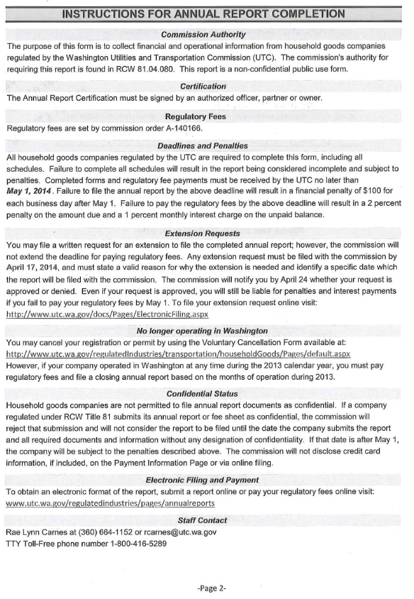
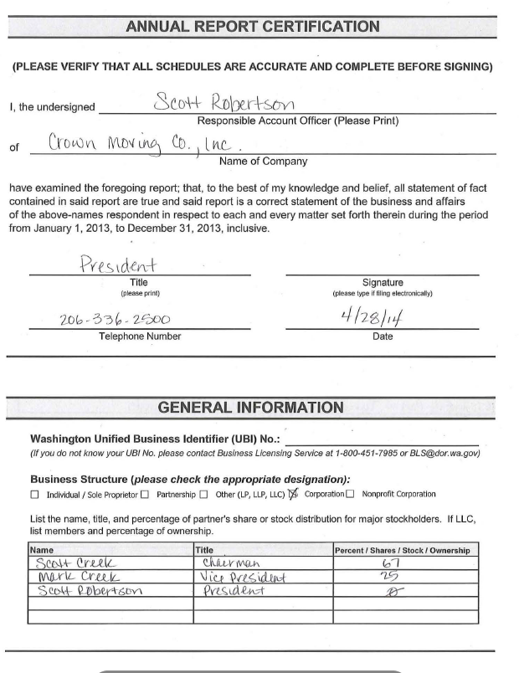

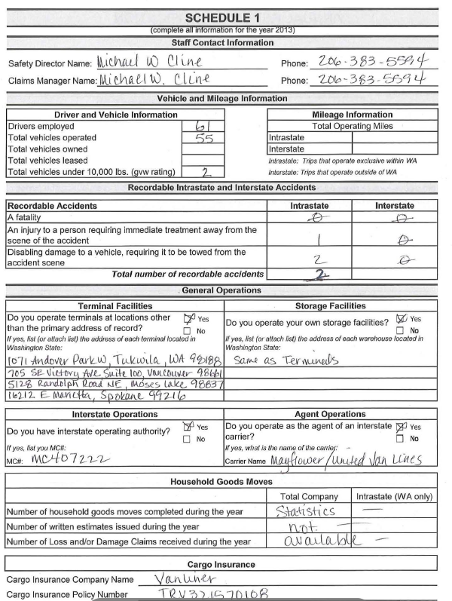

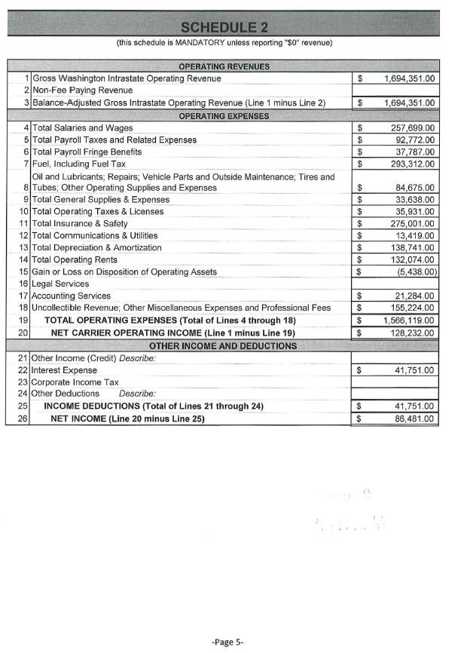
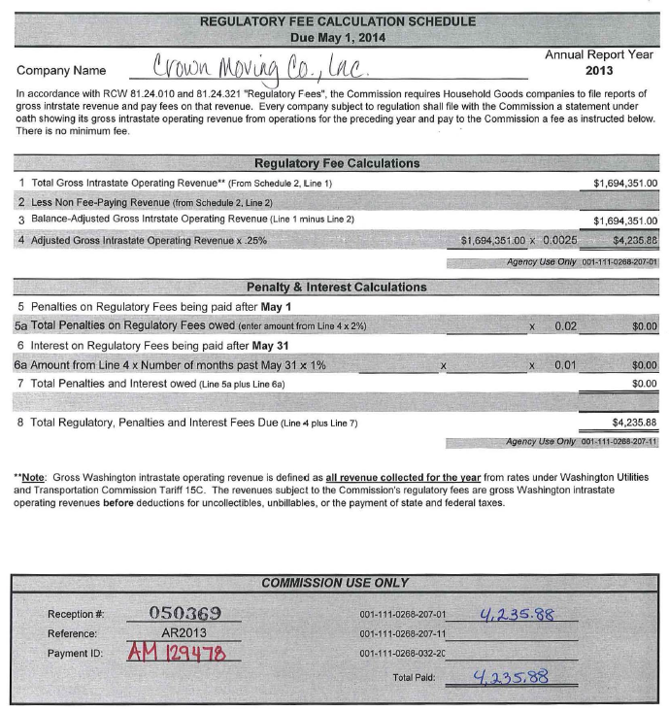

ATTACHMENT B

