June 24, 2014

Steven V. King, Executive Director and Secretary
Utilities and Transportation Commission
1300 S. Evergreen Park Dr. SW
P.O. Box 47250
Olympia, WA 98504-7250

RE: Washington Utilities and Transportation Commission v. Pack’s Delivery LLC

Commission Staff’s Response to Application for Mitigation of Penalties TV-140980

Dear Mr. King:

On June 6, 2014, the Utilities and Transportation Commission issued a $1,000 Penalty Assessment in Docket TV-140980 against Pack’s Delivery LLC for 10 violations of Washington Administrative Code (WAC) 480-15-480, which requires household goods carrier companies to furnish annual reports to the commission no later than May 1 each year.¹

On June 9, 2014, Pack’s Delivery LLC wrote the commission requesting mitigation of penalties (Mitigation Request).² In its Mitigation Request, Pack’s Delivery LLC does not dispute that the violation occurred, nor did the company provide any information for an administrative law judge to consider.

It is the company’s responsibility to ensure that the regulatory fee is paid and the annual report is filed by the May 1 deadline. On February 28, 2014, Annual Report packets were mailed to all regulated household goods companies. The instructions for annual report completion page of the annual report informed the regulated company that it must complete the annual report form, pay the regulatory fees, and return the materials by May 1, 2014, to avoid enforcement action.

On June 9, 2014, Pack’s Delivery LLC filed the 2013 annual report, paid the required regulatory fees and late payment penalty. The company has been active since July 22, 2013 and the household goods permit was voluntarily canceled per Docket TV-141302. No previous violations of WAC 480-15-480 are on commission record. Staff supports the company’s request

UTC Annual Reports
June 24, 2014
Page 2

for mitigation despite the written statement not being provided as required in the mitigation request. Staff recommends to waive the penalty based solely on the company filing the 2013 annual report for its partial year in operation, paying the required fees and canceling the household goods operating permit.

If you have any questions regarding this recommendation, please contact Amy Andrews, Regulatory Analyst, at (360) 664-1157, or aandrews@utc.wa.gov.

Sincerely,

Sondra Walsh, Director
Administrative Services

ATTACHMENT A
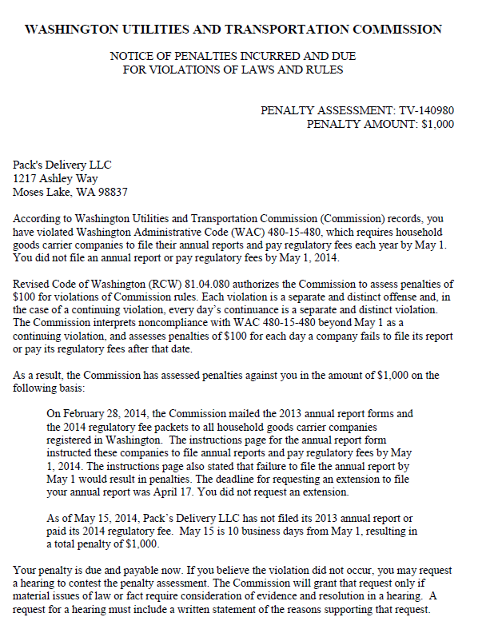

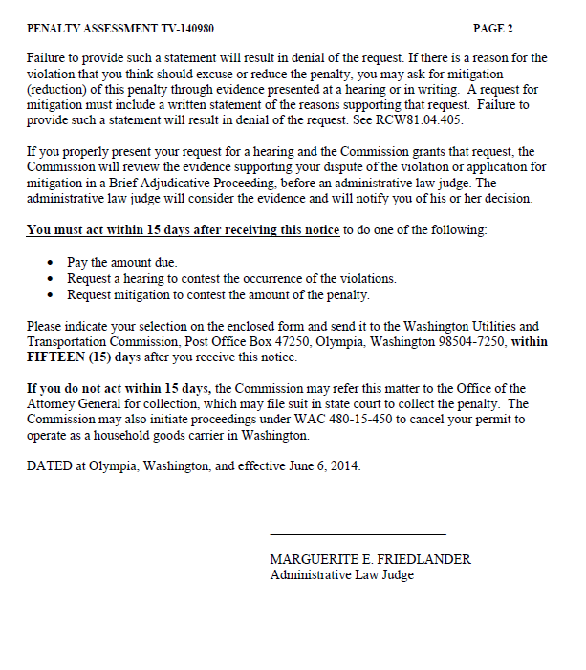

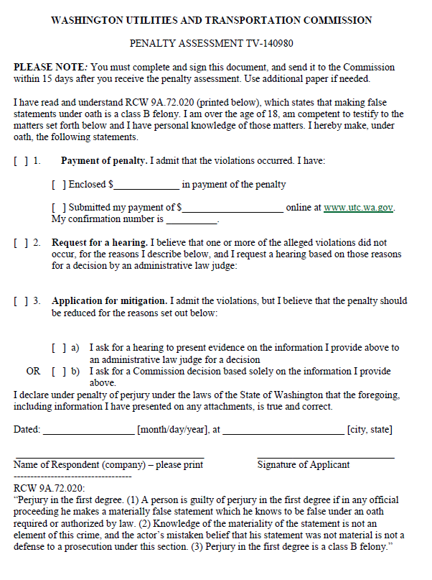

ATTACHMENT B
