January 31, 2017

Mr. Steven King
Executive Director and Secretary
Washington Utilities and Transportation Commission
1300 South Evergreen Park Drive SW
Olympia WA 98504-7250

RE: Annual Lifeline Certification – Form 555; Docket UT-170008

Attached please find a copy of the Annual Lifeline Eligible Telecommunications Carrier Certification Form (FCC Form 555) for YCOM Networks, Inc. d/b/a FairPoint Communications, which was filed with the Universal Service Administrative Company as well as with the Federal Communications Commission.

Please contact Beth Westman at 207.535.4249 or bwestman@fairpoint.com with any questions or concerns regarding this filing.

Sincerely,
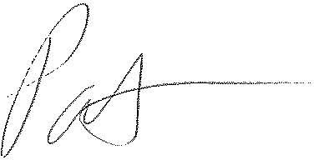
Patrick L. Morse
Senior VP Governmental Affairs
FairPoint Communications
P: 620-227-4409
F: 620-227-8576

