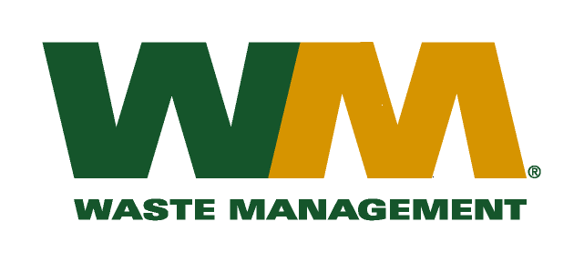
October 21, 2009
Washington Utilities and Transportation Commission
Chandler Plaza Building
1300 S. Evergreen Park Drive SW
P.O. Box 47250
Olympia, WA. 98504-7250

Dear Sirs:
Subject: Waste Management of Ellensburg Docket TG-091472
Please find enclosed substitute tariff pages 21, 22, 23, 29, 30 and 31 to Waste Management of Ellensburg Tariff No. 11. Waste Management of Ellensburg is a division of Waste Management of Washington, Inc. (G-237). These pages are being submitted in accordance with Staff recommendations. Please do not re-docket.

If you have any questions or need additional information, please contact me at (425) 814-7840.
Respectfully,

Michael A. Weinstein
Senior Pricing Manager, Pacific Northwest Market Area

cc: J.R. Lesure
Joe Krukowski

