CERTIFICATION

I am Vice President – Regulatory Operations for CenturyLink. I hereby certify that I have overall responsibility for supervision of the personnel who prepare all of the data supporting the CenturyLink Operating Companies– July 1, 2017 Annual Access Charge Tariff Filing bearing Tariff F.C.C. Nos. 1, 2, 3, 6, 7, 8, 9 and 11 for all issuing carriers and that I am authorized to execute this certification. Based upon the information provided to me by employees responsible for the preparation of, or for the supervision of the preparation of, the data submitted in support of the Tariff Review Plan information contained herewith, I hereby certify that the data has been examined and reviewed and is true, correct and complete to the best of my knowledge and belief.

Further, based upon the information provided to me by employees responsible for the preparation of, or for the supervision of the preparation of, the data submitted in support of the Eligible Recovery for Price Cap Carriers and Access Recovery Charge information contained herewith, I hereby certify that the data has been examined and reviewed and is true, correct and complete to the best of my knowledge and belief, that the CenturyLink Operating Companies are not seeking duplicative recovery in the state jurisdiction for any Eligible Recovery subject to the recovery mechanism, and that CenturyLink Operating Companies have complied with sections 51.915(d), 51.915(e) and 51.915(f) of the Commission's rules.

May 22, 2017

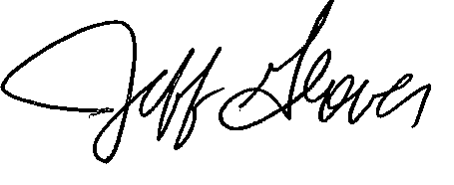

Jeff Glover
Vice President – Regulatory Operations

Contact Person: Gary Kepley
Director, Regulatory Operations
Telephone Number: (913) 353-7080

