Bench Request No. 8: Staff: With regard to Christopher H. Hancock’s exhibits, CSH-2 at page 10, column 4.01 and CSH-3 at page 9, column 4.01:
1. Please provide a breakdown of the referenced adjustments to show in individual columns the net operating income, rate base, and revenue requirement impacts of each planned capital project recommended by Staff. Please provide the responses based on end-of-period (EOP) and average-of-monthly averages (AMA) balances.
2. Please provide the comparable unadjusted values of the planned capital projects as proposed by the Company.
Please provide the responses in printed and electronic spreadsheet format with all formulas and links intact.
Response:
- AMA and EOP are two methodologies for determining the rate base balance during the test year; as these are out-of-period additions to rate base, AMA and EOP methodologies are not applicable. However, the net operating income, rate base, and revenue requirement impacts of the 14 major projects Staff included into rate base during calendar year 2015 are displayed below, for electric (CSH-2) and natural gas (CSH-3) service, respectively. Additionally, electronic copies are provided:
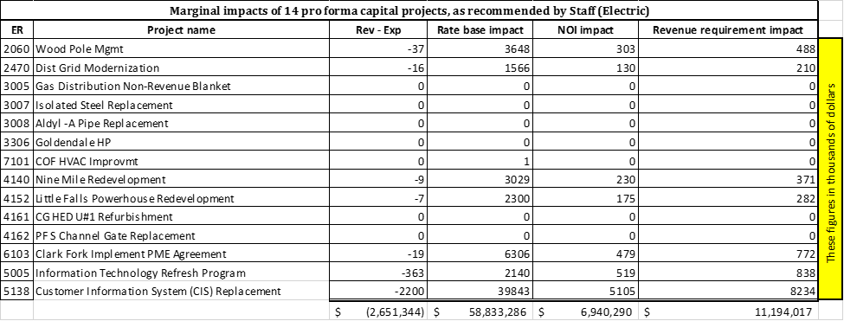

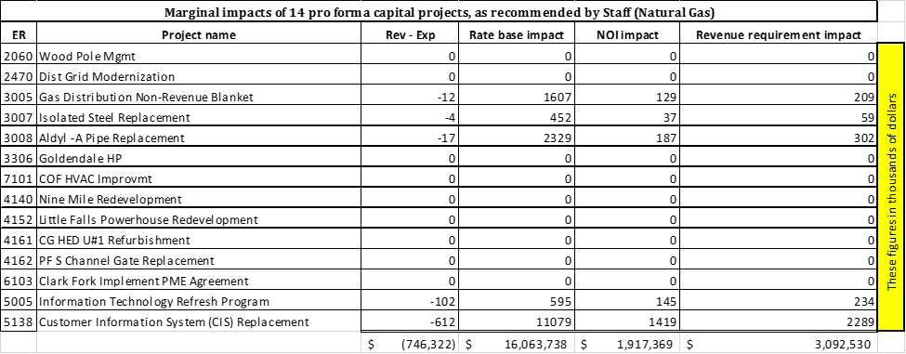

- The same 14 projects are listed below, using the 2015 planned capital addition figures the Company provided in its initial filing. Additionally for each capital project, the difference between the revenue requirement impacts (in thousands of dollars) in Staff’s case and in the Company’s case is reflected in the rightmost column:
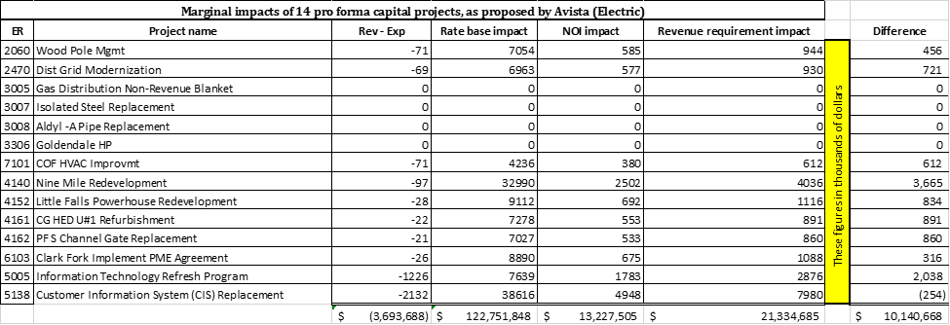

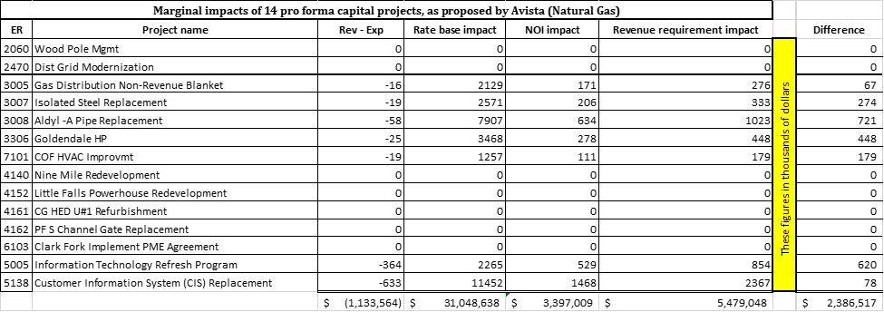
Bench Request No. 9: Staff: Please provide work papers in electronic format (Excel) with formulas intact, supporting all contested adjustments in Christopher H. Hancock’s exhibits, Exh. Nos. CSH-2 and CSH-3.
Response:
These work papers are provided in electronic format only.

