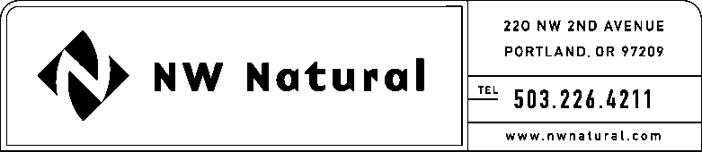

ONITA R. KING
Rates & Regulation
Tel: 503.721.2452
Fax: 503.721.2516
Email: ork@nwnatural.com

March 12, 2015

VIA ELECTRONIC FILING

Steven V. King, Executive Director and Secretary
WASHINGTON UTILITIES &
TRANSPORTATION COMMISSION
1300 S Evergreen Park Drive, SW

Post Office Box 47250
Olympia, Washington 98504-7250

Re: UG-150409 / NWN WUTC Advice No. 15-02 – General Rule 3: Deposits

Northwest Natural Gas Company, dba NW Natural (“NW Natural” or the “Company”), respectfully request that the effective date of the above-referenced advice filing be extended to May 15, 2015. Following discussions with Staff it was determined that additional review time is needed.

Sincerely,

NW NATURAL

/s/ Onita King

Onita R. King
Rates and Regulation

