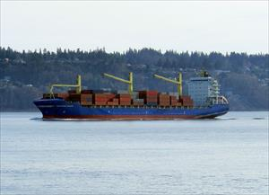
- WESTWOOD FRASER

https://www.marinetraffic.com/en/ais/details/ships/shipid:3774976/mmsi:-9226073/imo:9226073/vessel:WESTWOOD_FRASER

ADD TO FLEET
CREATE NOTIFICATIONS
Voyage Information
UNLOCK VOYAGE INFORMATION
PAST TRACK
ROUTE FORECAST

Reported ETA: -
Calculated ETA:
••••••••••
Calculated ETA at:
••••••••••
Predictive ETD:
••••••••••
Reported Destination: -

Distance Travelled:
••••••••••
Distance to Go:
••••••••••
Total Voyage Distance:
••••••••••
Time to Destination:
••••••••••

Draught (Reported/Max): - /
••••••••••
Load Condition:
••••••••••
Speed recorded (Max / Average): - / -

EVENTS TIMELINEPOSITION HISTORY
Reported Destination and ETA Received 2015-11-29 01:08
Summary
Where is the ship?
General Cargo WESTWOOD FRASER is currently located at unknown area at position 0° 0' 0" N, 0° 0' 0" E as reported by MarineTraffic Terrestrial Automatic Identification System on (****)

What kind of ship is this?
WESTWOOD FRASER (IMO: 9226073) is a General Cargo .
It’s carrying capacity is 45000 t DWT and her current draught is reported to be null meters. Her length overall (LOA) is 199.9 meters and her width is 32 meters.
Vessel Information
General
IMO: 9226073
Name: WESTWOOD FRASER
Vessel Type - Generic: Cargo
Vessel Type - Detailed: General Cargo
Status: Cancelled order
MMSI: -
Call Sign: -
Flag: -
Gross Tonnage: 31772
Summer DWT: 45000 t
Length Overall x Breadth Extreme: 199.9 x 32 m
Year Built: -
Home Port: -
Classification Society:
••••••••••
Builder:
••••••••••
Owner:
••••••••••
Manager:
••••••••••

