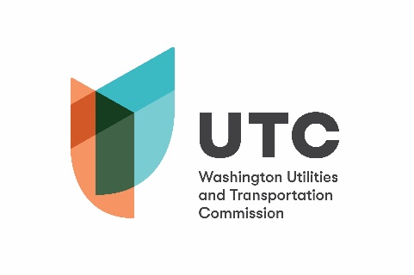

Memorandum
Jun. 27, 2019

To: File

From: Betty Young, Rail Safety Program Advisor

Subject: TR-170060 – Snohomish County
Completion of Grade Crossing Protective Fund (GCPF) Project
48th Ave. NW – USDOT 084683A

On Mar. 8, 2017, the Washington Utilities and Transportation Commission (UTC) awarded a GCPF grant totaling $262,693 to Snohomish County (County) for a project related to installing active warning devices at the 48th Ave. NW crossing (USDOT 084683A). On Aug. 15, 2018, the County requested an additional $218,101 in funds, due to an increase in the costs of the project. The UTC approved a revised grant amount of $480,794 on Aug. 16, 2018. The actual cost of the project was $438,174.51.

This crossing was identified in the 2014 Marine and Rail Oil Transportation Study as an under-protected crossing on an oil route and was funded through a $1.1 million GCPF appropriation.

On Jun. 26, 2019, the County submitted a request for reimbursement. Rail Safety staff inspected the crossing on Jun. 12 and confirmed that the installation was completed according to the specifications outlined in the order approving the grant.

Please close this docket.

