July 7, 2014

Steven V. King, Executive Director and Secretary
Utilities and Transportation Commission
1300 S. Evergreen Park Dr. SW
P.O. Box 47250
Olympia, WA 98504-7250

RE: Washington Utilities and Transportation Commission v. Exponential Communications, LLC

Commission Staff’s Response to Application for Mitigation of Penalties UT-140884

Dear Mr. King:

On May 29, 2014, the Utilities and Transportation Commission issued a $1,000 Penalty Assessment in Docket UT-140884 against Exponential Communications, LLC. for 10 violations of Washington Administrative Code (WAC) 480-120-382, which requires telecommunications companies to furnish annual reports to the commission no later than May 1 each year.¹

On June 20, 2014, Exponential Communications, LLC wrote the commission requesting mitigation of penalties (Mitigation Request).² In its Mitigation Request, Exponential Communications, LLC does not dispute that the violation occurred. The company states, “I’m an unprofitable (since inception in 2009) small business run solely by me (owner). As of this date, I have not filed my report, which will further increase my penalty. Obviously, I can’t make a living out of this so I do have a day job to take care of. Thanks for your consideration. Also, I’ve closed operations as Dec. 31, 2013.

It is the company’s responsibility to ensure that the regulatory fee is paid and the annual report is filed by the May 1 deadline. On February 28, 2014, Annual Report packets were mailed to all regulated telecommunication companies. The instructions for annual report completion page of
the annual report informed the regulated company that it must complete the annual report form, pay the regulatory fees, and return the materials by May 1, 2014, to avoid enforcement action.

UTC Annual Reports
July 7, 2014
Page 2

As of June 30, 2014, Exponential Communications, LLC has not filed its complete annual report are paid any regulatory fees due. The company has been active since September 22, 2008. Exponential Communications, LLC was previously delinquent in filing the 2011 annual report. The company has not requested to voluntarily cancel their registration to date. Staff does not support the company’s request for mitigation due to the prior filing violation and failure to cancel the registration.

If you have any questions regarding this recommendation, please contact Amy Andrews, Regulatory Analyst, at (360) 664-1157, or aandrews@utc.wa.gov.

Sincerely,

Sondra Walsh, Director
Administrative Services

ATTACHMENT A
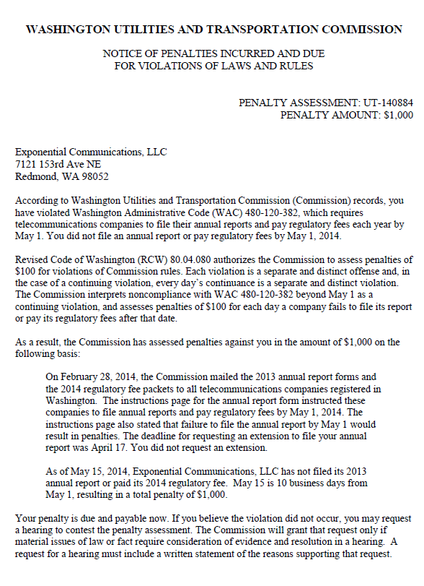

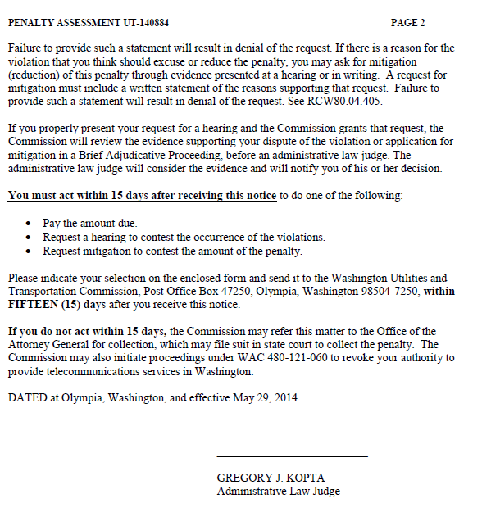

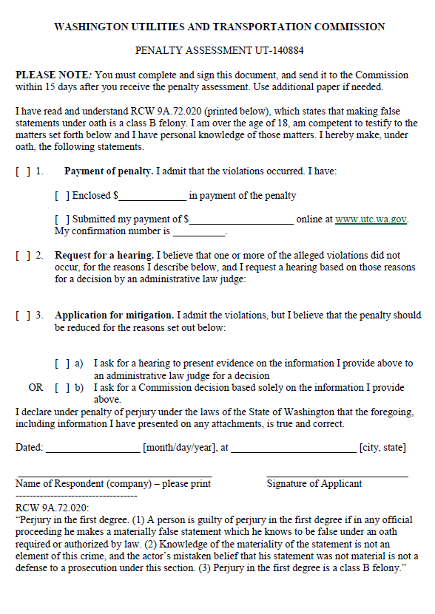

ATTACHMENT B
