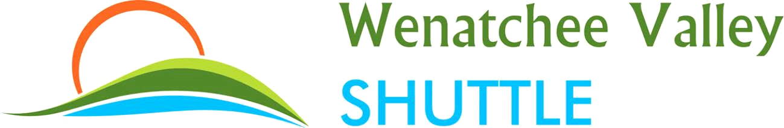
PUBLIC NOTICE February 28, 2017
Fare Increase
EFFECTIVE March 31, 2017
************************************************************************
Wenatchee to/from Quincy or Ephrata, Ritzville to/from Moses Lake, Ephrata or Quincy
Current fare: $18.46 one way/$31.92 round trip Proposed fare: $22.50 one way/$40 round trip
************************************************************************
Wenatchee to/from Moses Lake or Ritzville
Current fare: $27.68 one way/$50.36 round trip Proposed fare: $32.50 one way/$60 round trip
************************************************************************
Moses Lake or Ritzville to/from Spokane International Airport or River Park Square
Current fare: $32.30 one way/$59.60 round trip Proposed fare: $37.50 one way/$70 round trip
***********************************************************************
Wenatchee or Peshastin to/from North Bend, Bellevue or Sea-Tac Airport
Wenatchee, Pangborn Memorial Airport, Quincy or Ephrata to/from Spokane International Airport or River Park Square
Current fare: $41.52 one way/$78.04 round trip Proposed fare: $47.50 one way/$90 round trip
***********************************************************************
Quincy or Ephrata to/from North Bend, Bellevue or Sea-Tac Airport
Current fare: $59.98 one way/$114.96 round trip Proposed fare: $67.50 one way/$130 round trip
***********************************************************************
Moses Lake to/from North Bend, Bellevue or Sea-Tac Airport
Current fare: $69.20 one way/$133.40 round trip Proposed fare: $77.50 one way/$150 round trip
************************************************************************
https://www.wenatcheevalleyshuttle.com/fares HYPERLINK "https://www.wenatcheevalleyshuttle.com/fares"
If you have specific questions or need additional information about our proposed fare increase call us at 509-293-5773, stop by our office located at 400 S Wenatchee Avenue, Wenatchee, WA 98801 or mail us at Wenatchee Valley Shuttle, P.O. Box 1725, Wenatchee, WA 98807.
******************************************************************************
The Utilities and Transportation Commission regulates the rates and services offered by BML Investments LLC dba Wenatchee Valley Shuttle. If you would like to submit comments or oppose the proposed fare increase contact the commission at HYPERLINK "http://www.utc.wa.gov/"www.utc.wa.gov HYPERLINK "http://www.utc.wa.gov/" HYPERLINK "http://www.utc.wa.gov/"and click “Submit a Comment,” or by one of the following options:
Washington Utilities and Transportation Commission 1300 S. Evergreen Park Drive SW P.O. Box 47250, Olympia, WA 98504-7250 E-mail: comments@utc.wa.gov Telephone: 1-888-333-WUTC (9882)

