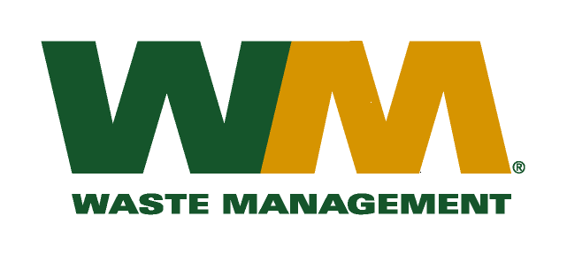
August 23, 2010
Washington Utilities and Transportation Commission
Chandler Plaza Building
1300 S. Evergreen Park Drive SW
P.O. Box 47250
Olympia, WA. 98504-7250

Dear Sirs:
Subject: Brem-Air Disposal, a division of Waste Management of Washington, Inc. (G-237); Tariff # 20; Docket TG-101248
Please find enclosed substitute tariff pages 19 and 23 to the above-referenced tariff. This page is being submitted in order to correct a clerical error. Please do not re-docket.

If you have any questions or need additional information, please contact me at (425) 814-7840.
Respectfully,

Michael A. Weinstein
Senior Pricing Manager, Pacific Northwest Market Area

