February 3, 2016

Mr. Steven King
Executive Director and Secretary
Washington Utilities and Transportation Commission
1300 South Evergreen Park Drive SW
Olympia WA 98504-7250

RE: Tariff Revision – WN U-4 for Ellensburg Telephone Company d/b/a FairPoint Communications

Dear Mr. King:

Pursuant to WAC 480-80-123, please find enclosed the following revised tariff pages. As this is a non-rate affecting change, we are requesting an effective date of February 4, 2016.

Second Revised Sheet No. 2
First Revised Sheet No. 25
Schedule 14, Second Revised Sheet No. 97

The purpose of this filing is to remove some residtual references to WTAP that were overlooked when WTAP was removed from the tariff in July of 2015. This filing does not affect any current or new customers terms or rates.

Please contact Beth Westman at 207.535.4249 or bwestman@fairpoint.com with any questions or concerns regarding this filing.

Sincerely,
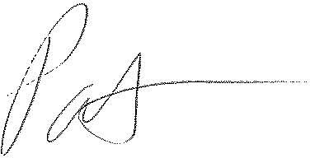
Patrick L. Morse
Senior VP Governmental Affairs
FairPoint Communications
P: 620-227-4409
F: 620-227-8576

