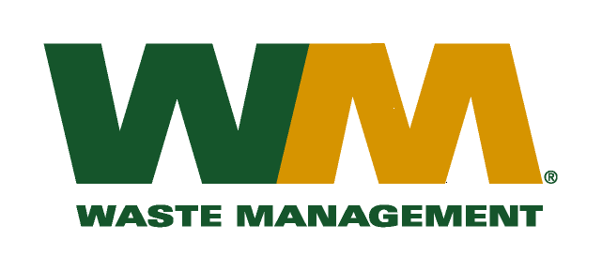

May 4, 2010
Washington Utilities and Transportation Commission
Chandler Plaza Building
1300 S. Evergreen Park Drive SW
P.O. Box 47250
Olympia, WA. 98504-7250

Subject: Waste Management of Ellensburg, a division of Waste Management of Washington, Inc.(G-237); Tariff # 11
Dear Sirs:
Enclosed herein, please find revised pages 2, 16, 21, 22, 23, 28, 29, 30, and 31 to the above-referenced tariff. These proposed revised tariff pages contain increased rates for residential and commercial garbage collection services. The requested rate increase is necessary in order to recover increased disposal costs at the Kittitas County Solid Waste System. The Kittitas County Commissioners approved the increase in disposal fees from $72.64 to $86.84 per ton as reflected in Kittitas County Resolution 2010-45. The effective date of the disposal fee increase will be July 1, 2010. The increased rates, if approved by the commission, would approximately increase Company revenue by $125,000, and residential and commercial garbage rates by 6%. The effective date of the proposed tariff revisions is July 1, 2010.
Also enclosed for your review are our accounting workpapers and Resolution No. 2010-45 for Kittitas County. Upon approval by the Commission, affected customers will be notified of this rate increase on their next regularly scheduled billing. If you have any questions or need additional information, please contact me at (425) 814-7840.

Very truly yours,
Michael A. Weinstein
Senior Pricing Manager, Pacific Northwest Market Area

cc: JR Lesure
Adam Winston
Joe Krukowski
Clerk of the Board, Kittitas County Chair

