- IMPROPER TREATMENT OF AND TRANSITION OF EXISTING RENTAL CUSTOMERS
Q. Mr. Cebulko claims that in its existing rental service PSE “continues to comply with the Commission’s order to install water heaters with an efficiency of at least 0.6.” Is this accurate?
A. Yes. In fact, on April 15, 20152016, the National Appliance Energy Act went into effect requiring all manufactures to produce products that meet increased
efficiency standards, see figure 3 below.
Figure 3: National Appliance Energy Act Standards
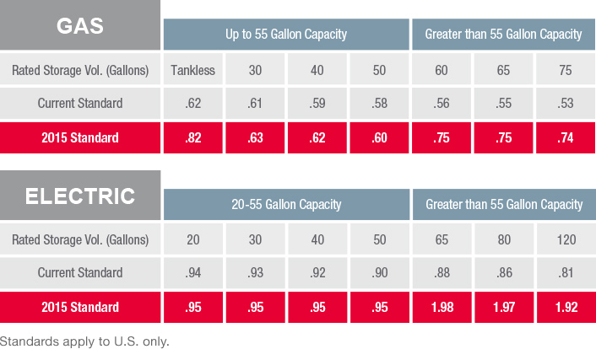
PSE has worked with its existing distribution and installation partners to ensure that rental equipment being replaced is done so with equipment that meets or exceeds these standards.

Cebulko, Exh. No. ___(BTC-1TH) at 16:10-11.

