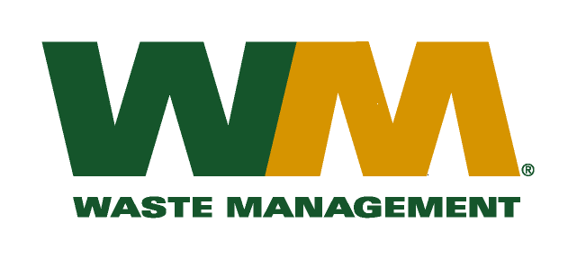

July 6, 2016

Washington Utilities and Transportation Commission
Chandler Plaza Building
1300 S. Evergreen Park Drive SW
P.O. Box 47250
Olympia, WA. 98504-7250

Subject: Waste Management – North Sound and Waste Management - Marysville, divisions of Waste Management of Washington, Inc. (G-237); Tariff No. 19 Docket No. 160792

Enclosed is substitute page 25 to the above referenced docket. The purpose of this replacement page is to correct a clerical error.
If you have any questions or need additional information, please contact me at:
Address: 720 4th Avenue, Suite 400, Kirkland, WA 98033
Telephone /Fax #: (425) 814-7840 / (425) 814-7866
e-mail: mweinstein@wm.com

Respectfully,

Michael A. Weinstein
Senior Pricing Manager, Pacific Northwest Market Area

