US Electric Utilities & IPPs
Authorized ROEs: Don't Expect an Inflection Yet
Please Click Here for the Full Note
Where are ROEs heading? Likely still heading lower
With growing expectations for an uptick in rising treasuries to drive higher authorized ROEs in pending rate cases, we emphasize the historic spread between ROEs and treasuries remains notably elevated, which could well suggest a lag before authorized ROEs bottom. As such, we emphasize that pending rate cases are not immune from continued compression in ROEs and could well continue to see this trend into 2017 in many key pending cases. We emphasize the below charts as well as our additional datapoints from Commission surveys, our FERC transmission ROE analysis and recent rate cases all confirm this risk in our view, with current spreads still 70-90bps above that of the 15 year average, suggesting ROEs could well head to the low-to-mid 9% range still off the trailing average in 2016 of 9.77% authorized for electric utilities per SNL. See the tables below.
US-treasury spreads vs ROEs still historically high but trending lower
The spread between US electric/gas ROEs relative to treasuries is beginning to regress from recent highs as treasuries continue their climb post the election. However, the question now is to what extent the spread will continue to tighten - from either the authorized ROE side or from US treasuries.
FERC ROEs could see some pressure as well given peer group methodology
We highlight that our latest MtM analysis of authorized FERC transmission ROEs shows an inflection off the lows, but we note risk for a return to previous lows without the inclusion of AGR, which includes a higher growth rate in the ROE calculation. We see a base ROE outcome of 9.8% w/AGR and 8.9% without. Inclusive of a 50bp adder for RTO participant this would appear to result in an outcome largely similar with the average 9.77% authorized ROE in 2016 for Electric Utilities
Utility Commissioners affirm sentiments in latest survey too
Previously, in our 5th "What Do Regulators Really Think" survey from September (pre-election) 32 respondents from Commissioners and Commission staff responded once again that ROEs are more likely to decline than not, though we note there was no strong analysis among tying returns to treasuries directly, we see a modest inclination towards the belief that some existing approaches to capital spending are too formulaic.
Next datapoints to watch – rate case outcomes for AEE, GXP, EXC, PNW & CA
We highlight the above names under our coverage where ongoing rate cases should provide further datapoints of affirmation. Principally in Missouri, we see further risk of ROE degradation should legislative prospects not prove fruitful, noting negative Staff recommendations for both AEE Missouri and KCPL. At KCPL MO, Staff recommended no rate increase, with a lower authorized ROE (8.65% vs 9.90% ask). We believe developments in other states could be more constructive specifically at PNW among others. We continue to expect a modest reduction in the ROE in pending cost of capital settlements and/or litigation in California as well (will the CPUC and/or parties continue to acquiesce to the argument that California warrants a premium for its higher-risk operational environment—or to what extent?). Other cases to watch include EXC's recent PEPCO case where interveners recommended an 8.6% (vs 10.6% ask), albeit a settlement at the midpoint would be near PEPCOs current authorized return. While the ability to earn ROEs has seemingly improved in recent years across much of our coverage universe, we continue to assume a compressing authorized ROE trend in many of our projections.

Figure 1: Historical Gas/Electric ROEs & Treasury Spreads : Spread Remains High for both Gas & Electric
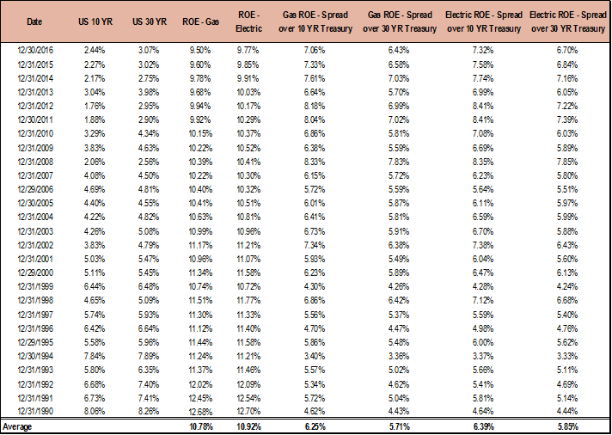
Source: SNL and FactSet

Figure 2:US Electric ROEs vs Average |  | Figure 3: US Gas ROEs vs Average
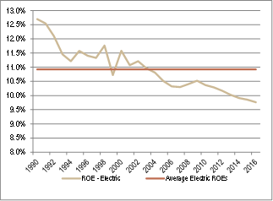 |  | 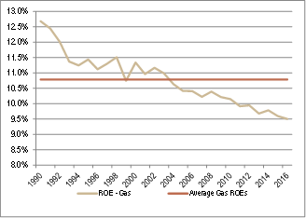
Source: SNL |  | Source: SNL

Figure 4: US Gas ROE vs Treasuries
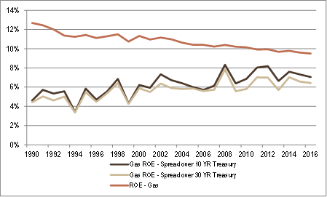
Source: SNL

Figure 5: US Electric ROEs vs Treasuries
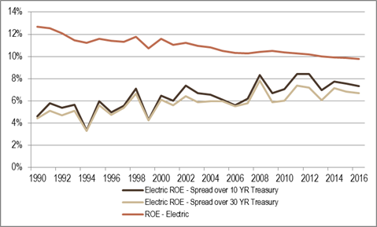
Source: SNL

