CenturyLink

1600 7th Avenue

Seattle, Washington 98191

(206) 345-6224

(425) 301-8411 (cell)
Email: phil.grate@centurylink.com

Philip E. Grate

State Governmental Affairs Director

Public Policy

January 16, 2019
Via Web Portal

Mr.Mark. Johnson, Executive Director and Secretary
Washington Utilities & Transportation Commission
1300 S. Evergreen Park Drive SW
P.O. Box 47250
Olympia, WA 98504-7250

Re: Docket UT-180004
CenturyLink’s CAF II Deployment Update

Dear Mr. King:

The attached letter serves as notice that, based on preliminary data, CenturyLink may not have reached the year-end 2018 Connect America Fund Phase II (CAF II) location deployment milestone of 60% in Washington. CenturyLink continues to deploy broadband to CAF II locations in Washington, anticipates reaching the sixty percent milestone soon, and remains committed to meeting its CAF II obligations.

Please contact me at (206) 345-6224 or via e-mail at phil.grate@centurylink.com if you have any questions.

Sincerely,

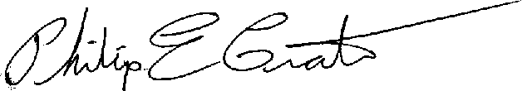

Philip E. Grate

