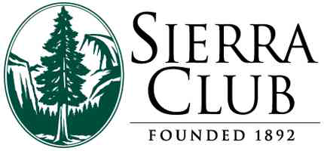 | Northwest Regional Office  180 Nickerson Street, Suite 202  Seattle, WA 98109  Phone: (206) 378-0114  Fax: (206) 378-0034

December 23, 2015

Washington Utilities and Transportation Commission
P.O. Box 47250
1300 S. Evergreen Park Dr. SW
Olympia, WA 98504-7250

Docket # 141170 – Request for Extension of Comment Period

On December 18, 2015, the Sierra Club filed comments on Docket #141170 for Puget Sound Energy’s 2015 Integrated Resource Plan requesting an extension of the public comments from January 15, 2016 to February 15, 2016. That request is attached again for the record.

After consultation with staff from the Washington Utilities and Transportation Commission (UTC), the Sierra Club now amends its request to extend the comment to 5:00pm, Monday, February 1, 2016 instead of 5:00pm, Monday, February 15, 2016. The Sierra Club believes this is an acceptable compromise given scheduling needs and ensuring sufficient time for public comments.

Thank you for your consideration.

____/s/ Doug Howell_____

Doug Howell
Sr. Campaign Representative
doug.howell@sierraclub.org
(206) 378-0114 x304

