July 9, 2014

Steven V. King, Executive Director and Secretary
Utilities and Transportation Commission
1300 S. Evergreen Park Dr. SW
P.O. Box 47250
Olympia, WA 98504-7250

RE: Washington Utilities and Transportation Commission v. All American Spirit Moving Co., LLC

Commission Staff’s Response to Application for Mitigation of Penalties TV-140939

Dear Mr. King:

On June 4, 2014, the Utilities and Transportation Commission issued a $400 Penalty Assessment in Docket TV-140939 against All American Spirit Moving Co., LLC for 4 violations of Washington Administrative Code (WAC) 480-15-480, which requires household goods carrier companies to furnish annual reports to the commission no later than May 1 each year.¹

On June 24, 2014, All American Spirit Moving Co., LLC wrote the commission requesting mitigation of penalties (Mitigation Request).² In its Mitigation Request, All American Spirit Moving Co., Inc. does not dispute that the violation occurred. The company states, “I am a 1 man operation and while this does not excuse my failure to compile it is none the less the reason I’m asking for empathy. I guess in that I am struggling to survive. Just looking at my annual gross income should explain that. And I’m asking for an opportunity to get better and if the economy continues to get better I’m sure I will too.”

It is the company’s responsibility to ensure that the regulatory fee is paid and the annual report is filed by the May 1 deadline. On February 28, 2014, Annual Report packets were mailed to all regulated household goods companies. The instructions for annual report completion page of the annual report informed the regulated company that it must complete the annual report form, pay the regulatory fees, and return the materials by May 1, 2014, to avoid enforcement action.

UTC Annual Reports
July 9, 2014
Page 2

On May 7, 2014, All American Spirit Moving Co., LLC. filed its 2013 annual report and paid the regulatory fees and late payment penalty. The company has been active since July 27, 2010. All American Spirit Moving Co., LLC was delinquent in filing the 2011 and 2012 annual report and received mitigation both reporting years. Staff does not support the company’s request for mitigation due to a lack of new compelling information and prior violations of WAC 480-15-480.

If you have any questions regarding this recommendation, please contact Amy Andrews, Regulatory Analyst, at (360) 664-1157, or aandrews@utc.wa.gov.

Sincerely,

Sondra Walsh, Director
Administrative Services

ATTACHMENT A
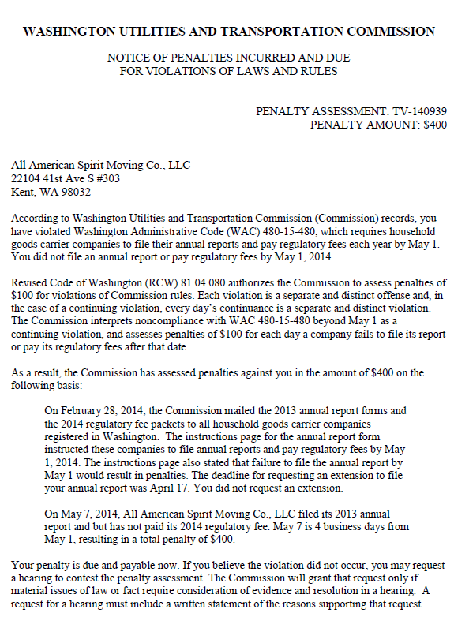

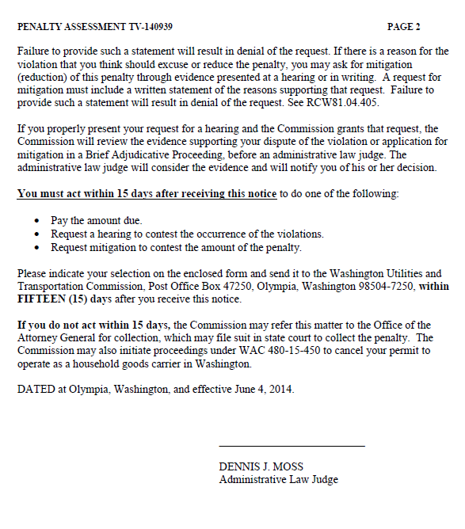

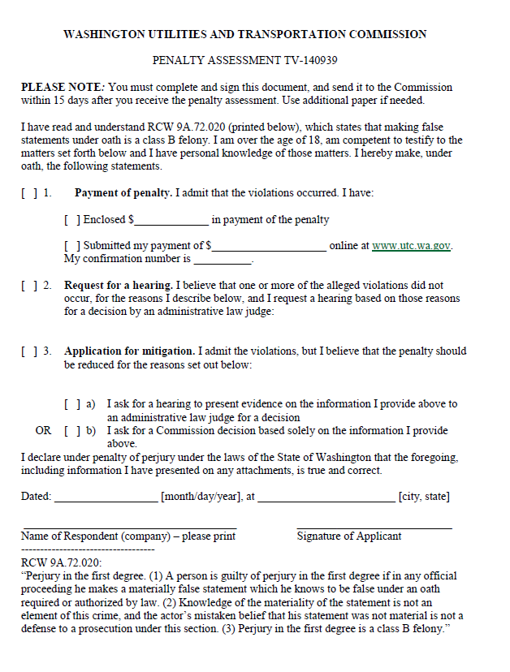

ATTACHMENT B
