Eligible Telecommunications Carriers’ annual recertification on High Cost Fund pursuant to WAC 480-123-060, 070 and 080

July 21st, 2016

Mr. Steven King, Executive Secretary
Washington Utilities and Transportation Commission
1300 South Evergreen Park Drive SW
Olympia, WA 98504-7250

Re: Amended ECT Certification UT-160850

Dear Mr. King:

Attached is our NECA1 report which completes this filling.

Sincerely,

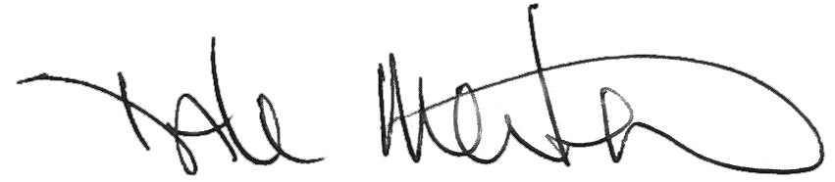

Dale Merten
Chief Operating Officer

