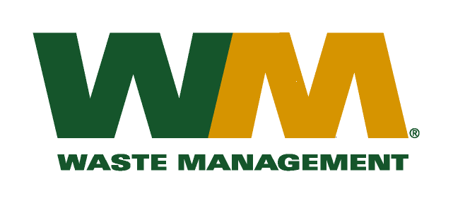

December 18, 2012

Washington Utilities and Transportation Commission
Chandler Plaza Building
1300 S. Evergreen Park Drive SW
P.O. Box 47250
Olympia, WA. 98504-7250

Subject: Waste Management – Sno-King, a division of Waste Management of Washington, Inc. (G-237); Tariff No. 15; TG-121818

Enclosed herein, you will find revised substitute pages 21, 24, 25 and 26 for the above referenced docket. This page is being substituted to correct a worksheet formula error that has been communicated and agreed to by WUTC staff. Please do not re-docket.
If you have any questions or need additional information, please contact me at:
Address: 720 4th Avenue, Suite 400, Kirkland, WA 98033
Telephone /Fax #: (425) 814-7840 / (425) 814-7866
e-mail: mweinstein@wm.com
Respectfully,

Michael A. Weinstein
Senior Pricing Manager, Pacific Northwest Market Area

