February 15, 2017

Steven V. King
Executive Director and Secretary
Washington Utilities and Transportation Commission
1300 South Evergreen Park Drive SW
PO Box 74250
Olympia, WA 98504-7250

RE: Washington Utilities and Transportation Commission v. Puget Sound Energy, Dockets UE-161123
FILINGS ON BEHALF OF NWEC

Dear Mr. King:

Please accept the following documents for filing:

- An original and one copy of Exhibit B, Expert Agreements for D. Kelley and M. O'Brien concerning confidential information in the above-entitled docket;

- Certificate of Service for documents listed herein.

Sincerely,

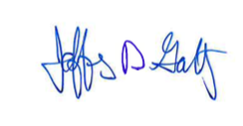

Jeffrey D. Goltz
Direct Line: (360) 528-3026
Email: jgoltz@cascadialaw.com
Office: Olympia

JG:jt

Enclosures

