June 13, 2014

Steven V. King, Executive Director and Secretary
Utilities and Transportation Commission
1300 S. Evergreen Park Dr. SW
P.O. Box 47250
Olympia, WA 98504-7250

RE: Washington Utilities and Transportation Commission v. Puget Sound Express, Inc.

Commission Staff’s Response to Application for Mitigation of Penalties TS-141008

Dear Mr. King:

On May 22, 2014, the Utilities and Transportation Commission issued a $1,000 Penalty Assessment in Docket TS-141008 against Puget Sound Express, Inc. for 10 violations of Washington Administrative Code (WAC) 480-51-100, which requires commercial ferry companies to furnish annual reports to the commission no later than May 1 each year.¹

On June 2, 2014, Puget Sound Express, Inc. wrote the commission requesting mitigation of penalties (Mitigation Request).² In its Mitigation Request, Puget Sound Express, Inc. does not dispute that the violation occurred. The company states, “On May 1st I called into the UTC to ask if the report needed to be post marked by May 1 or received by the 1st…I was told it needed to be received by May 1. I asked if a fax was acceptable and was given 360-664-1289. I sent the report in by fax and paid the fee over the phone the same morning.”

It is the company’s responsibility to ensure that the regulatory fee is paid and the annual report is filed by the May 1 deadline. On February 28, 2014, Annual Report packets were mailed to all regulated commercial ferry companies. The instructions for annual report completion page of the annual report informed the regulated company that it must complete the annual report form, pay the regulatory fees, and return the materials by May 1, 2014, to avoid enforcement action.

UTC Annual Reports
June 13, 2014
Page 2

On May 28, 2014, Puget Sound Express, Inc. filed the 2013 annual report and timely paid the required regulatory fees on May 1, 2014. The company permit was issued on March 22, 1994. The company has one previous violations of WAC 480-30-071 for the 2005 annual report. Upon being contacted by the company regarding the penalty assessment and attempted fax submission, commission staff was able to determine an unidentified partial fax which was received on May 1, 2014 was in fact that of Puget Sound Express, Inc.³ Staff recommends the penalty be waived as evidenced by the company’s good faith effort to submit the annual report via fax on May 1, 2014 and prior filing history.

If you have any questions regarding this recommendation, please contact Amy Andrews, Regulatory Analyst, at (360) 664-1157, or aandrews@utc.wa.gov.

Sincerely,

Sondra Walsh, Director
Administrative Services

ATTACHMENT A
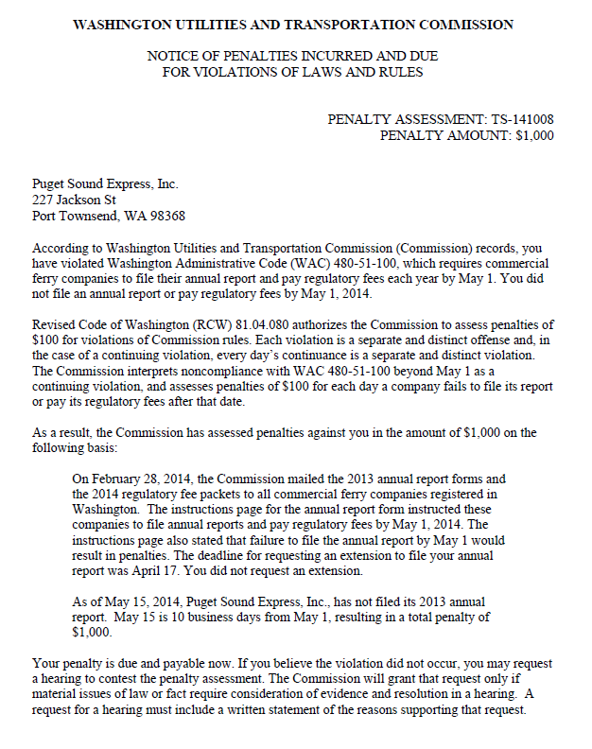

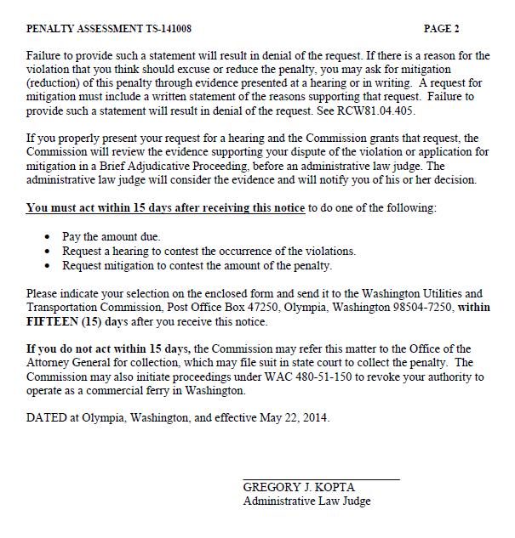

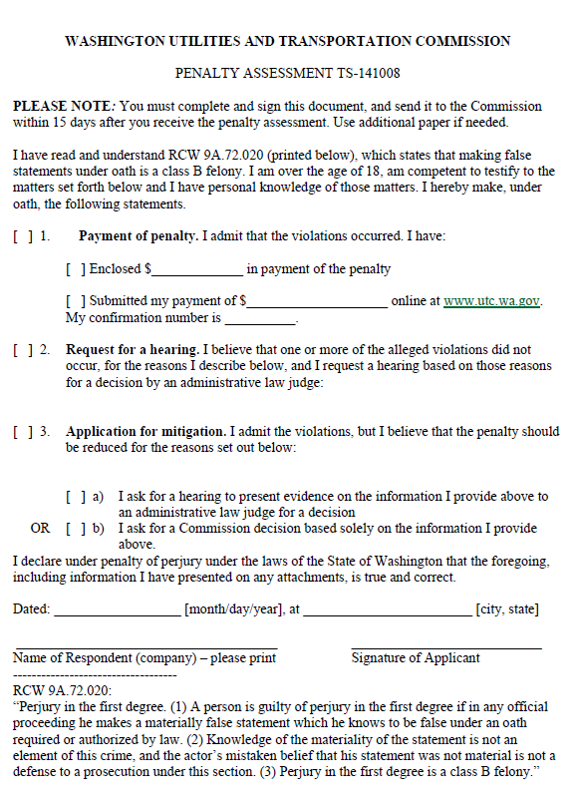

ATTACHMENT B
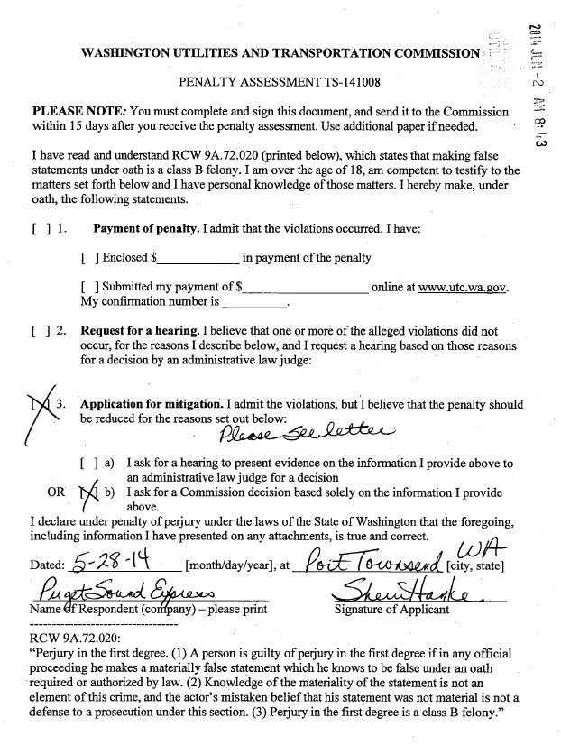

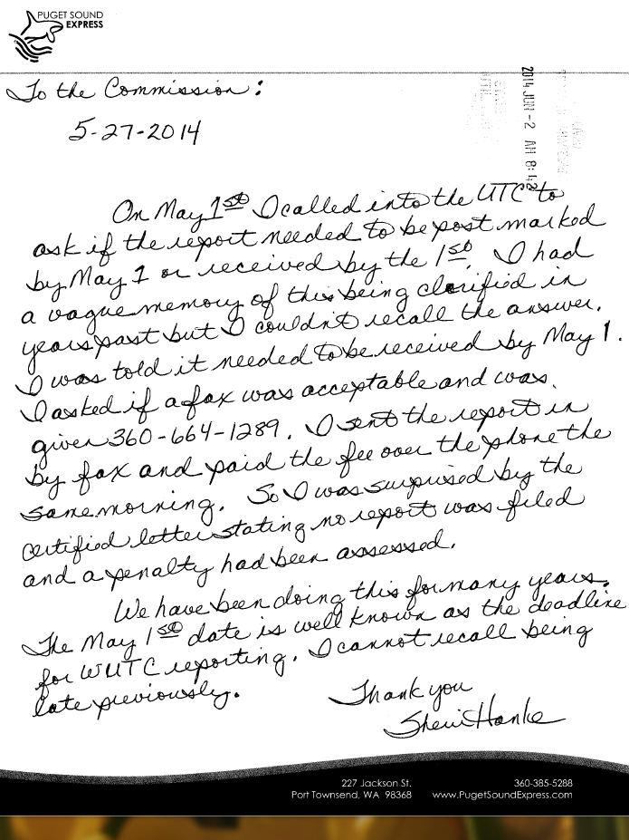

ATTACHMENT C
