EXHIBIT 8

FINANCIAL ACCOUNTING CERTIFICATE

I, Dale Merten an officer of The Toledo Telephone Company, Inc. with personal knowledge and responsibility, based upon my discussions with the outside consultants retained by the Company to handle such matters, under penalty of perjury, state that the Company complies with state and federal accounting, cost allocation and cost adjustment rules pertaining to incumbent local exchange companies.

Dated this 27th day of July, 2016.

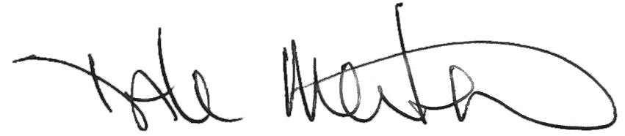

Dale Merten
C.O.O.

