June 30, 2014

Steven V. King, Executive Director and Secretary
Utilities and Transportation Commission
1300 S. Evergreen Park Dr. SW
P.O. Box 47250
Olympia, WA 98504-7250

RE: Washington Utilities and Transportation Commission v. American Patriot Coach LLC

Commission Staff’s Response to Application for Mitigation of Penalties TN-141050

Dear Mr. King:

On May 27, 2014, the Utilities and Transportation Commission issued a $1,000 Penalty Assessment in Docket TN-141050 against American Patriot Coach for 10 violations of Washington Administrative Code (WAC) 480-30-071, which requires charter and excursion carriers to furnish annual reports to the commission no later than May 1 each year.¹

On June 16, 2014, American Patriot Coach LLC wrote the commission requesting mitigation of penalties (Mitigation Request).² In its Mitigation Request, American Patriot Coach LLC does not dispute that the violation occurred. The company provided supporting reasons for the mitigation request being a mistake due to the change in filing deadlines required for the charter and excursion industry this year.

It is the company’s responsibility to ensure that the regulatory fee is paid and the annual report is filed by the May 1 deadline. On February 28, 2014, Annual Report packets were mailed to all regulated charter and excursion companies. The instructions for annual report completion page of the annual report informed the regulated company that it must complete the annual report form, pay the regulatory fees, and return the materials by May 1, 2014, to avoid enforcement action.

On June 10, 2014, American Patriot Coach LLC filed the 2013 annual report and timely paid the required regulatory fees on December 11, 2013. The company permit was issued July 18, 2003.

UTC Annual Reports
June 30, 2014
Page 2

American Patriot Coach LLC was previously delinquent in filing the 2009 and 2012 annual
reports. Staff does not support the company’s request for mitigation due to previous compliance filing history and lack of compelling new information to support the request.

If you have any questions regarding this recommendation, please contact Amy Andrews, Regulatory Analyst, at (360) 664-1157, or aandrews@utc.wa.gov.

Sincerely,

Sondra Walsh, Director
Administrative Services

ATTACHMENT A
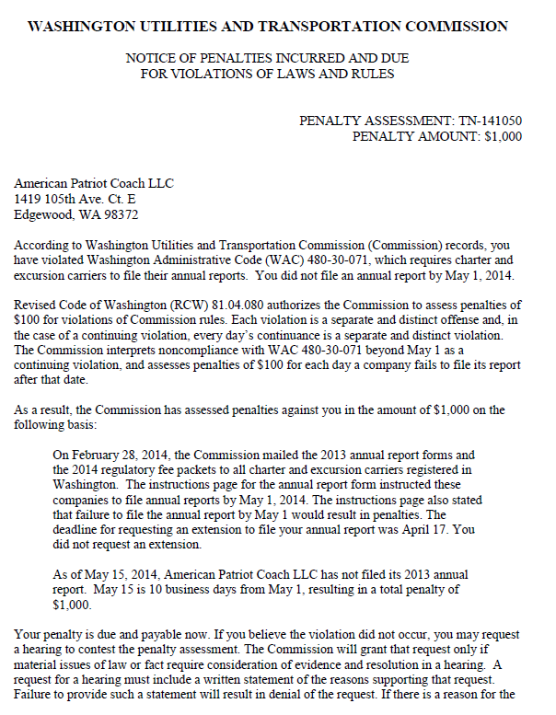

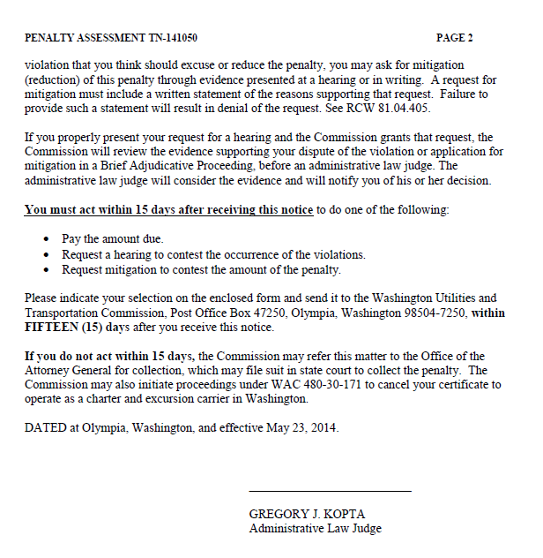

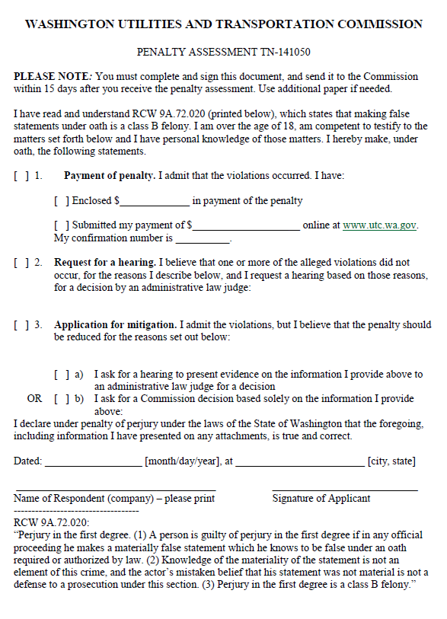

ATTACHMENT B
