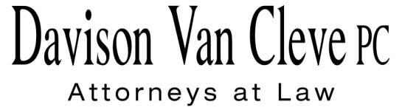
TEL (503) 241-7242 ● FAX (503) 241-8160 ● jog@dvclaw.com
Suite 400
333 S.W. Taylor
Portland, OR 97204

August 2, 2016

Via Electronic Filing and Federal Express

Mr. Steven V. King
Executive Director
Washington Utilities & Transportation Commission
1300 S. Evergreen Pk. Dr. S.W.
P. O. Box 47250
Olympia, WA 98504-7250

Re: Puget Sound Energy Revisions to Electric Schedule No. 135 and Electric Schedule No. 136
Docket UE-160921

Dear Mr. King:

Enclosed for filing in the above-referenced docket, please find the original and twelve (12) copies of the Notice of Appearance of the Industrial Customers of Northwest Utilities.

Thank you for your assistance. If you have any questions, please do not hesitate to call.
Sincerely,

/s/ Jesse O. Gorsuch
Jesse O. Gorsuch
Enclosure

CERTIFICATE OF SERVICE

I hereby certify that I have this day served the attached Notice of Appearance of the Industrial Customers of Northwest Utilities upon the parties shown below by sending a copy via electronic mail and by mailing a copy via First Class U.S. Mail, postage prepaid.
DATED this 2nd day of August, 2016.
Davison Van Cleve, P.C.

/s/ Jesse O. Gorsuch
Jesse O. Gorsuch

KEN JOHNSON  Director – Rates & Regulatory Affairs  Puget Sound Energy  P.O. Box 97034, PSE-08N  Bellevue, WA 98009-9734  ken.s.johnson@pse.com  JENNIFER CAMERON-RULKOWSKI  Assistant Attorney General  WUTC  P.O. Box 40128  Olympia, WA 98504-0128  jcameron@utc.wa.gov | SHEREE CARSON  Perkins Coie, LLP  10885 N.E. Fourth St.  Bellevue, WA 98004-5579  scarson@perkinscoie.com  LISA GAFKEN  Office of the Attorney General  800 Fifth Avenue STE 2000  Seattle, WA 98104-3188  LisaW4@atg.wa.gov

