EXHIBIT NO. ___( AF-1T )
DOCKETS UE-151871/UG-151872
PSE LEASING TARIFF
WITNESS: AHMAD FARUQUI, PhD

BEFORE THE
WASHINGTON UTILITIES AND TRANSPORTATION COMMISSION

WASHINGTON UTILITIES AND  TRANSPORTATION COMMISSION,  Complainant,  v.  PUGET SOUND ENERGY,  Respondent. |  | Dockets UE-151871  UG-151872

PREFILED DIRECT TESTIMONY OF
AHMAD FARUQUI, Ph.D.
ON BEHALF OF PUGET SOUND ENERGY

February 25, 2016
PUGET SOUND ENERGY
PREFILED DIRECT TESTIMONY OF
AHMAD FARUQUI, Ph.D.
CONTENTS
I. INTRODUCTION 1
II. BARRIERS TO ADOPTION OF NEW, EFFICIENT PRODUCTS 3
III. THESE BARRIERS ARE ADDRESSED BY THE PROPOSED PSE LEASE SOLUTIONS 13
IV. POTENTIAL LEASE SOLUTIONS ADOPTION 16
V. QUANTIFIABLE PROGRAM BENEFITS 19
VI. CONCLUSION 30

PUGET SOUND ENERGY
PREFILED DIRECT TESTIMONY OF
AHMAD FARUQUI, Ph.D.

I. INTRODUCTION
Q. Please state your name, business address, and position.
A. My name is Ahmad Faruqui. My business address is 201 Mission Street, Suite 2800, San Francisco, California 94105. I am a Principal at The Brattle Group. I am testifying on behalf of Puget Sound Energy (“PSE”) in this proceeding.
Q. Have you prepared an exhibit describing your education, relevant employment experience, and other professional qualifications?
A. Yes, I have. It is Exhibit No. ___(AF-2).
Q. Please summarize your testimony.
A. Customers do not always purchase new, efficient products, even when it is in their best interest to do so. To understand the barriers to the adoption of new, efficient products, I undertook a review of the academic and industry literature. Five barriers stand out: credit constraints, myopic behavior, risk aversion, search costs, and externalities. Traditional energy efficiency programs, whether run by electric utilities or third parties, do address some of these barriers, but not all of them. I believe PSE’s proposed Lease Solutions will act as a complement to its energy efficiency programs to help further address these barriers. I have developed a model to quantify the benefits that PSE’s Lease Solutions will provide to both participating and non-participating customers. The leasing service will ensure that newer and more efficient units are installed in customer’s premises, and accelerate the replacement of older, less-efficient equipment that would continue to be operated in a world without Lease Solutions. Benefits to all customers include conservation of both electricity and natural gas, reduced greenhouse gas emissions and pollution, and deferred capacity investments. Benefits to participating customers include lower utility bills, increased comfort and quality of life due to better equipment performance, peace of mind due to the maintenance feature of Lease Solutions, and greater control over their energy usage. I have used my model to quantify several of these benefits and found that in the first 20 years of existence, Lease Solutions would likely yield the following benefit streams:
- Over 321,000 MWh of electric energy conservation (equivalent to powering over 1,300 homes each year for twenty years).
- 190 million therms of gas energy conservation (equivalent to fueling over 11,500 homes each year for twenty years).
- 1.3 million tons of carbon dioxide (CO₂) emissions avoided (equivalent to taking over 12,500 cars off the road).
- $5.5 million in avoided generation and distribution capacity costs.
- $144 million saved in lower utility bills for participating customers.
Given that the proposed PSE Lease Solutions will address key barriers to customer adoption of new, efficient products by making the purchasing and maintenance process easier and more attainable, I expect that the PSE Lease Solutions will reach thousands of customers and generate significant benefits in terms of bill savings, enhanced comfort and quality of life, avoided energy costs, avoided capacity costs, and avoided emissions.

II. BARRIERS TO ADOPTION OF NEW, EFFICIENT PRODUCTS
Q. Do all customers adopt efficient products?
A. No, customers do not always make optimal decisions when purchasing new consumer products. Academic and industry research along with a number of case studies have identified the presence of an “efficiency gap.” This is “the difference between the actual level of investment in energy efficiency and the higher level that would be cost-beneficial from the consumer’s […] point of view.” In their 2009 discussion report “Energy Efficiency Economics and Policy,” Gillingham et al. indicate that the efficiency gap illustrates underinvestment in energy efficiency overall compared to a socially optimal level; essentially, that adoption of efficient technologies is “too slow.”
Many customers in PSE’s service territory hold onto equipment that is far past its useful life. A recent survey of PSE customers showed that some of this equipment has been in operation for almost twice its intended life. Additionally, it has been observed that some customers do replace their equipment at the correct time, but often replace their aging equipment with less efficient models than is optimal. Older equipment may have degraded performance after decades of use and was most likely built using less efficient technologies. This results in wasted energy, higher CO₂ and other greenhouse gas emissions, higher utility bills, and loss of comfort. Furthermore, in a 1996 report for the Lawrence Berkeley National Laboratory, William H. Golove and Joseph H. Eto discuss the fact that energy efficient products could provide energy services at lower costs than the development of new energy supplies. Thus, the efficiency gap implies that there are significant, cost-effective energy savings that are not being taken advantage of.
Q. Are there barriers to the consumer adoption of new, efficient products?
A. Yes. Several studies and papers over the past 40 years have categorized market and behavioral barriers to the adoption of new and efficient products by consumers. These barriers affect different customers to varying extents—not all customers will be affected by all barriers, and some will not be affected by any. Nonetheless, the existence of these barriers means that some customers do not adopt new products even when it is in their own and/or society’s benefit to do so.
Q. What are the barriers to the adoption of new, efficient products?
A. Five key barriers emerge from a review of the literature: credit constraints, risk aversion, imperfect information and search costs, myopic behavior (hyperbolic discounting), and externalities that do not directly benefit those customers who purchase new, more efficient products.
Q. What are credit constraints and how do they inhibit customer adoption of efficient products?
A. Credit constraints can be defined as the lack of access to capital to pay for the upfront costs of an investment. More efficient consumer products “typically require a substantial upfront investment in exchange for savings that accrue over the lifetime of the deployed measures.” If an individual or organization does not have the internal funds required to invest in costly upgrades, and is unable to access that capital through borrowing or other means, such investments may not occur in a timely manner.
In addition to significant immediate costs, potential consumers of new, more efficient equipment may face high financing costs. For both individuals and small commercial and industrial customers, acquiring the required capital can be difficult due to the perceived riskiness of efficiency opportunities. Lenders generally do not adjust the interest rate based on the improvement in the borrower’s cash flow that comes from the savings that accrue with energy efficient investments. At the same time, some potential borrowers, such as low-income residential households or small business owners, may be unable to borrow money due to their low “credit-worthiness.” Further, credit may be unavailable in some regions and loan terms may be too short compared to the lifetime of the investment. In her 2001 article, “Market failures and barriers as a basis for clean energy policies,” Marilyn A. Brown et al. discuss the existence of an “interest rate gap” where energy suppliers can borrow capital at lower interest rates than energy consumers can, likely because of “differences in the knowledge base of the lenders about the likely performance of investments as well as the financial risk of the potential borrower.”
Q. What is risk aversion and how does it impede customer adoption of efficient products?
A. Risk aversion refers to the natural tendency of people to dislike uncertainty when making decisions. Investments in new, efficient products have technical and financial risks that lead the rational decision-maker to require shorter payback periods as compensation for this risk. In particular, the cost savings associated with product upgrades can be difficult to estimate, as they depend on “future economic conditions in general,” and in the case of energy efficiency, “on future energy prices and availability,” which fluctuate over time. Financing efficient investments at a guaranteed rate is often discussed as a method to address this concern.
The uncertainty associated with new consumer products leads to a cognitive bias towards not making these types of investments. Behavioral economists call this cognitive bias the “certainty effect.” The certainty effect is the idea that “people underweight outcomes that are merely probable in comparison with outcomes that are obtained with certainty.” For example, since the upfront installment cost of new products are more definite and certain than the higher energy savings associated with higher efficient products, people are not inclined to purchase the higher efficient products.
Q. What are imperfect information and search costs and how do they obstruct customer adoption of new, efficient products?
A. Imperfect information is the lack of adequate information to make an optimal decision. In general, customers lack information on the performance and availability of new products compared to existing equipment or systems. This lack of knowledge can impede investment in viable new (replacement) technologies. For example, in the paper, “Overcoming Social and Institutional Barriers to Energy Conservation,” Carl Blumstein et al. note that information issues “range from mundane questions such as how to find a reliable insulation installer, to very complex topics such as the optimum design for a house.”
Obtaining this information is not a trivial task. Searching for information is a costly endeavor. Finding accurate information is difficult since customers often face a plethora of competing products, technologies, and vendors. Customers and small businesses “rarely have the time and money” to invest in this research. In the case of energy efficiency, information on savings potential may be inaccurate due to the difficulty associated with measuring energy savings, as well as the aforementioned uncertainty associated with quantifying cost savings due to the fluctuation of energy prices.
Asymmetric information is a specific type of imperfect information where “parties to a transaction have access to different levels of information.” Equipment vendors are usually more informed about the product than prospective buyers, and thus:
[If] improving the information held by consumers is difficult or costly, the problem of adverse selection may arise: given competitive markets, producers may be unable to market clearly desirable technologies since consumers are unable to observe their superior characteristics prior to sale.

Another form of imperfect information rests in the credibility of the information provider. In their book, Energy Use: The Human Dimension, Paul C. Stern and Elliot Aronson note that “other things being equal, the greater the expertise and trustworthiness of the communicator, the greater the impact on the audience,” —thus, the more knowledgeable and trustworthy an information source is, the more likely customers would make decisions based on the information.
Overall, imperfect information and the associated search costs lead customers to “make sub-optimal decisions based on provisional and uncertain information,” and thus under-invest in efficient products.
Q. What are myopic behavior and hyperbolic discounting and how do they deter customer adoption of new, efficient products?
A. Myopic behavior, or short-term thinking, refers to the tendency of individuals to focus on their present lives rather than their future selves. In a working paper for the World Bank, Elke U. Weber and Eric J. Johnson state that myopia “prevents people from accurately perceiving the future benefits of immediate costs or of reductions in immediate benefits.” Research has shown that decision-makers tend to discount future benefits and costs compared to the weight they give more immediate events—a behavior described as hyperbolic discounting.
Colin F. Camerer and George Loewenstein state in “Advances in Behavioral Economics” that:
Hyperbolic time discounting implies that people will make relatively farsighted decisions when planning in advance—when all costs and benefits will occur in the future—but will make relatively shortsighted decisions when some costs or benefits are immediate.

This behavior inhibits efficient product investments since such investments involve upfront costs rewarded by benefits that are uncertain and accrue in the future and over time.
Q. What are externalities and how do they hinder customer adoption of new, efficient products?
A. An externality is the effect of an activity that does not directly affect the parties involved. When these externalities are positive, the market underprovides the underlying good. For example, immunization benefits not just the recipient, but also anyone else that could have been infected by him or her. Since individuals will only invest up until the point where the incremental benefit of an action exceeds the incremental cost and the private benefit is less than the public benefit, individuals will underinvest in the good. Likewise, when externalities are negative, these costs are not factored into individual choice decisions and the market will overprovide the good. For example, noise pollution. Expressed differently, negative externalities arise when goods are not priced in a market and are in a sense given away for “free.” Consumption of physical products can create various negative costs for society, such as greenhouse gas emissions and air pollution, which are only partially borne by the consumer. In many markets, such as that for electricity, the price of these negative externalities is essentially zero. This results in a higher level of consumption than is good for society. For example, Blumstein et al. state that the “market cannot be expected to produce a socially-optional [energy] conservation response” due to artificially low energy prices.
New products that are more efficient than their predecessors will reduce these social costs or externalities. However, since a price has not been set on these external costs, new, more expensive consumer technologies have difficulty competing with less efficient incumbent products. Furthermore, since customers do not directly feel the external benefits of their investment of efficiency upgrades, they do not usually account for them in their purchasing decisions. This increases the challenge that efficient end-use equipment has in competing with incumbent products on the market.

III. THESE BARRIERS ARE ADDRESSED BY THE PROPOSED PSE LEASE SOLUTIONS
Q. In the case of energy efficient products, are these barriers addressed by utility energy efficiency programs?
A. Utility energy efficiency programs trace their origins back to the energy crisis in the 1970s, when a new concept of “energy conservation” emerged to help customers cope with soaring energy prices. Energy efficiency programs primarily act through rebates and discounts on energy efficient equipment and customer education programs like home energy audits. A policy brief from The Edison Foundation notes that traditional energy efficiency programs “often do not go far enough to offset the high cost of energy efficiency investments that yield significant and persistent savings.”
Energy efficiency programs address some of the barriers to new product adoption, but not all of them. Customer-side subsidies for energy-efficient equipment can align private and public benefits, if the subsidy is set to the level of the positive externality produced by the equipment. Similarly, by lowering equipment costs, energy efficiency programs reduce the payback period and partially address the issue of risk aversion. However, this issue is not fully addressed, since customers still have uncertainty over future benefits and expenses. Energy efficiency programs also reduce search costs by conducting home energy audits that help inform customers about their energy use and educate them about new products that can enhance their energy efficiency. Yet significant search costs remain since not all equipment is subsidized by traditional energy efficiency programs and customers still need to research efficient products and find the best vendors and installers. Credit constraints are not addressed at all by energy efficiency programs. Although the cost of the equipment is lower, customers who find it difficult or costly to obtain credit will still face this challenge. Similarly, large upfront investment costs remain and myopic behavior will preclude some customers from investing in new products since the payoffs from these investments lies in the distant future.
Q. In the case of energy efficient equipment, are these barriers addressed by PSE’s proposed Lease Solutions?
A. Yes. By removing the large upfront investment cost, Lease Solutions reduces credit constraints for those customers who find it costly, difficult or distasteful to obtain credit. Similarly, leasing services align the costs and benefits of energy efficient equipment by removing barriers created by myopic behavior. Since the proposed Lease Solutions includes options to access energy efficient and connected equipment, predefined equipment maintenance, and equipment replacement throughout the lease terms for a fixed term and fixed monthly rate, customers have certainty over the benefits and future costs of the equipment, remediating customer risk and the barrier of risk aversion. Lease Solutions will reduce search costs and remove the information asymmetry. In 2015, approximately 82,000 customers called PSE’s Energy Advisors asking for advice on how to reduce their bills and more effectively manage their energy use. As a trusted third-party advisor, PSE is in a unique position to advise their customers on the best energy efficient products. By conducting extensive research into the best products, installers and vendors, PSE will reduce search costs for their customers. Finally, by ensuring that customers invest in energy efficient equipment, positive externalities from these investments will be realized. Figure 1 below illustrates how utility energy efficiency programs and the proposed leasing service address the barriers to the adoption of efficient products.
Figure 1: How Energy Efficiency Programs and the Proposed Leasing Service Address the Barriers to Customer Adoption of Efficient Products
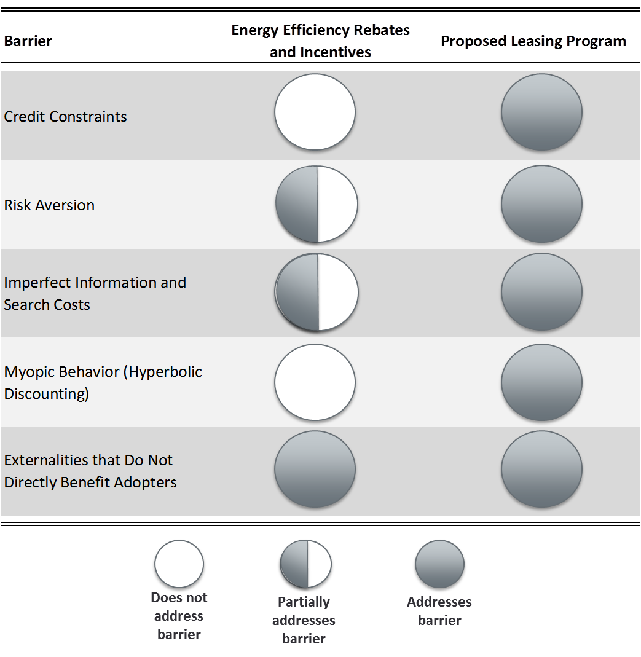

IV. POTENTIAL LEASE SOLUTIONS ADOPTION
Q. How did you estimate the potential market size for Lease Solutions?
A. I relied on PSE’s estimate of the market size, which was derived from both the company’s customer demographic data as well a customer survey. PSE surveyed a representative sample of its customers and confirmed the share of customers that owned the equipment under consideration and their willingness to lease higher efficiency replacement equipment subject to the constraints of the leasing service. To illustrate this process, let me discuss how PSE calculated the realizable market size for residential gas furnaces. There are over 1.3 million residential premises in the PSE service territory, including gas-only customers, electric-only customers, and customers taking both services. PSE data show that 65 percent of PSE customers have natural gas furnaces; of these, 23 percent have indicated in the survey that they are likely to undertake a lease, if offered the option; 65 percent of PSE’s population has credit worthiness that make them eligible for Lease Solutions; and 80 percent have viable housing stock for the equipment. The total realizable market size is calculated by discounting PSE’s population by all of these factors, yielding a total realizable market size of approximately 102,000 residential gas furnaces. PSE assumes that the number of these furnaces replaced each year is equal to the total realizable market size divided by the product’s useful life. Since the useful life of a gas furnace is 17 years, the annual realizable market size for leased gas residential furnaces is approximately 6,000 units.
Q. How does PSE’s annual lease market size account for the fact that some customers may continue to use equipment that is past its useful life?
A. Each year a number of heating and cooling units reach the end of their useful life, and many customers choose to replace the equipment at this time. However, there is also a population of customers that continue to use their increasingly inefficient equipment even though it may no longer be economic to do so. For example, 22 percent of residential gas furnaces are older than 17 years, the common useful life for a gas furnace.
Customers replace equipment that is past its useful life for a variety of reasons, such as the ultimate failure of the equipment or critical performance degradations. Lease Solutions may encourage customers that would have otherwise delayed replacement to replace earlier. I refer to this effect as accelerated replacement, since customers are replacing old, less efficient equipment with new, more efficient models, earlier than they would otherwise have done in a world without Lease Solutions.

V. QUANTIFIABLE PROGRAM BENEFITS
Q. What are the public benefits of the new products that would be adopted in response to the proposed Lease Solutions?
A. There are various benefits associated with customer adoption of the products that would be leased by PSE. Benefits stem from both newer and more efficient units being offered than those that would otherwise be purchased in the market in addition to the accelerated replacement of older, less-efficient equipment that would continue to be operated in a world without Lease Solutions.
Utilizing more efficient equipment leads directly to conservation benefits with less gas and electricity being utilized to achieve the same levels of customer-comfort. Reducing energy consumption consequently reduces participating customers’ utility bills and improves environmental quality for all customers by reducing greenhouse gas emissions and harmful air pollutants.
There are also savings associated with reducing the load on electric generation and distribution systems during peak demand hours. This allows for capacity investments to be deferred, benefitting all customers.
Participating customers also receive the benefits of increased comfort and quality of life due to better home temperature control, peace of mind due to the reduction in uncertainty over future expenses, and greater control over their energy usage with the proposed Lease Solutions.
Q. Can these public benefits be quantified?
A. Yes. Several of Lease Solutions’ public benefits are quantifiable, including conservation of electricity and natural gas, pollution and greenhouse gas emissions reductions, deferred electric capacity investments, and utility bill reductions for customers.
Q. How did you estimate the benefits of the proposed Lease Solutions?
A. In order to quantify the potential benefits of Lease Solutions, I developed a simulation model that uses the realizable annual market size to forecast a full deployment of leased units. The model replicates PSE’s market sizing analysis by collecting data from surveys of PSE customers, vendor feedback, and other sources on ownership of space and water heating equipment, the likelihood that these equipment owners will lease more efficient products, customer debt eligibility, product useful lifetimes and efficiency, and the share of particular leased equipment that could viably be installed where several models exist. Using this data, the model calculates the annual realizable market size for each product by applying the aforementioned shares, probabilities, and product replacement rates (calculated using product lifetimes) to the total number of customer premises in PSE’s service territory.
Summing and tracking annual installations, I create a cumulative measure of installed units in service over time predicated on full deployment. Each installed unit saves energy because it is more efficient than the unit that would have been purchased in the marketplace in the absence of Lease Solutions. Additional conservation benefits are obtained by units that are replaced earlier than they would otherwise have been in the absence of Lease Solutions. These units replace aged equipment that is still in operation despite having exceeded its useful life. In some instances equipment is still in operation despite having served almost double its useful life. This equipment was most likely built using older, less efficient technologies and has undergone decades of performance degradation, rendering it relatively inefficient compared to contemporary units in line with modern efficiency standards (even though such units may be less efficient still than those units being offered by PSE’s Lease Solutions). This additional conservation benefit from accelerated replacement is obtained only for those years during which the customer would have otherwise kept the original equipment. At the stage at which the equipment’s life would have ended (due to failure), the equipment would have been replaced even without Lease Solutions and thus the benefit of acceleration ends.
Annual conservation savings (in kWhs and therms) are obtained by multiplying energy savings per product by the number of cumulative installs in a given year. Avoided greenhouse gas emissions (in tons of CO₂-equivalents) and customer bill savings (in real dollars) flow directly from this conserved energy.
Equipment is not run 24 hours a day and a disproportionate amount of the proposed lease equipment’s usage falls during the peak system hours. Usage during these hours drives capacity investment. By reducing capacity requirements (measured in kW and therms/hour) during peak hours, the utility can defer future capacity investments.
Finally, using the dollar values of wholesale energy, avoided capacity and avoided greenhouse gas emissions, we can obtain the pecuniary benefits to society stemming from PSE’s Lease Solutions.
Q. Can you provide an illustrative example of how the model works?
A. Yes. Take for example the residential gas furnace product. As described above, I calculate the annual realizable market size for this equipment to be around 6,000 units. I assume that this value includes people replacing their equipment on time and those who have accelerated their replacement due to Lease Solutions.
All customers leasing equipment receive an efficiency benefit from replacement equal to the difference in usage between PSE’s efficient equipment and that which they would have purchased in the absence of Lease Solutions. A leased gas furnace saves 119 therms annually compared to furnaces that have efficiency levels at code.
Additionally, customers who accelerate replacement for equipment that is beyond its useful life get an incremental benefit for those years of early replacement. In the absence of hard data, I am assuming that an old furnace past its useful life has efficiency savings that are 20 percent greater than the units that would have been replaced at the end of their useful life.
Survey data indicates that 22 percent of residential customers with a natural gas furnace have kept their furnace past the useful life, and that 15 percent of these customers would be likely to accelerate their replacement under a leasing option. This results in around 200 furnaces replaced early each year, out of the 6,000 units in the realizable market. Survey data also shows that among the 22 percent of furnaces older than the 17-year useful life, the median age is 23 years old. Therefore, I assume that these 200 customers replace their gas furnaces six years earlier than they would have otherwise, saving an incremental 24 therms per year. After six years, the furnace would have been replaced anyway, so there are no more incremental savings to those which Lease Solutions already provides.
Therefore, the 6,000 new units each year will save approximately 719,000 therms each year for the first six years and about 714,000 therms each year for the last 11 years of units’ useful lives.
Q. How does the model value the benefits of Lease Solutions based on a forecast of deployments and the associated energy savings?
A. The model values avoided energy costs by multiplying a forecast of wholesale energy prices by the energy savings in each year. For example, if 6,000 residential gas furnace leases save 719,000 therms in a year and the wholesale gas price is $0.40 per therm, the avoided energy costs are almost $300,000. Similarly, the model evaluates bill savings with a forecast of retail energy prices. If the retail price is $1.35 per therm, then the bill savings are over $970,000.
Avoided electricity capacity costs are based on the coincidence of the product’s demand curve with the generation and distribution peaks. The model only considers electricity capacity savings, so in the example of gas furnaces, there are no capacity savings.
Finally, the emissions savings are based on forecasts of CO₂–equivalent prices where are all emissions are converted into carbon dioxide equivalents. Each therm of natural gas releases 0.01 ton of CO₂. If CO₂ is valued at $13.31 per ton, then the 6,000 residential gas furnace leases generate over $95,000 in carbon savings benefits for the first six years of their useful lives. Savings from other emissions types, methane and nitrous oxide, would be fairly negligible.
Q. What are the public benefits of the proposed leasing program?
A. In the first 20 years, Lease Solutions is estimated to result in over 321,000 MWh of electric energy conservation, which is equivalent to powering over 1,300 homes each year for 20 years. Figure 2 shows the estimated electric energy conservation over the first 20 years of Lease Solutions.
Figure 2: Avoided Energy Savings (kWh)
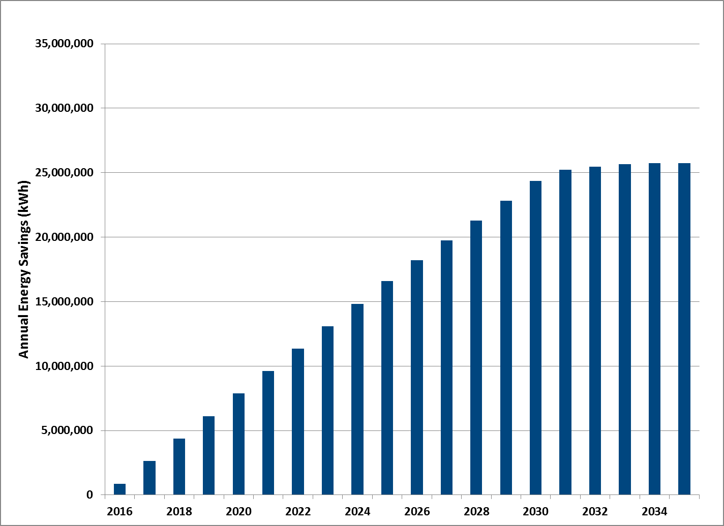
After the first 17 to 18 years, the ramp-up of public benefits associated with the program reaches a steady-state as the total realizable market is reached and customers continue to renew lease terms at the end of the useful life of their product.
Lease Solutions is also estimated to result in over 190 million therms of gas energy conservation in the first 20 years, which is equivalent to fueling over 11,500 homes each year for 20 years. Figure 3 shows the estimated gas energy conservation over the first 20 years of Lease Solutions.
Figure 3: Avoided Energy Savings (Therms)
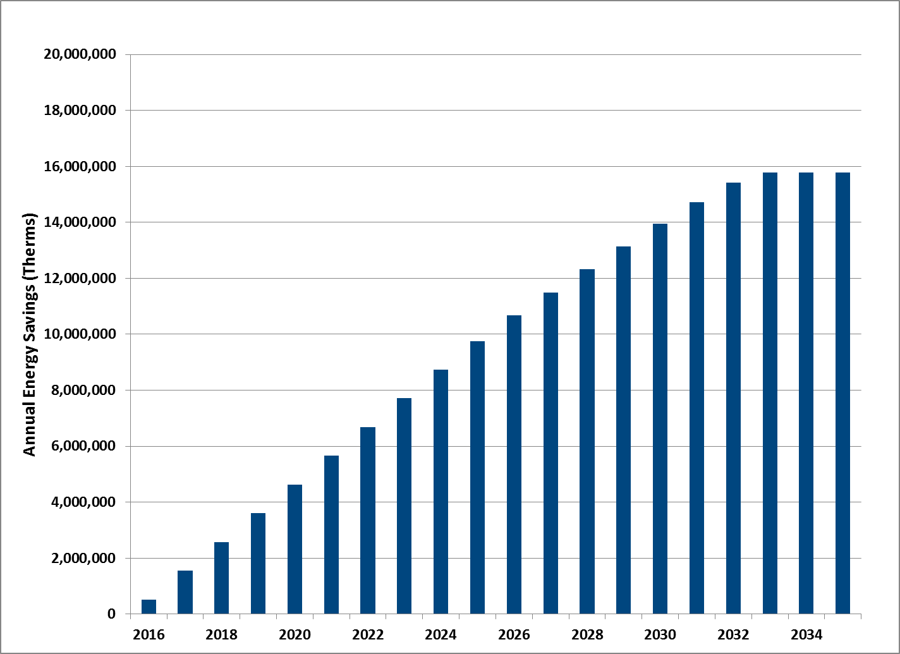
These energy savings results in 1.3 million tons of CO₂-equivalent emissions avoided, which is equivalent to taking over 12,500 cars off the road. Figure 4 shows the avoided CO₂-equivalent emissions over the first 20 years of Lease Solutions.
Figure 4: Avoided Emissions Savings (Tons of Carbon Equivalents)
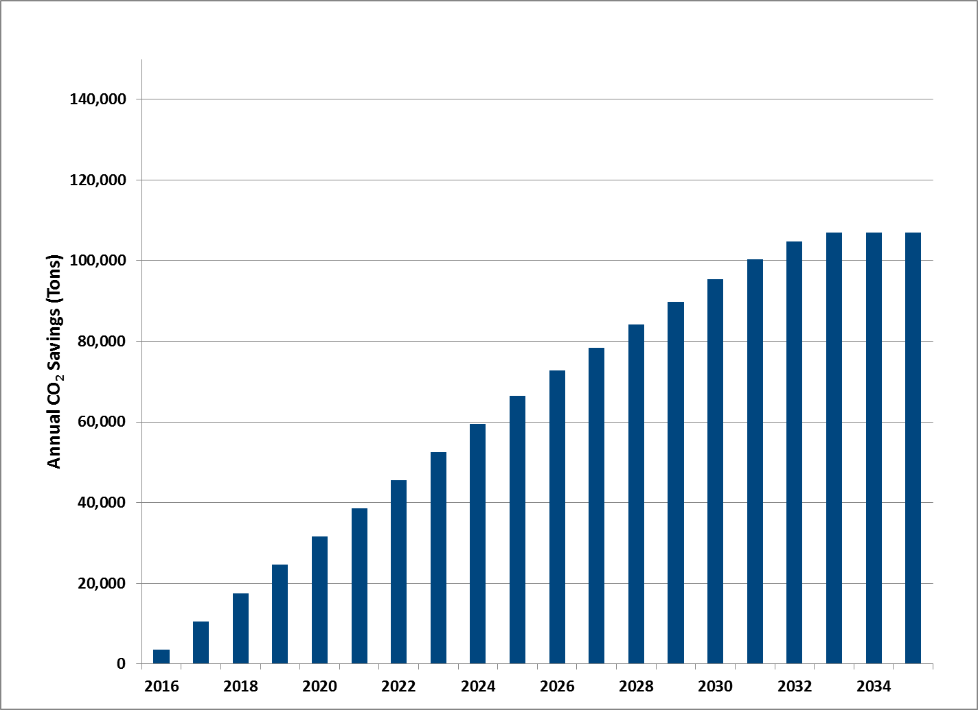
The leasing program is also estimated to result in $5.5 million in avoided generation and distribution capacity costs and $144 million in utility bill savings for participating customers over the first 20 years.
Figure 5 depicts the present value of estimated savings in the first 20 years of the service by the source of the savings, and Figure 6 presents annual savings in 2016 dollars over the first 20 years of the service. These charts illustrate that the bulk of Lease Solutions’ public benefits come in the form of avoided energy costs, followed by avoided greenhouse gas emissions.
Figure 5: Net Present Value for First 20 Years of the Program
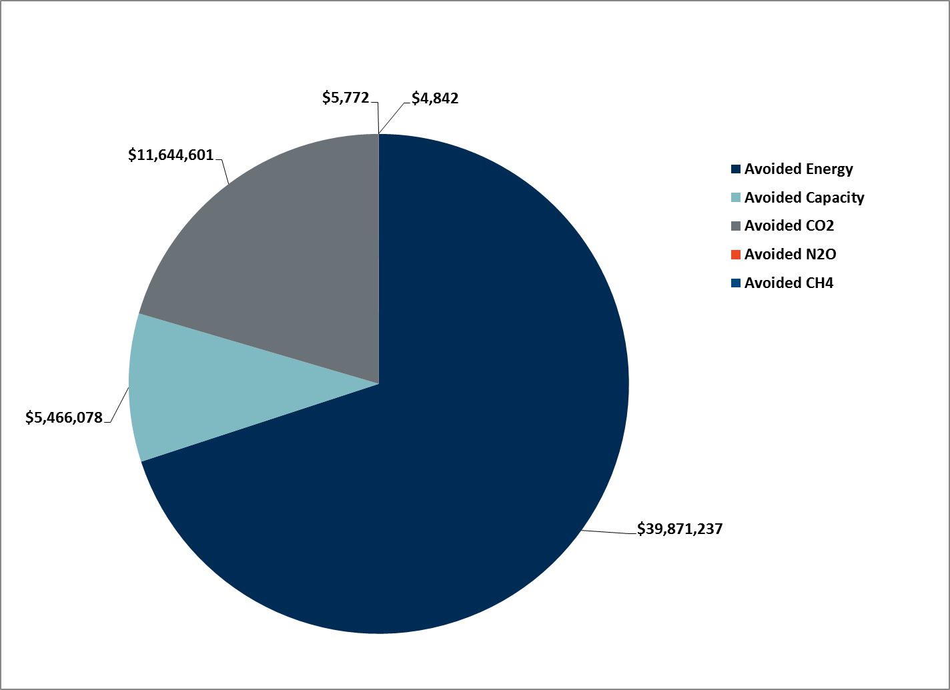
Figure 6: Annual Savings By Avoided Cost Category (2016 $)
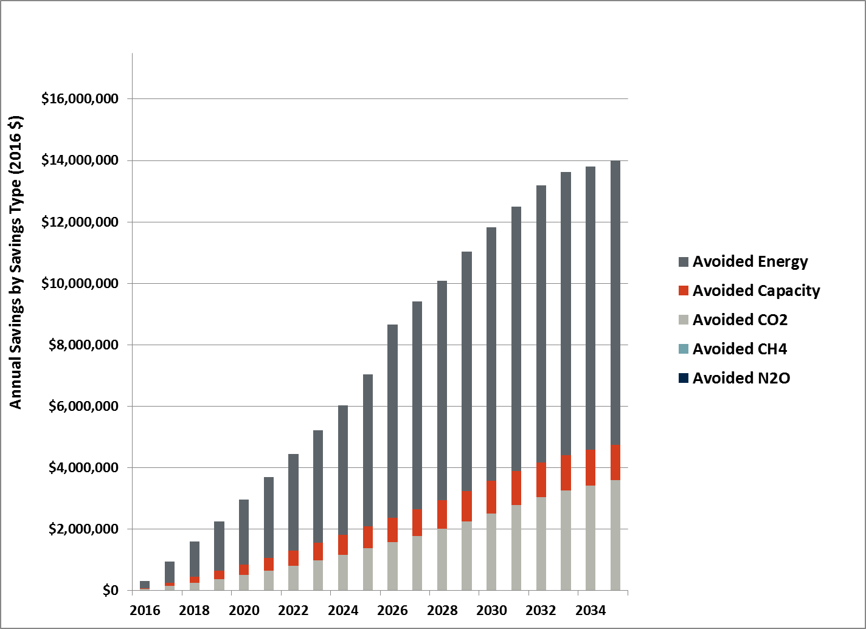
Figure 7 shows annual savings in 2016 dollars, broken out by the end-use equipment being leased. Residential gas furnaces make up the largest source of savings.
Figure 7: Annual Savings by Program (2016 $)
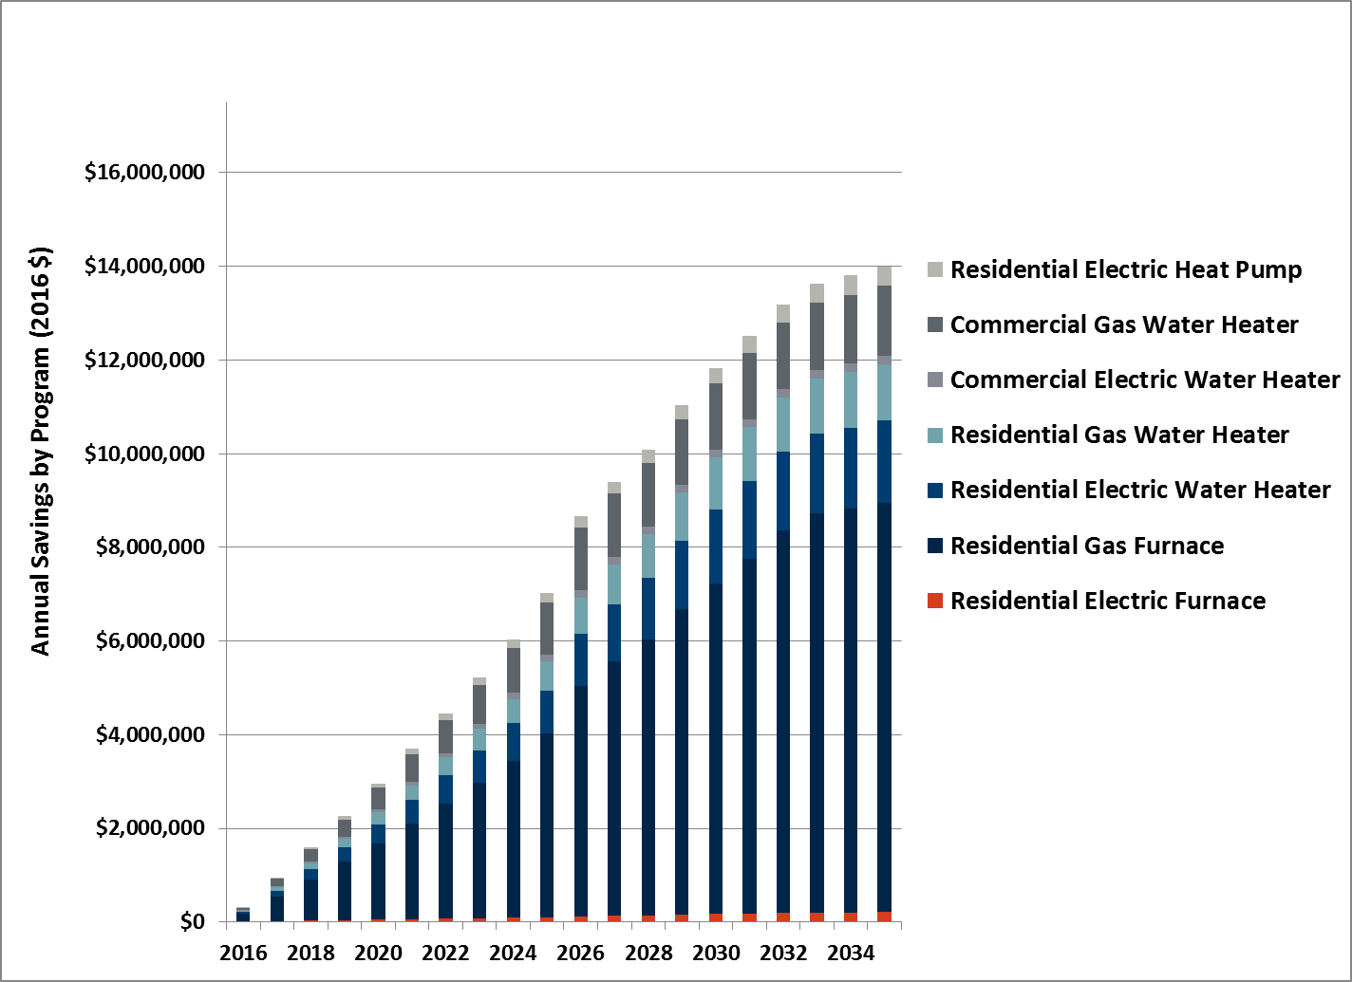

VI. CONCLUSION
Q. What is your conclusion?
A. The proposed PSE Lease Solutions addresses key barriers to customer adoption of new, efficient products by making the purchasing and maintenance process easier and more attainable, and is a compliment to the Company’s existing energy efficiency programs. I expect that the PSE Lease Solutions will sign up thousands of customers and result in the installation of energy efficient equipment, at a more accelerated pace in some instances, that otherwise would not have been installed. This will generate significant benefits in terms of bill savings, enhanced comfort and quality of life, avoided energy costs, avoided capacity costs, and avoided emissions.
Q. Does that conclude your testimony?
A. Yes, it does.

Marilyn A. Brown, “Market failures and barriers as a basis for clean energy policies,” Energy Policy 29 (2001): 1198.
Kenneth Gillingham, Richard G. Newell, and Karen Palmer, “Energy Efficiency Economics and Policy,” Resources for the Future (2009): 7, accessed February 5, 2016, http://www.rff.org/files/sharepoint/WorkImages/Download/RFF-DP-09-13.pdf.
William H. Golove and Joseph H. Eto, “Market Barriers to Energy Efficiency: A Critical Reappraisal of the Rationale for Public Policies to Promote Energy Efficiency,” Lawrence Berkeley National Laboratory (March 1996): 7, accessed February 3, 2016, http://eetd.lbl.gov/sites/all/files/lbnl-38059.pdf.
Hannah Choi Granade et al., “Unlocking Energy Efficiency in the U.S. Economy,” McKinsey Global Energy and Materials (July 2009): viii, accessed February 2, 2016, http://www.mckinsey.com/client_service/electric_power_and_natural_gas/latest_thinking/unlocking_energy_efficiency_in_the_us_economy.
Steve Sorrell, Alexandra Mallett, and Sheridan Nye, “Barriers to industrial energy efficiency: A literature review,” working paper for the United Nations Industrial Development Organization Industrial Development Report (2011): viii, accessed February 1, 2016, https://www.unido.org/fileadmin/user_media/Services/Research_and_Statistics/WP102011_Ebook.pdf.
Carl Blumstein et al., “Overcoming Social and Institutional Barriers to Energy Conservation,” Energy 5 (1980): 356-357.
Golove and Eto, 10.
Marilyn A. Brown et al., “Carbon Lock-In: Barriers To Deploying Climate Change Mitigation Technologies,” Oak Ridge National Laboratory (November 2007): 37-38.
Brown (2001), 1202.
Sorrell, Mallett, and Nye, viii.
Paul C. Stern and Elliot Aronson, Energy Use: The Human Dimension (New York: W.H. Freeman and Company, 1984), 40, accessed February 3, 2016, http://www.nap.edu/catalog/9259.html.
Patrik Thollander, Jenny Palm, and Patrik Rohdin, “Categorizing Barriers to Energy Efficiency: An Interdisciplinary Perspective,” in Energy Efficiency, ed. Jenny Palm, 53-54, (InTech, 2010), accessed February 1, 2016, http://cdn.intechopen.com/pdfs/11463/InTech-Categorizing_barriers_to_energy_efficiency_an_interdisciplinary_perspective.pdf.
Amulya K.N. Reddy, “Barriers to improvements in energy efficiency,” Energy Policy (1991): 954, accessed February 5, 2016, http://josiah.berkeley.edu/2008Spring/ER291/Readings/2.27-3.04/AKN_Reddy-Barriers-1991.pdf.
Daniel Kahneman and Amos Tversky, “Prospect Theory: An Analysis of Decision under Risk,” Econometrica 47 (1979): 263, accessed February 3, 2016, http://people.hss.caltech.edu/~camerer/Ec101/ProspectTheory.pdf.
Elke U. Weber and Eric J. Johnson, “Psychology and Behavioral Economics: Lessons for the Design of a Green Growth Strategy,” The World Bank (October 2012): 19, accessed February 1, 2016, http://www-wds.worldbank.org/external/default/WDSContentServer/WDSP/IB/2012/10/17/000158349_20121017141002/Rendered/PDF/wps6240.pdf.
Sorrell, Mallett, and Nye, viii and 17; Alan H. Sanstad and Richard B. Howarth, “‘Normal’ markets, market imperfections and energy efficiency,” Energy Policy 22 (1994): 814, accessed February 3, 2016, http://www.sciencedirect.com/science/article/pii/0301421594901392.
Blumstein et al., 356.
Thollander Palm, and Rohdin, 52; Sorrell Mallett, and Nye, 17.
Lowell Ungar et al., “Guiding the Invisible Hand: Policies to Address Market Barriers to Energy Efficiency,” American Council for an Energy-Efficient Economy Summer Study on Energy Efficiency in Buildings (2012): 6-323, accessed February 1, 2016, http://aceee.org/files/proceedings/2012/data/papers/0193-000214.pdf.
Stern and Aronson, 40.
Granade et al., viii.
Stern and Aronson, 40.
Sanstad and Howarth, 814.
Ibid.
Stern and Aronson, 45.
Sorrell Mallett, and Nye, 17.
David Laibson, “Golden Eggs and Hyperbolic Discounting,” Quarterly Journal of Economics (1997): 449, accessed February 3, 2016, http://harbaugh.uoregon.edu/Readings/Time/Laibson%201997%20QJE,%20Golden%20eggs%20and%20hyperbolic%20discounting.pdf.
Weber and Johnson, 16.
Colin F. Camerer and George Loewenstein, “Behavioral Economics: Past, Present, Future,” in Advances in Behavioral Economics, ed. Colin F. Camerer, George Loewenstein, and Matthew Rabin, 22 (Princeton: Princeton University Press, 2004), accessed February 3, 2016, http://www.cmu.edu/dietrich/sds/docs/loewenstein/BehEconPastPresentFuture.pdf.
Ibid, 23.
Brown (2007), 30.
Blumstein et al., 355.
Brown (2007), 30.
American Council for an Energy-Efficient Economy (ACEEE) website: http://aceee.org/portal/programs, accessed February 20, 2016.
Matthew McCaffree, “Alternative Financing Mechanisms for Energy Efficiency,” Institute for Electric Efficiency, The Edison Foundation (February 2010): 1, accessed February 1, 2016, http://www.edisonfoundation.net/iei/Documents/IEE_AltFinancingMech_McCaffree.pdf.
Third Exhibit to the Prefiled Testimony of Malcolm B. McCulloch, Exhibit. No. ___(MBM-4).
PSE Analysis.
PSE Vendor Feedback.
(1,312,189 premises) * (65% of customers have a gas furnace) * (23% of customers are likely to accept a lease) * (65% of customers have eligible credit) * (80% of customers have viable housing stock) = 102,010 residential gas furnaces.
PSE Lease Solutions, gas furnace lease term.
(102,010 residential gas furnaces likely and eligible to lease) / (17 years) = 6,001 residential gas furnaces.
The estimate of 22 percent is calculated using the age distribution of equipment obtained from the survey. I prorated the number of units in the 16-20 year group in order to only include those units which were over the useful life of 17 years. See Exhibit No. ___(AF-3), Puget Sound Energy Equipment Leasing Survey, Table Q12 Page 12 (Attachment A 3.Equipment Leasing Crosstab Banner).
To keep the model parsimonious, we assume that the number of customers replacing equipment remains constant across years. Mechanically this implies that the pool of customers who continue to operate equipment beyond it useful life remains constant and consequently that the number of customers exiting this pool in a given year is matched by those entering.
PSE’s 2016-2017 approved conservation plan
I assume that additional savings of 20 percent applies to all accelerated units, not just to furnaces.
The estimate of 15 percent is calculated by looking at the probability of acceleration in the survey of customers conditional on their equipment age. I prorated the number of units in the 16-20 year group in order to only include those units which were over the useful life of 17 years. See Exhibit No. ___(AF-3) Puget Sound Energy Equipment Leasing Survey, Table Q12 Page 12 (Attachment B 4.Equipment Leasing Crosstab Banner).
(6,001 units) * (22%) * (15%) = 198 units.
Puget Sound Energy, Figure: Northwest Energy Efficiency Alliance’s 2012 residential Building Stock Assessment, Letter to Washington Utilities Transportation Commission, “Docket No. UE-151871 (Advice 2015-23) Substitute Tariff Filing,” November 6, 2015, p. 2.
(119 therms) * (20% additional efficiency savings for replacement of aged equipment) = 23.8 therms.
(6,001 units) * (119 therms) = 714,119 therms for 17 years, the full useful life of residential gas furnaces. (198 units) * (23.8 therms) = 4,712 therms for six years, the additional years of benefits due to accelerated replacement. 714,119 + 4,712 = 718,831 therms for the first 11 years.
($0.40/therm) * (718,831 therms) = $287,532.
($1.35/therm) * (718,831 therms) = $970,422.
Factor developed by the Environmental Protection Agency for the Mandatory Reporting Rule (40 CFR Part 98).
(718,831 therms) * (0.01 tons CO₂ per therm) * ($13.31 per ton of CO₂) = $95,676.
PSE assumes average residential use of 1,000 kWh per month. See: https://pse.com/savingsandenergycenter/tips-tools-ideas/Pages/Energy-Cost-Guide.aspx, accessed February 25, 2016.
PSE assumes average residential use of 68 therms per month. See: https://pse.com/savingsandenergycenter/tips-tools-ideas/Pages/Energy-Cost-Guide.aspx, accessed February 25, 2016.
EPA estimates that the average passenger vehicle emits 4.7 metric tons of carbon dioxide per year. See: https://www3.epa.gov/otaq/climate/documents/420f14040a.pdf, accessed February 25, 2016.

