June 13, 2014

Steven V. King, Executive Director and Secretary
Utilities and Transportation Commission
1300 S. Evergreen Park Dr. SW
P.O. Box 47250
Olympia, WA 98504-7250

RE: Washington Utilities and Transportation Commission v. Vanderveen Family Transport, Inc.

Commission Staff’s Response to Application for Mitigation of Penalties TG-141017

Dear Mr. King:

On May 23, 2014, the Utilities and Transportation Commission issued a $200 Penalty Assessment in Docket TG-141017 against Vanderveen Family Transport, Inc. for 2 violations of Washington Administrative Code (WAC) 480-70-071, which requires solid waste companies to furnish annual reports to the commission no later than May 1 each year.¹

On June 3, 2014, Vanderveen Family Transport, Inc. wrote the commission requesting mitigation of penalties (Mitigation Request).² In its Mitigation Request, Vanderveen Family Transport, Inc. does not dispute that the violation occurred. The company states, “Postal service told me it would be delivered by May 1st. It was 2 days late unfortunately. We did not owe any fees for 2013 as we had 0 regulatory income in 2013.”

It is the company’s responsibility to ensure that the regulatory fee is paid and the annual report is filed by the May 1 deadline. On February 28, 2014, Annual Report packets were mailed to all regulated solid waste companies. The instructions for annual report completion page of the annual report informed the regulated company that it must complete the annual report form, pay the regulatory fees, and return the materials by May 1, 2014, to avoid enforcement action.

On May 5, 2014, Vanderveen Family Transport, Inc. filed the 2013 annual report with no regulatory fees due. The company has been active since August 22, 2006. Vanderveen Family Transport, Inc. previously missed the deadline for filing its annual report and paying its regulatory fees for the 2012 reporting year. Staff does not support the company’s request for
UTC Annual Reports
June 13, 2014
Page 2

mitigation as the company has not presented any new or compelling information and prior missed deadline.

If you have any questions regarding this recommendation, please contact Amy Andrews, Regulatory Analyst, at (360) 664-1157, or aandrews@utc.wa.gov.

Sincerely,

Sondra Walsh, Director
Administrative Services

ATTACHMENT A
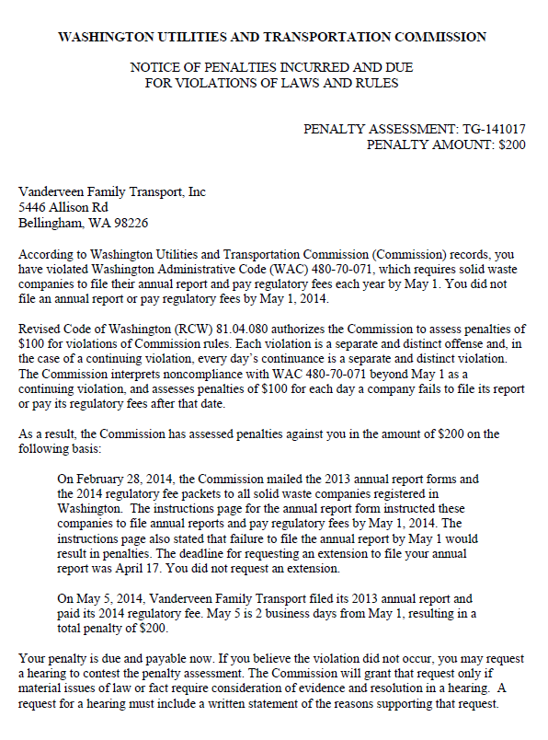
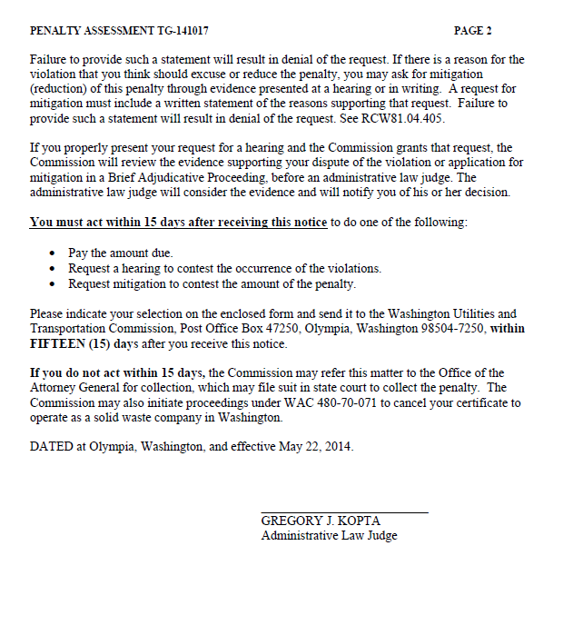

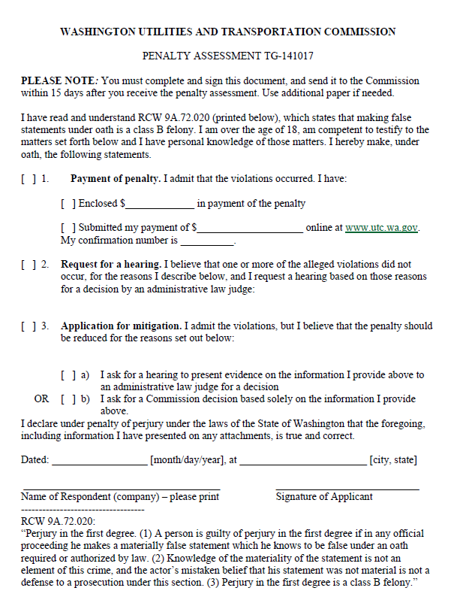

ATTACHMENT B
