June 24, 2014

Steven V. King, Executive Director and Secretary
Utilities and Transportation Commission
1300 S. Evergreen Park Dr. SW
P.O. Box 47250
Olympia, WA 98504-7250

RE: Washington Utilities and Transportation Commission v. MOL Logistics (USA) Inc.

Commission Staff’s Response to Application for Mitigation of Penalties TV-140969

Dear Mr. King:

On June 5, 2014, the Utilities and Transportation Commission issued a $1,000 Penalty Assessment in Docket TV-140969 against MOL Logistics (USA) Inc. for 10 violations of Washington Administrative Code (WAC) 480-15-480, which requires household goods carrier companies to furnish annual reports to the commission no later than May 1 each year.¹

On June 9, 2014, MOL Logistics (USA) Inc. wrote the commission requesting mitigation of penalties (Mitigation Request).² In its Mitigation Request, MOL Logistics (USA) Inc. does not dispute that the violation occurred. The company states, “As part of our day to day business practices, we do not engage in intrastate household goods deliveries.” The company also requested to voluntarily terminate its household goods operating permit.

It is the company’s responsibility to ensure that the regulatory fee is paid and the annual report is filed by the May 1 deadline. On February 28, 2014, Annual Report packets were mailed to all regulated household goods companies. The instructions for annual report completion page of the annual report informed the regulated company that it must complete the annual report form, pay the regulatory fees, and return the materials by May 1, 2014, to avoid enforcement action.

On June 9, 2014, MOL Logistics (USA) Inc. filed the 2013 annual report with no regulatory fees due. The company’s household goods permit was canceled per Docket TV-141265. No previous violations of WAC 480-15-480 are on commission record. Staff supports the

UTC Annual Reports
June 24, 2014
Page 2

company’s request for mitigation as this is the company’s first delinquent filing. Staff recommends to waive the penalty as the company provided no household goods services during 2013 and has voluntarily canceled their permit.

If you have any questions regarding this recommendation, please contact Amy Andrews, Regulatory Analyst, at (360) 664-1157, or aandrews@utc.wa.gov.

Sincerely,

Sondra Walsh, Director
Administrative Services

ATTACHMENT A
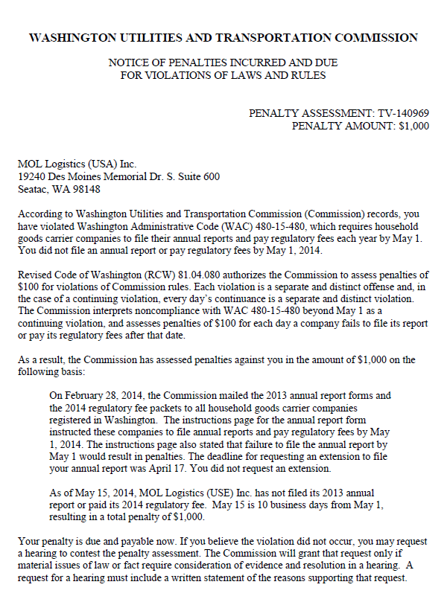

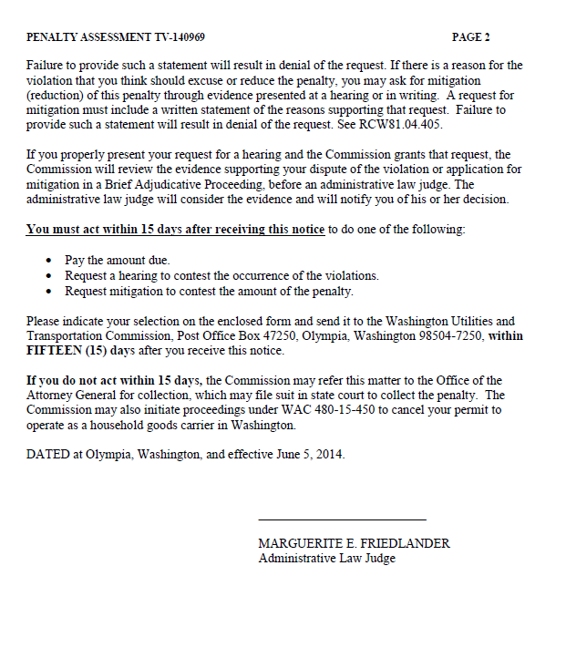

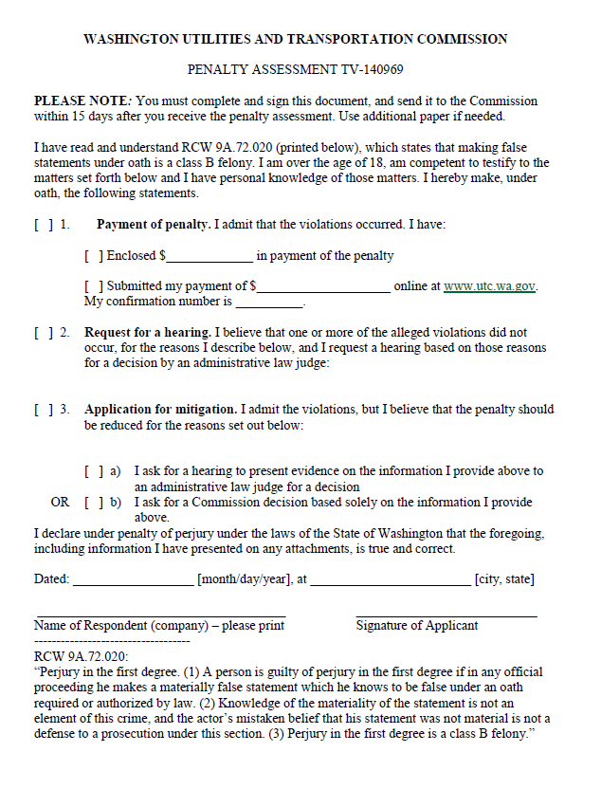

ATTACHMENT B
